Please select the "live" profile. You can select a profile in upper right corner. In case you have already created the separate profile with directions at top, as described here Making charts, - then select it.
To create the report by independent systems: press Details mark in the topmost line and chose the required time window on the chart or place a slider to the time under investigation (Single Timeslot).
Then select the desired report type in menu Options (under Netflow Processing):
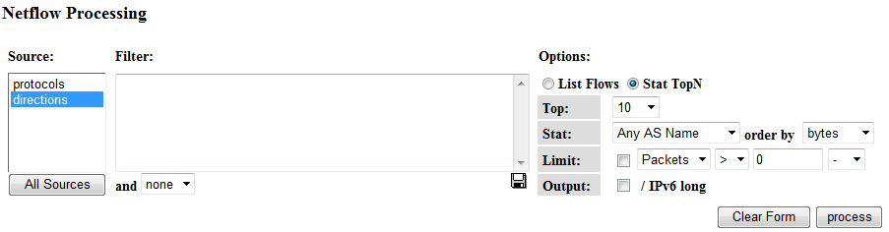
Here:
Stat TopN - is a list of top directions
Top: 10 - is a number of elements in top
Stat: Any AS Name/SRC AS Name or DST AS Name - count all the traffic or only that in one direction
Order By: bytes - count top by data amount
and press Process button.
For "live" profile you should mark only Source: directions
The report by top directions of dataflow will be created:
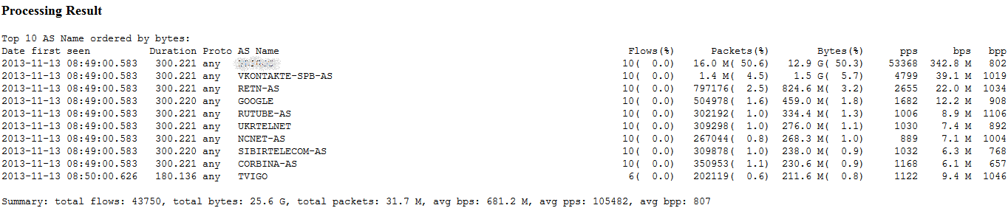
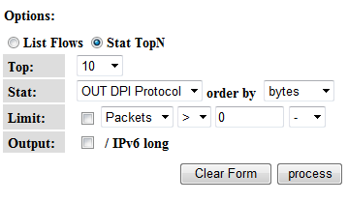
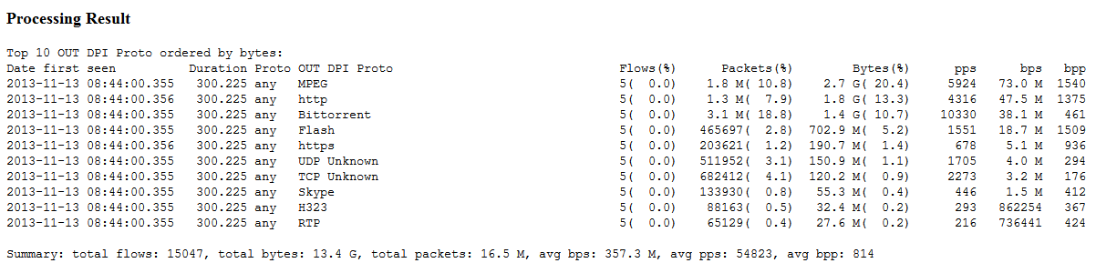
Similarly, by selecting Source: protocols or a single profile with top protocols you can get reports by protocols in one or two directions DPI Protocol/IN DPI Protocol/OUT DPI Protocol

