Identifying the Number of Subscriber Devices (Behind a Router)
The number of subscriber devices calculated using UserAgent metric in ClickStream QoE.
Metrics work well on large amount of data. When working with this metrics, mind the following nuances:
- In QoE, device count is only determined for devices that were online during data collection. The longer the collection period - the more accurate the data.
- Not all devices are detected by this metric. Some devices generate multiple different UserAgents simultaneously when running multiple applications.
How to collect data in the QoE Analytics section:
- Move to ClickStream
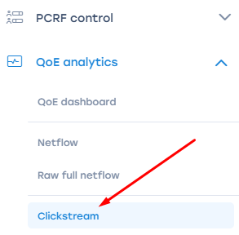
- Select "Top Subscribers" from the standard reports list on the right and "Default" preset
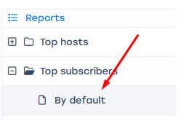
- Select the "Devices" statistics column. This column shows the approximate number of devices per subscriber.
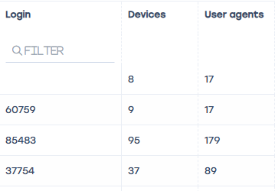
- You can perform various actions with this metric for convenience:
  - Apply a device count filter. For example, filter subscribers that have from 3 to 10 devices.
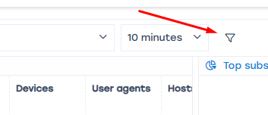
  - Export this subscriber list to .xls for further analytical work.
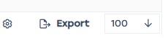
Important: The longer the selected ClickStream period, the more accurate the data. We recommend selecting a period of at least 24 hours.


