Detecting DDoS attacks, BotNet activity, and visits to specific resources using triggers in QoE
Triggers are used to search data in QoE Stor based on specified parameters. When a trigger fires, one of the following actions can occur:
- Notification in GUI
- HTTP action
- Email notification
Required SSG DPI options:
- Statistics gathering and analysis on protocols and directions
- Subscriber notifications
Required additional modules:
- DPIUI2 (GUI - Graphical User Interface)
- Implementation and administration

Example: configuring a trigger to detect the source of a Flood-type DDoS attack

General trigger information
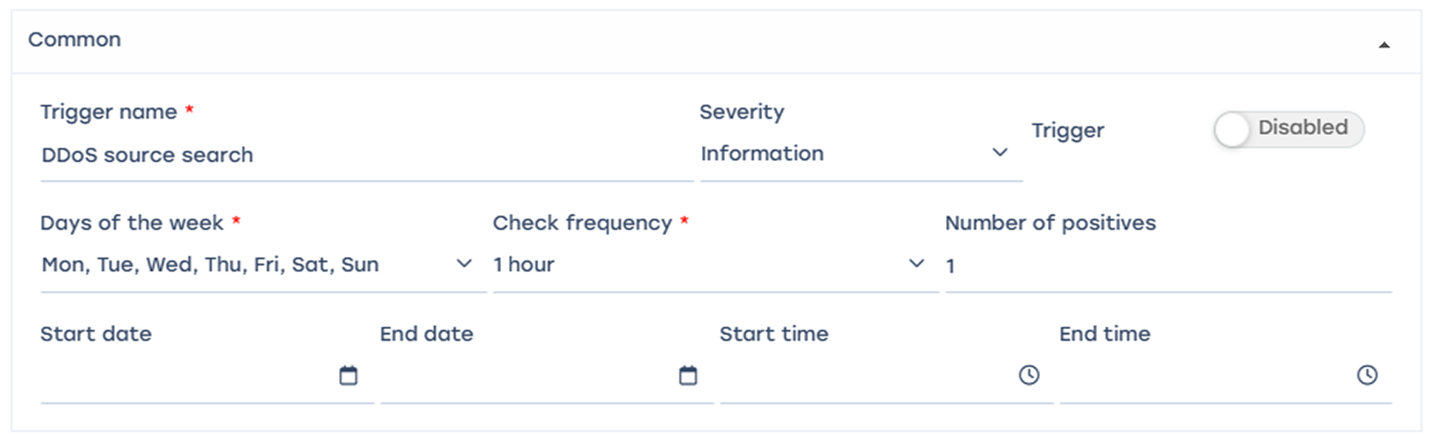
Trigger name: “DDOS source detection”, days of the week – all, check frequency – 1 hour, trigger activation frequency – once, start and end times not set.
Every day, the system will perform a check every hour based on the conditions described below.

Queries
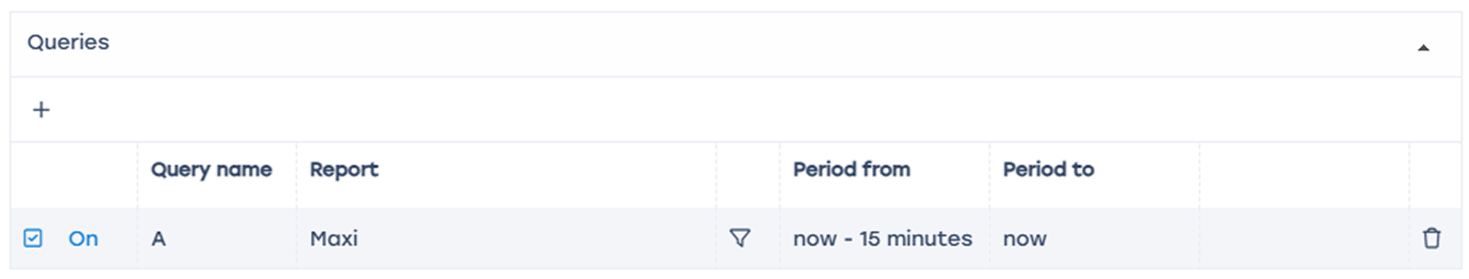
- Add field
- Name: A
- Select table for scanning: Raw full netflow → Tables → Attacks detection → Top hosts IPs → Maxi
- Select period from “now – 15 minutes” to “now”
In this case, the system analyzes traffic for the selected page during the last 15 minutes.

Conditions
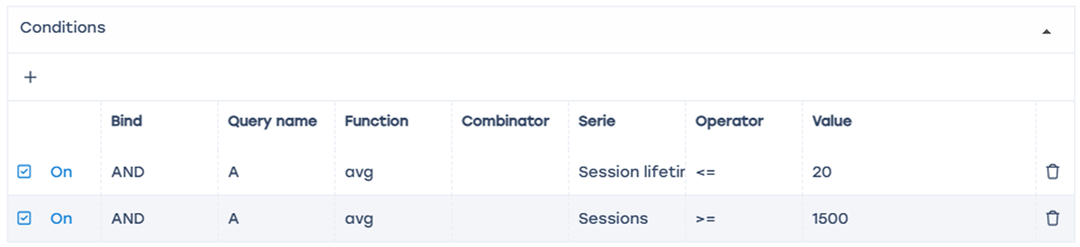
- Add two "+" fields
- Link – AND
- Function – avg
- Condition 1 – session lifetime <= 20 (ms)
- Condition 2 – number of sessions >= 1500
This means the trigger will fire if sessions with lifetimes ≤ 20ms AND more than 1500 sessions from the same IP host are detected.

Error handling
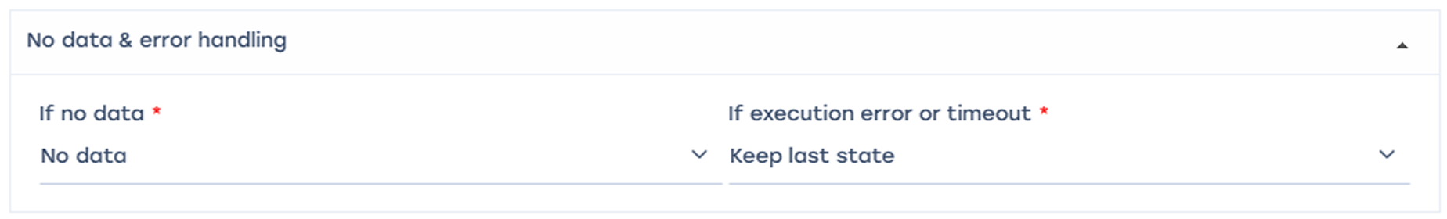
- “If no errors” — no data
- “If there is an error or timeout” — save last state
In this configuration, no data will be saved if there are no errors, but if errors occur, information about suspicious sessions will be saved as a table.

Actions

E-mail action
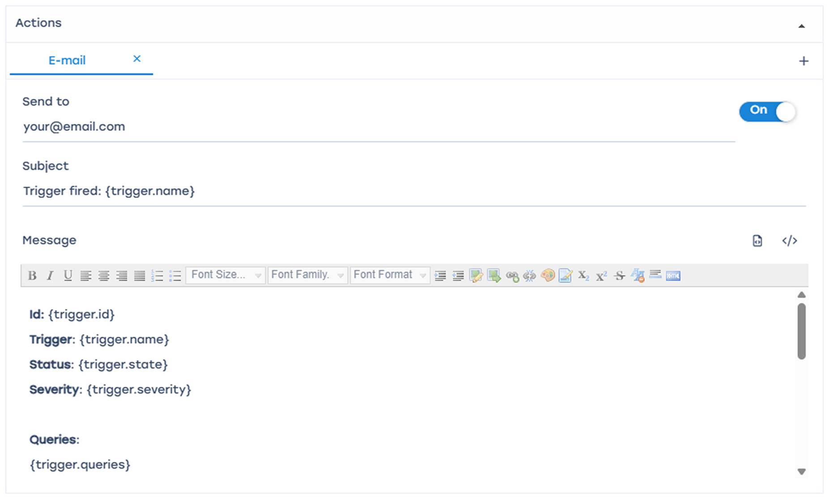
- Click the "</>" icon to auto-fill the form
- Enter the recipient email address in the “To” field
- When triggered, a notification will be sent to the specified email containing the trigger ID, name, status, and report link (saved state).

Notification
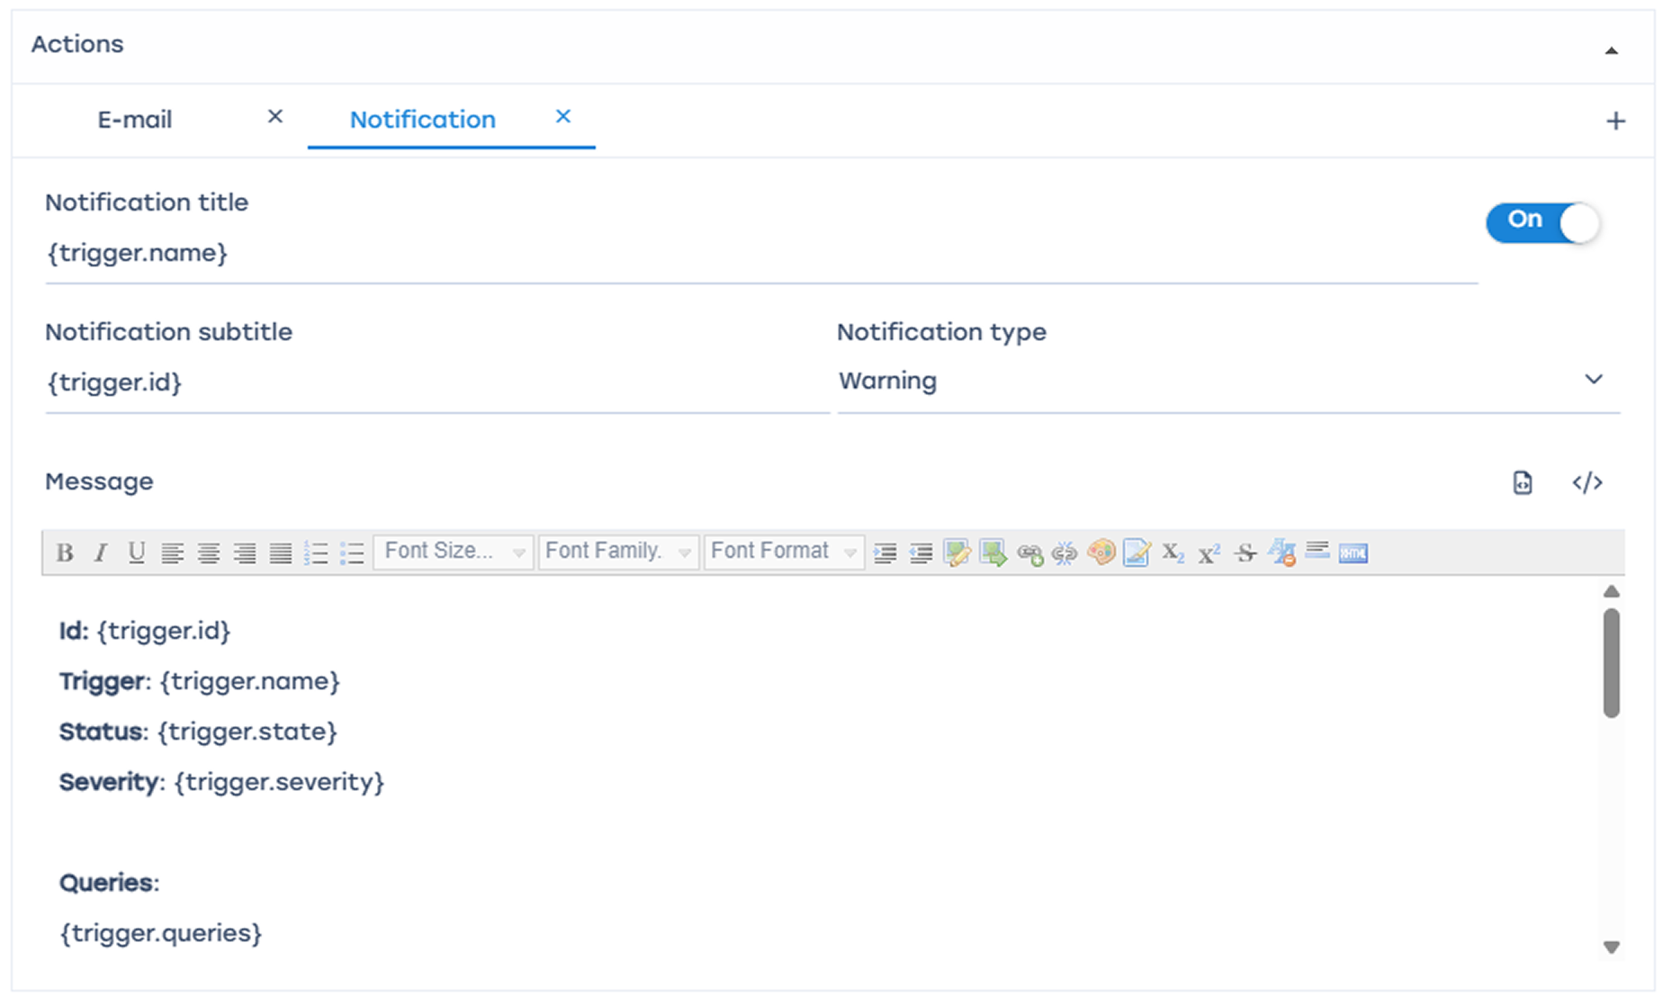
- Click "</>" to auto-fill the form
- Select notification type — “Warning”
- A notification will be created in the SSG system
The report link can be obtained from the notifications menu.
Select the notification Click Details
Follow the report link — it will open in a new browser window.

HTTP action
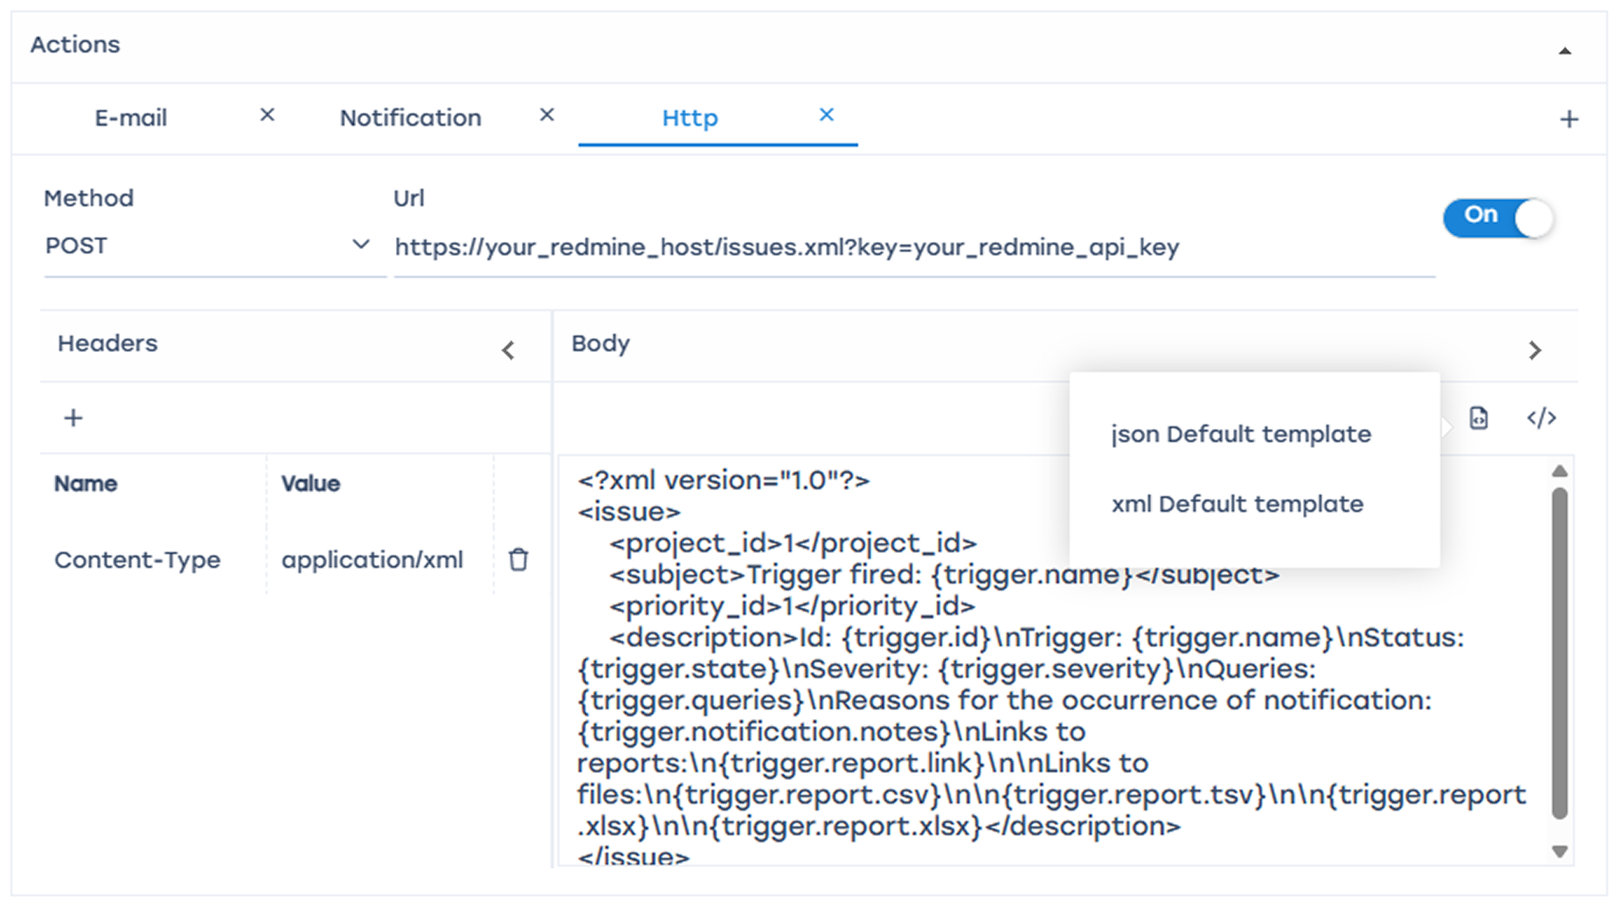
Click "</>" to auto-fill the form, select the method suitable for your ticket system, and enter the URL address.
Keep in mind — values such as session count and packet rate are averaged. Fine-tuning should be performed based on your network specifics.

Example: configuring a trigger to detect the target of a Flood-type DDoS attack
This configuration differs from the previous example in steps 2 and 3 (Queries and Conditions).

Queries
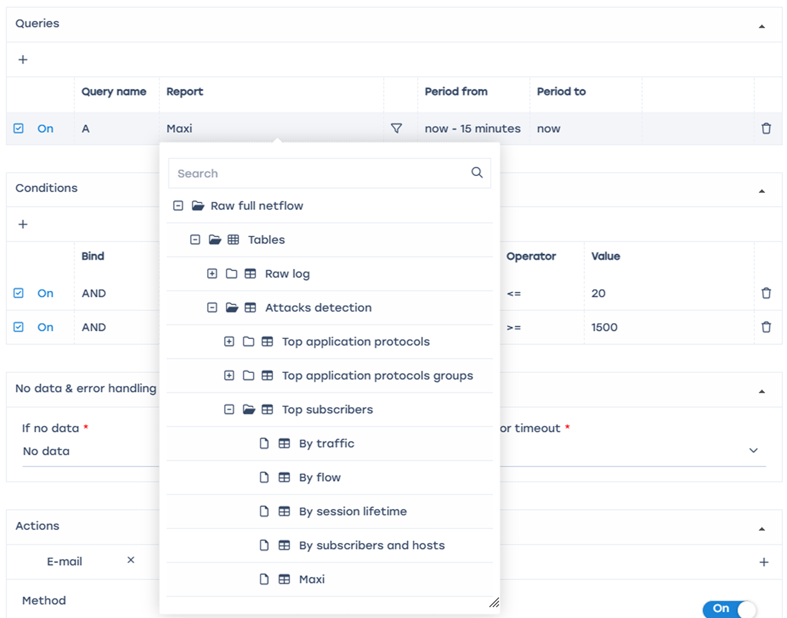
In the report field, select Raw full netflow → Tables → Attacks detection → Top subscribers → Maxi

Conditions
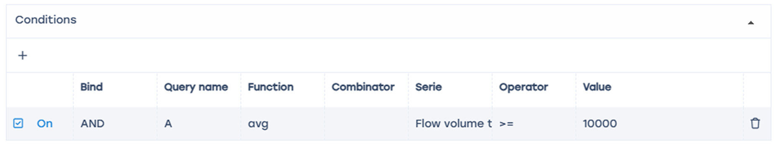
Series — “Flow volume to subscribers, Pct/s” >= 10000
Values such as session count and packet rate are averaged. Fine-tuning should be performed based on your network specifics.

BotNet analysis
This configuration differs from the previous example in steps 2 and 3 (Queries and Conditions).

Queries
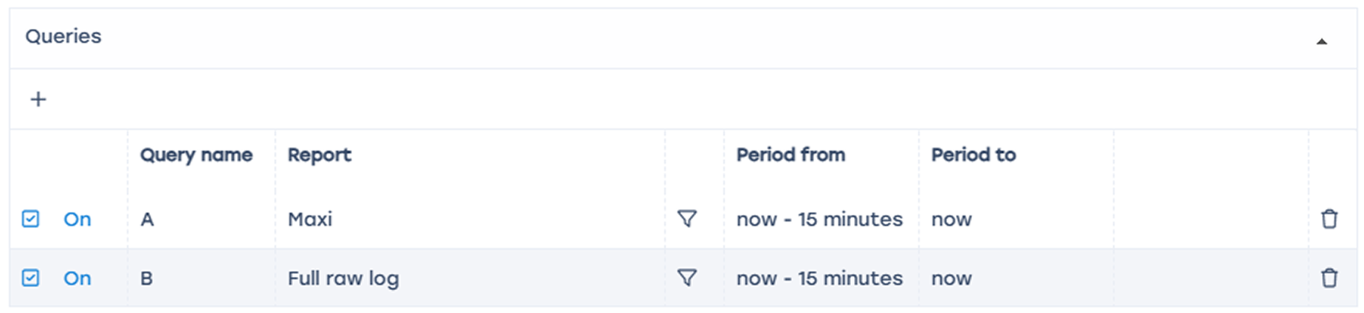
- Select Raw full netflow → Tables → Attacks detection → Top application protocols → Maxi for “A”
- Raw full network → Tables → Raw log → Full raw log for “B”

Conditions
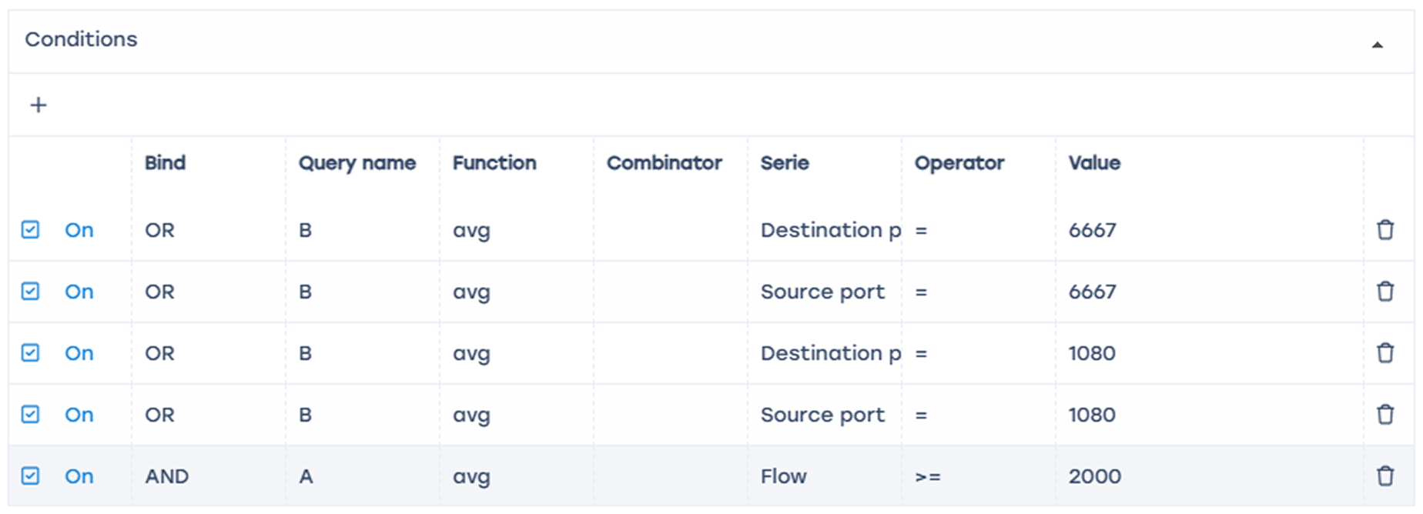
Since BotNet often uses ports 6667 and 1080 — add each destination/source port by selecting query “B” with “OR” condition, and Flow Pcts/s >= 2000.
In this configuration, the trigger will fire if on any of the ports (6667/1080) the packet rate exceeds 2000 per second.
Values such as session count and packet rate are averaged. Fine-tuning should be performed based on your network specifics.

Detecting subscriber visits to competitor resources

General trigger information
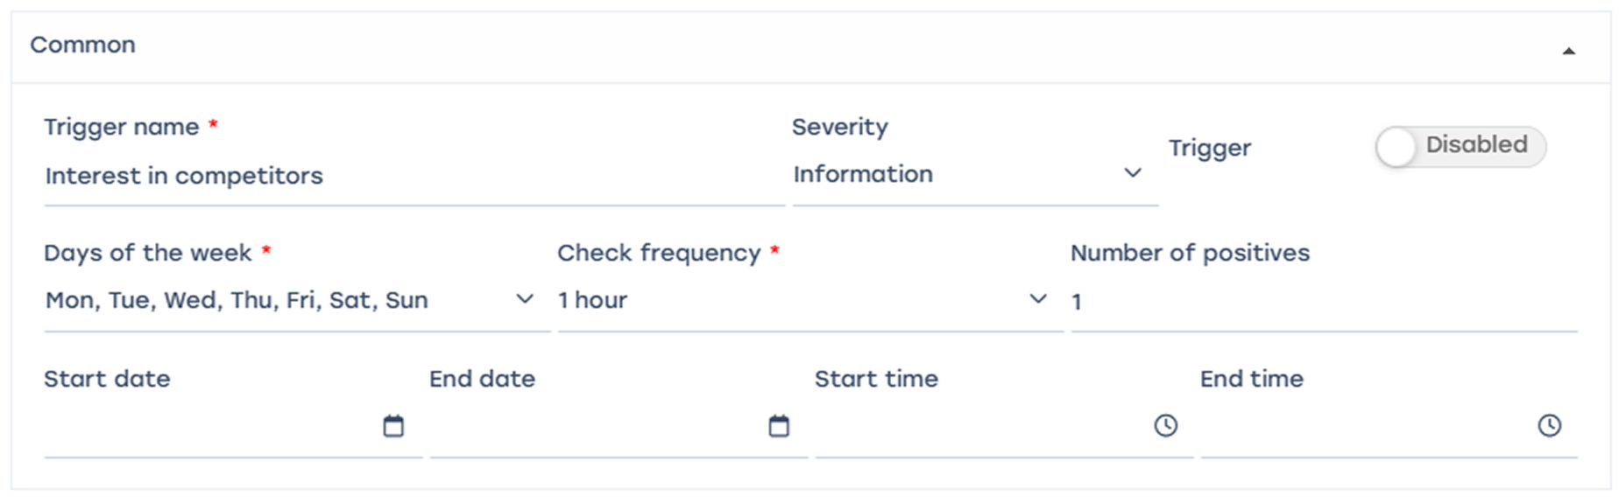
Trigger name: “Interest in competitors”, days of the week – all, check frequency – 1 hour, trigger activation frequency – once, start and end times not set.
Every day, the system will perform a check every hour based on the conditions described below.

Queries
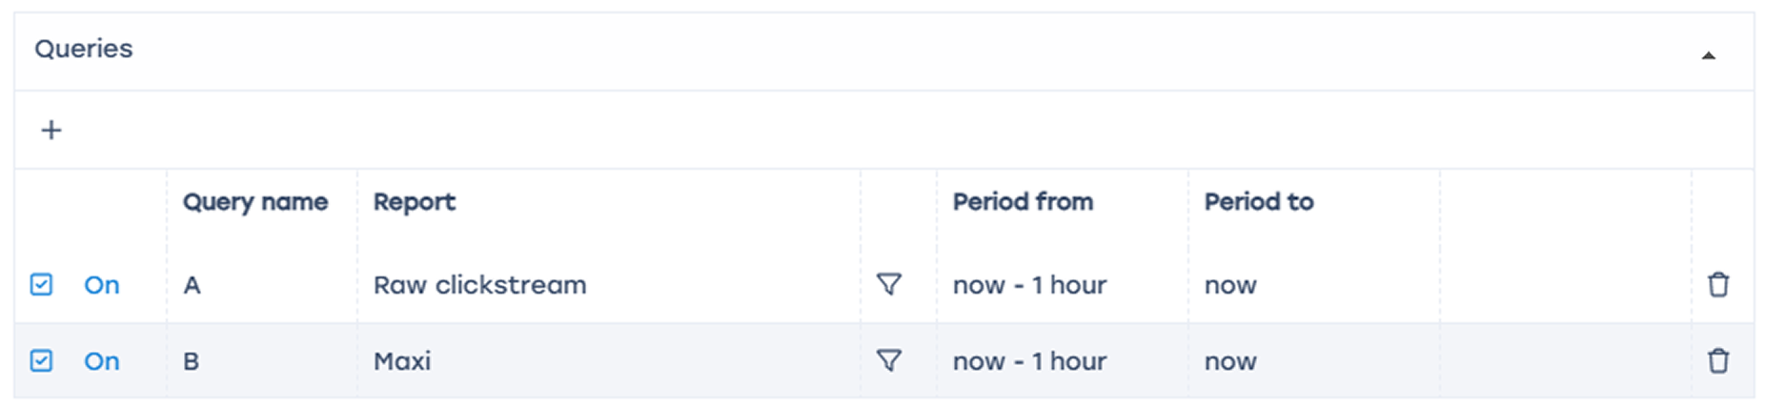
- Add “+” field
- Name A — select table: Raw clickstream → Tables → Raw clickstream
- Name B — select table: Raw full netflow → Tables → Attacks detection → Top hosts IPs → Maxi
- Select period from “now – 1 hour” to “now”
- This setup analyzes traffic hourly based on the selected tables.

Conditions
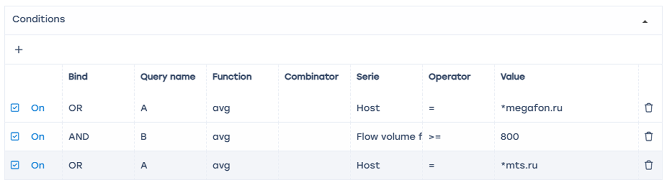
- Add 3 “+” fields
- First field — select table “A”; Link – “OR”; Function – “avg”; Series Host = *megafon.ru (or your competitor)
- Second field — select table “B”; Link – “AND”; Function – “avg”; Series Flow volume from subscriber, Pct/s >= 800
The trigger will fire if at least 800 packets (indicating a meaningful visit) from a subscriber to a competitor’s website are detected.

Error handling

- “If no errors” — no data
- “If there is an error or timeout” — save last state
In this configuration, no data will be saved if there are no errors, but if errors occur, information about suspicious sessions will be saved as a table.

Actions

E-mail action

- Click to auto-fill the form
- Enter recipient email address in “To” field
When triggered, an email containing notification details — ID, trigger name, status, and report link (saved state) — will be sent to the specified address.

Notification

- Click "</>" to auto-fill the form
- Select notification type — “Warning”
- A notification will be created in the SSG system

The report link can be obtained from the notifications menu.

Select the notification Click Details

Follow the report link — it will open in a new browser window.

HTTP action

- Click "</>" to auto-fill the form
- Select the method suitable for your ticket system and enter the URL address
Keep in mind — values such as session count and packet rate are averaged. Fine-tuning should be performed based on your network specifics.

