Deterioration of the quality of Internet access
DPI exports information about all client sessions in IPFIX format (NetFlow v10).
The simplest and most studied DPI metric for communication quality testing is RTT. DPI allows you to measure RTT and divide it by directions (to the subscriber and from the subscriber) and specify by protocols and devices if necessary. A large delay for a long time "from the subscriber" most likely indicates that the subscriber is experiencing difficulties with access to online services - games, video, communication. As a rule, the delay occurs due to the subscriber’s WiFi network, but it can also talk about overloading network nodes.
Action:
- Go to the section QoE Analytics → Subscribers → Netflix
- Create a filter where:
  - It is proposed to limit the search by http / https to screen out possible features of other protocols when installing a TCP connection.
  - indicate the average speed to make a sample of subscribers actively using the Internet
  - specify the lower threshold RTT from the client
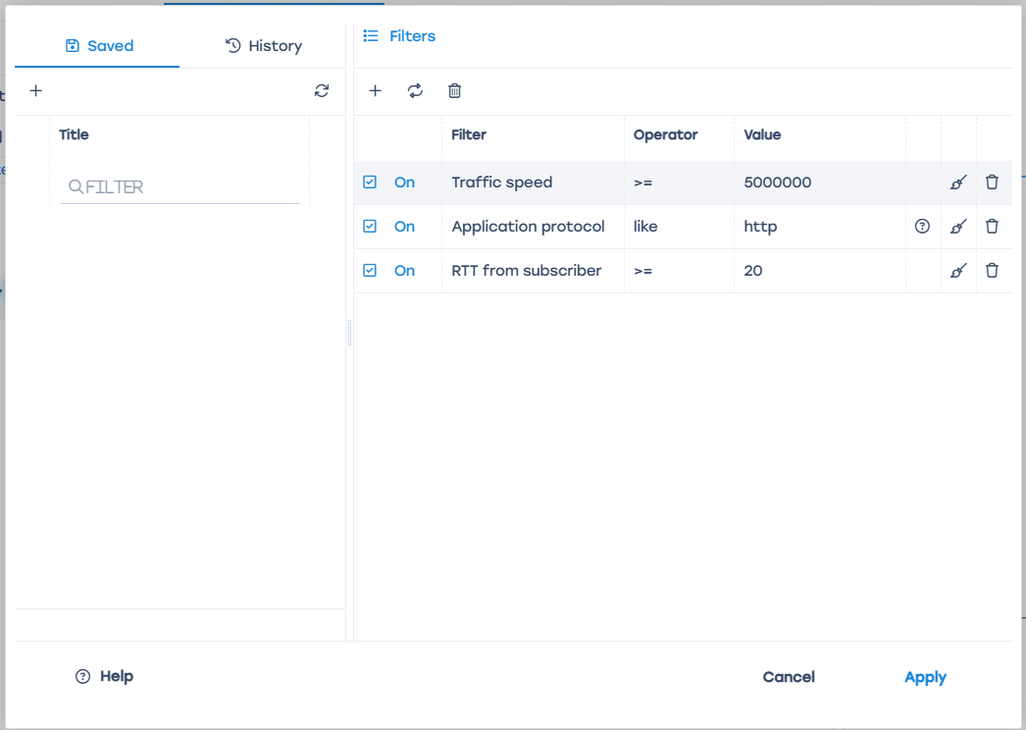
It is recommended to work with subscribers who have an average (and even better median) RTT of more than 100 in 24 hours. This can be done by:
- Upload data daily to your database via the API or directly from Click House QoE.
- Make a trigger in a graphical interface with specified parameters.
When processing, it is important to consider the following factors:
- It is worth checking the geographical distribution of the “problem” unloading. “Accuracy” usually occurs due to network congestion or an old switch, the problem can be fixed on the operator’s side. It happens that a “bad” area is connected by outdated technology (DSL or radio access), then a bad RTT is no longer a bug, but a feature.
- The subscriber may not experience discomfort due to the delay (and speaks directly about it if asked by phone), for example in cases of:
  - IoT devices are working, they may have a weak signal
  - Works on outdated equipment and does not expect miracles
  - Do not use online services
- Problems in Wi-Fi networks can occur due to:
  - Noisy Wi-Fi range 2.4 in an apartment building
  - router
  - complex topology or large size of the apartment / house
- Sometimes it is impossible to determine the host where the subscriber has contacted with a high RTT.
This can be for three reasons:
  - IP
  - http protocol
  - No SNI.
- In addition to RTT, you can use the % retransmit metric when searching for problem subscribers. If for a long time (>30 minutes) there is a significant excess of the background value for retransmits (usually 4-5%), this is a sign of degradation of the subscriber’s service. It is not recommended to use retransmitts without RTT, there is a high probability of false positives.

Example of a request to the database: Download script
Parameters in the script:
format='CSV is the output format. By default, CSV. Possible formats: https://clickhouse.com/docs/en/interfaces/formats/
periodSecs=24*3600 is the period in seconds. The default is 24 hours.
rttMore=100 is the value of RTT. By default, 100.

