10 Licensing
- Stingray Service Gateway (SSG) liceinsing depends on the bandwidth and its features.
- The license is unlimited, not limited in time.
- Technical support is not included in the license and is paid separately.

Bandwidth
Licenses grading of the bandwidth: SSG-6/10/20/40/60/80/100/120/200. Pay attention to the hardware requirements!
Depending on the installation scheme, the following restrictions are assumed:

1. When installing "in line" scheme
- SSG-6 corresponds to 5Gb/s of incoming and to 1Gb/s of outgoing traffic
- SSG-10 corresponds to 8Gb/s of incoming and to 2Gb/s of outgoing traffic
- SSG-20 corresponds to 15Gb/s of incoming and to 5Gb/s of outgoing traffic
- SSG-40 corresponds to 30Gb/s of incoming and to 10Gb/s of outgoing traffic
- SSG-60 corresponds to 45Gb/s of incoming and to 15Gb/s of outgoing traffic
- SSG-80 corresponds to 60Gb/s of incoming and to 20Gb/s of outgoing traffic
- SSG-100 corresponds to 75Gb/s of incoming and to 25Gb/s of outgoing traffic
- SSG-120 corresponds to 90Gb/s of incoming and to 30Gb/s of outgoing traffic
Licensing includes ISP traffic asymmetry. Usually, the incoming traffic is three times more than the outgoing one. For example, Incoming - 6G, Outgoing - 2G. License - SSG-10.

2. When installing using the "mirror" scheme
- SSG-6 corresponds to 6Gb/s of total incoming traffic
- SSG-10 corresponds to 10Gb/s of total incoming traffic
- SSG-20 corresponds to 20Gb/s of total incoming traffic
- SSG-40 corresponds to 40Gb/s of total incoming traffic
- SSG-60 corresponds to 60Gb/s of total incoming traffic
- SSG-80 corresponds to 80Gb/s of total incoming traffic
- SSG-100 corresponds to 100Gb/s of total incoming traffic
- SSG-120 corresponds to 120Gb/s of total incoming traffic

License Exceeding
If the license parameters are exceeded by the bandwidth, the DPI will process the traffic until the stored reserves are exhausted, when the reserves are exhausted the traffic will be skipped without processing. You can limit the bandwidth yourself using channel policing, this is only relevant if the total bandwidth over the ports exceedes the license bandwidth specification.

Features
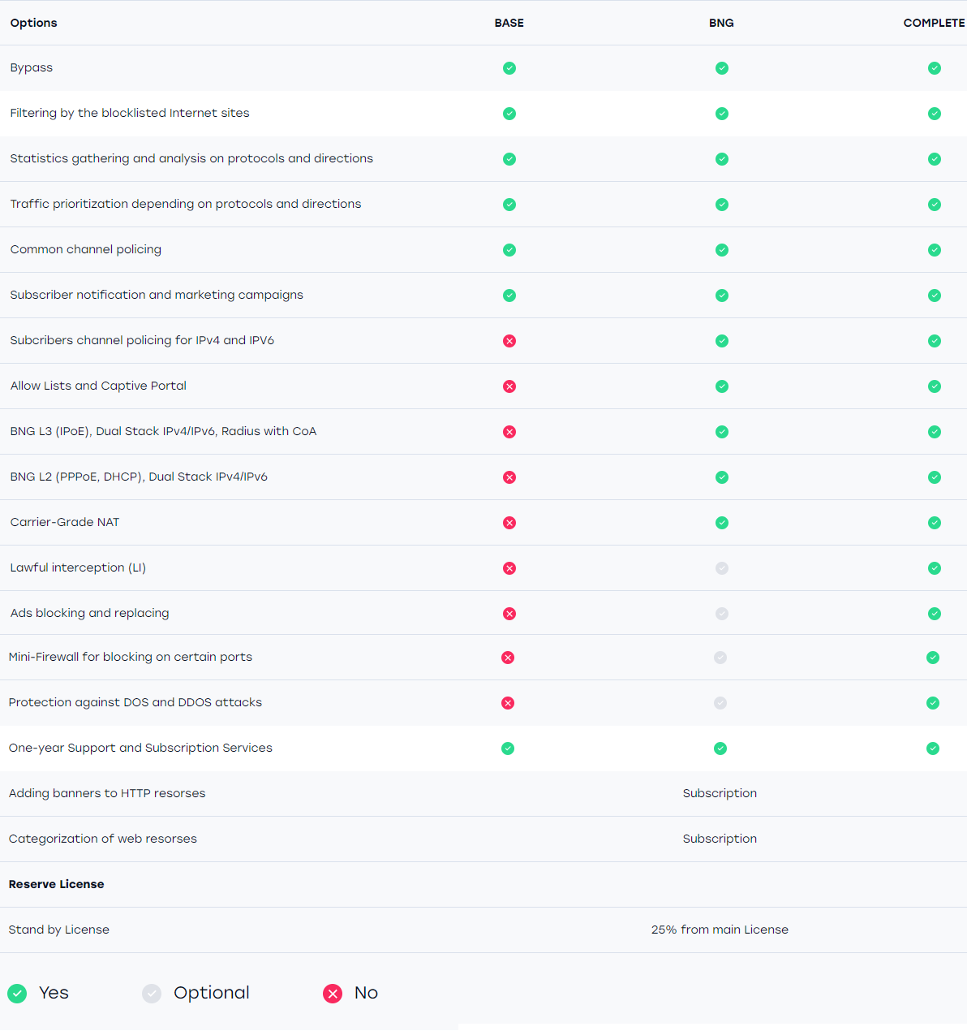
Licenses grading of the features: Base/BNG/Complete

