Licensing
The licensing is based on the number of simultaneously authorized subscribers on the ePDG.
The license is perpetual.
Based on calculations from various practical cases, after the WiFi Calling service launch, the number of simultaneous authorizations amounts to 10-13% of the operator's subscriber base.
Unfortunately, the service is not technically available to all subscribers, as there are two limitations:
- Phone model. No more than 40% of the phones in the hands of subscribers are released with WiFi Calling support, they are all fairly new (OS Android 12 and above or iOS 11.3 and above) and belong to the mid and high price categories. The share of such phones is growing as they are updated.
- Operator profile. A valid profile must be loaded on the phone, more details here. Due to the specifics of the procedure, the profile can only be loaded on 50-80% of phones, depending on the region and the size of the operator.
On these phones where the service is technically available, the corresponding service switch will appear. By default, it is always off, and the subscriber must go into the settings to enable it. According to our estimates, no more than 70% of subscribers will do this.
And as soon as the phone, where all the above conditions are met, connects to any WiFi, it will receive authorization on the ePDG. The number of these phones, simultaneously connected to WiFi, is used by VAS Experts in calculating licenses.
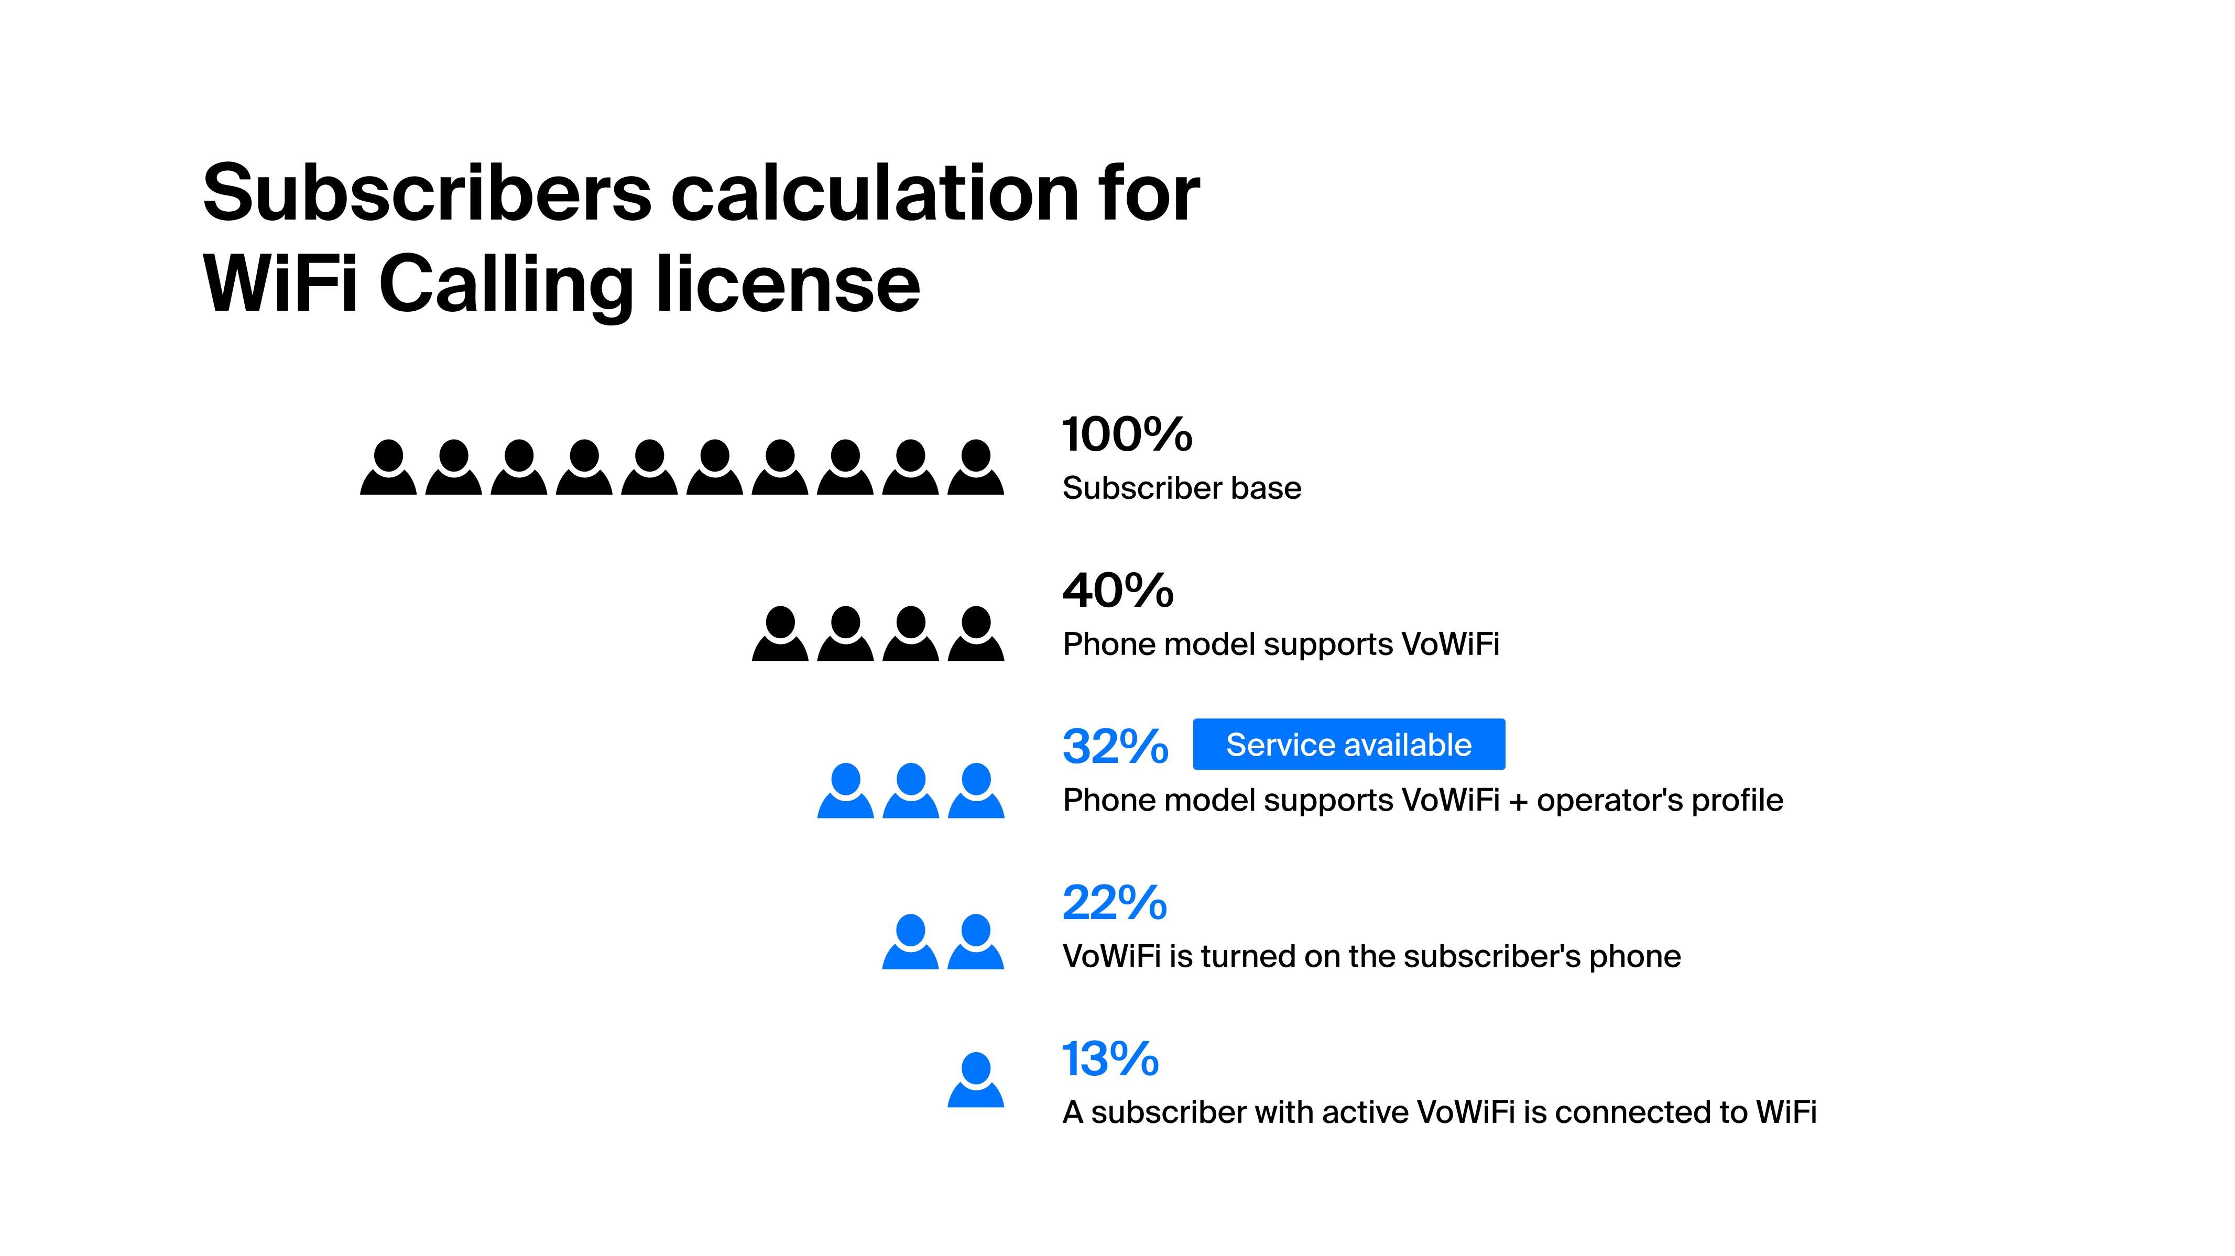
The process of loading the operator's profile on different phone models from various vendors takes time and happens gradually. Therefore, to launch WiFi Calling, it is possible to purchase a "starter package" for a small number of subscribers (up to 5% of the subscriber base) and then, as the service penetration increases, to increase the license package to the recommended 13% of the subscriber base.
For licensing inquiries, please contact your VAS Experts manager.

