Integration Cases of EPDG SCAT with Operator's IS
To deploy EPDG SCAT, integration with the following telecommunications operator systems needs to be configured:
- AAA server - for authentication and authorization;
- HSS (only if AAA server is absent);
- PGW - for receiving signaling and voice traffic.
Below are several possible integration cases.

Authentication and Authorization
The authorization of the client in EPDG is handled by the Authorization Management Module (AM), which allows implementing several cases on the operator's side.

Case 1. Authorization on AAA (Diameter protocol, SWm interface)
Conditions:
Operator's AAA operates via the standard SWm interface.
Process:
Authorization Management (AM) module requests authorization from Operator's AAA via SWm, then AAA interacts with HSS via SWx, and during a call, interacts with PGW via S6b.
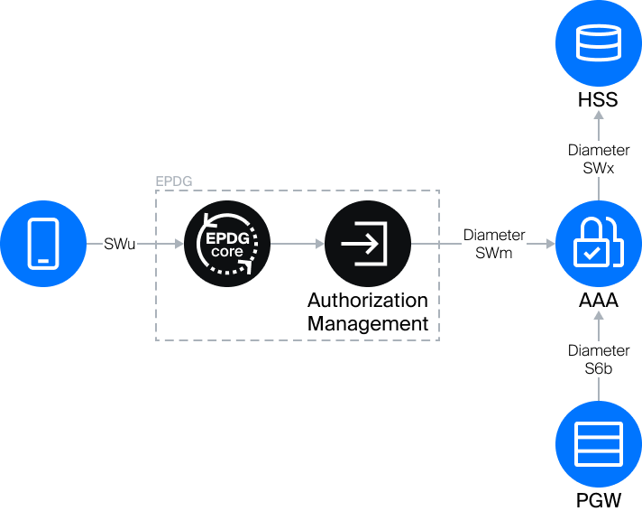

Case 2. Authorization on HSS (Diameter protocol, SWx interface)
Conditions:
The operator does not have its own AAA server; in this case, the AM obtains authorization directly from the Operator's HSS via SWx.
Process:
During a call, the AM replaces Operator's AAA: Operator's PGW queries it for authorization confirmation via the S6b interface, the AM queries HSS via SWx.
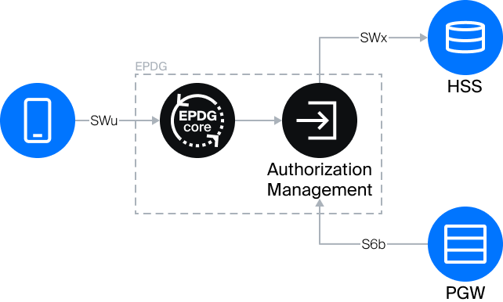

Option. AAA-proxy Mode (SWa (SWm) interface for External IS)
The operator does not have its own AAA server, but there is some IS, for which it is needed, for example, TWAN or another EPDG. In this case, EPDG SCAT can accept requests via the SWm interface and perform authorization on HSS and PGW via standard SWx and S6b interfaces.

Tunneling
The Tunneling Management Module (TMM) is responsible for organizing tunnels between EPDG Core and Operator's PGW. Several cases can be implemented on the operator's side with its help.

Case 1. Work via Standard Interface (S2b interface)
Conditions:
Operator's PGW supports EPDG's native interface - S2b.
Process:
Signaling traffic from EPDG to PGW flows through the GTP-C tunnel via the native S2b interface. User Plane (voice traffic) flows through the GTP-U tunnel.
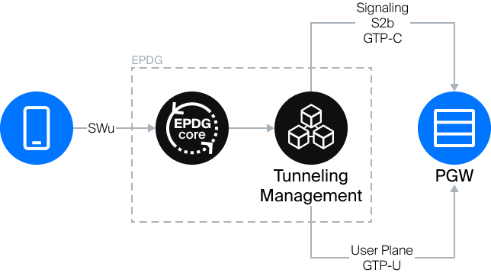

Case 2. SGW Emulation (S5/S8 interface)
Conditions:
Operator's PGW does not support S2b, only supports S5/S8.
Process:
In this case, TMM emulates the operation of SGW and communicates with PGW via the S5/S8 interface. User Plane (voice traffic) flows through the GTP-U tunnel.


