1 L2-connected BRAS description

Solution Components
L2-connected BRAS consists of the two components:
FastPCRF as an optional authorization component by means of the RADIUS server
FastDPI as a component designed to process the Subscriber traffic
General descripription
L2-Connected BRAS is designed to work in L2 IP networks when Subscribers are connected to the VAS Experts DPI through intermediate L2 switches. Subscriber traffic can be native IPoE using VLAN, QinQ and/or it can be encapsulated in PPoE. The preferred option of the ones listed above is to use IPoE with QinQ due to its flexibility, high performance and the capability to isolate Subscribers from each other.
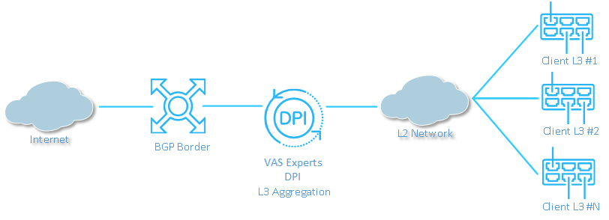
The source subscriber MAC addresses within the L2-Connected version are accessible to the BRAS, in addition it acts as an L3 device and terminates the Subscribers IP traffic. Assigning IP addresses to Subscribers is implemented both using DHCP or when the Subscriber sets static IP parameters on his own.
BRAS functions can only be used when using the FastDPI in the bridge mode, that is, when the FastDPI is connected using inline connection scheme. When implementing L2-Connected BRAS on a test bench with a small number of test subscribers, it should be noted that BRAS may not correctly work with the subscriber base consisting of 1-2 subscribers, which results in delays in responses to DHCP/PPPoE packets; it is caused by the BRAS architectural features and optimization for a large traffic volumes being passed through it. In order to get the full-fledged characteristics of L2-Connected BRAS, you should load up the BRAS with any traffic so that all the threads are used.

L2-Connected BRAS specific features
L2-connected BRAS provides the following functions for VLAN/QinQ networks:
- Termination of traffic from Subscribers to WAN, termination of response traffic from WAN to Subscribers
- DHCP: monitoring of DHCP requests from Subscribers and maintenance
- IP source guard – testing whether the LAN packet belongs to the same VLAN the DHCP registration was initiated from.
- The local traffic interconnect between subscribers and from subscribers to local resources.

Differences and advantages in contrast to traditional solutions
L2-connected BRAS powered by DPI technology when operating in a distributed network has many advantages and features compared to traditional solutions:
- Traffic monitoring and prioritization according to applications and autonomous systems withing the accessible bandwidth of each uplink
- Limiting the bandwidth occupied by torrent client traffic in case of common bandwidth shortage (when approaching to maximum bandwidth consumption)
- Traffic prioritization according to the applications and autonomous systems within the subscriber’s tariff plan (it is relevant for corporate clients, when many corporate users are working under one tariff plan and the need to allocate a bandwidth so that they do not interfere with one another arises)
- Support for Subscribers with an arbitrary IP addresses set, including assigned dynamically ones.
- Redirection of Subscribers to the Captive Portal in case of unpaid bills, with an allowed white list of resources, for example, bank portals for payment, based on a domain name or URL, including options with wildcard asterisks
- Capability to capture full NetFlow from the entire band or only for billable subscribers
- Support for the requirements of regulatory and law enforcement agencies, automatic loading and filtering by the corresponding black lists issued by regulatory authorities
- Interaction with lawful interception systems (operates as a trafic extractor for further analysis using statistical means)

