Making reports
Please select the "live" profile. You can select a profile in upper right corner. In case you have already created the separate profile with directions at top, as described here Making charts, then select it.
To create the report by independent systems: press Details mark in the topmost line and chose the required time window on the chart or place a slider to the time under investigation (Single Timeslot).
Then select the desired report type in menu Options (under Netflow Processing):
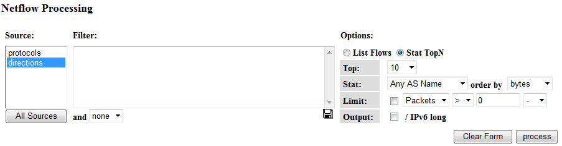
Here:
Stat TopN - is a list of top directions
Top: 10 - is a number of elements in top
Stat: Any AS Name/SRC AS Name or DST AS Name - count all the traffic or only that in one direction
Order By: bytes - count top by data amount
and press Process button.
For "live" profile you should mark only Source: directions
The report by top directions of dataflow will be created:
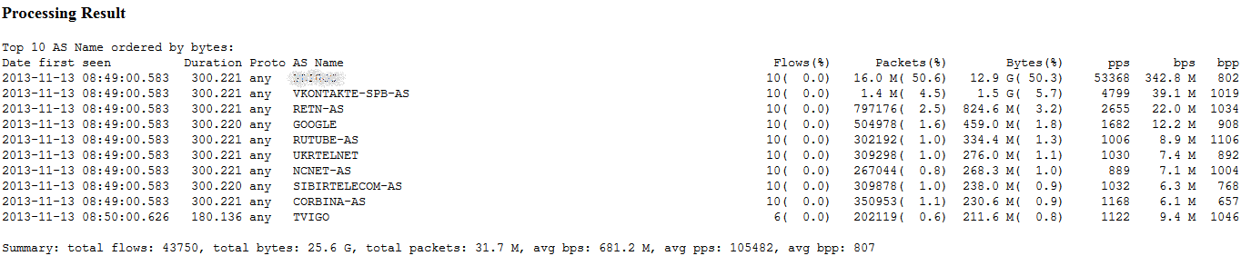
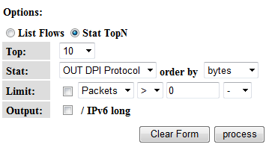
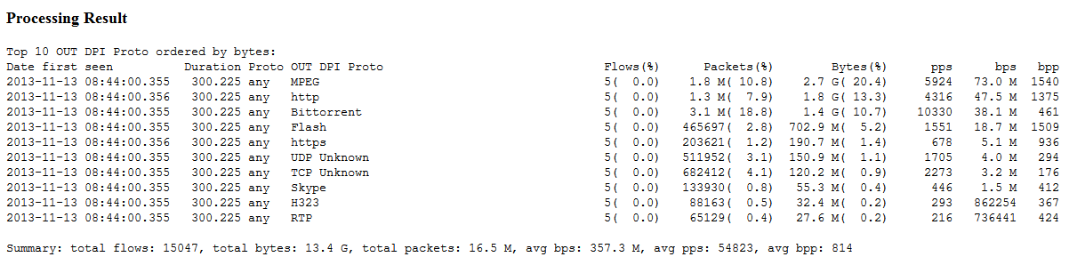
Similarly, by selecting Source: protocols or a single profile with top protocols you can get reports by protocols in one or two directions DPI Protocol/IN DPI Protocol/OUT DPI Protocol

