fastdpi_stat.log
The file is placed in the directory: /var/log/dpi/fastdpi_stat.log
This log contains statistics on traffic processed and blocked by VAS Experts DPI, on memory and processor load (file stat.log).
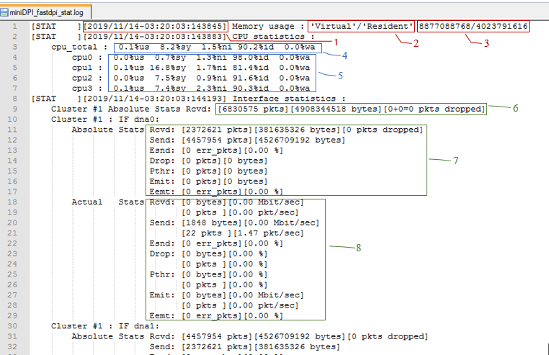
Image 1
Information is presented as follows (see Image 1, Image 2):
- Memory used:
1 – date and time of data accessing,
2 – memory type,
3 – information volume.
- CPU load:
4 – general load,
5 – load by cores.
- Statistics on VAS Experts DPI interfaces:
6 – full statistics on received packets/bytes, blocked packets on all interfaces,
7 - full statistics on received packets/bytes, blocked packets on the dna0 interface, here:
  - Rcvd: [2372621 pkts][381635326 bytes][0 pkts dropped] – received packets/bytes
  - Send: [4457954 pkts][4526709192 bytes] – transmitted packets/bytes
  - Esnd: [0 err_pkts][0.00 %] - errors occurred while sending packets
  - Drop: [0 pkts][0 bytes] – blocked packets/bytes
  - Pthr: [0 pkts][0 bytes] – the number of packets/bytes passing without analysis and processing
  - Emit: [0 pkts][0 bytes] – packets formed by VAS Experts DPI
  - Eemt: [0 err_pkts][0.00 %] - errors that occurred when sending packets generated by VAS Experts DPI
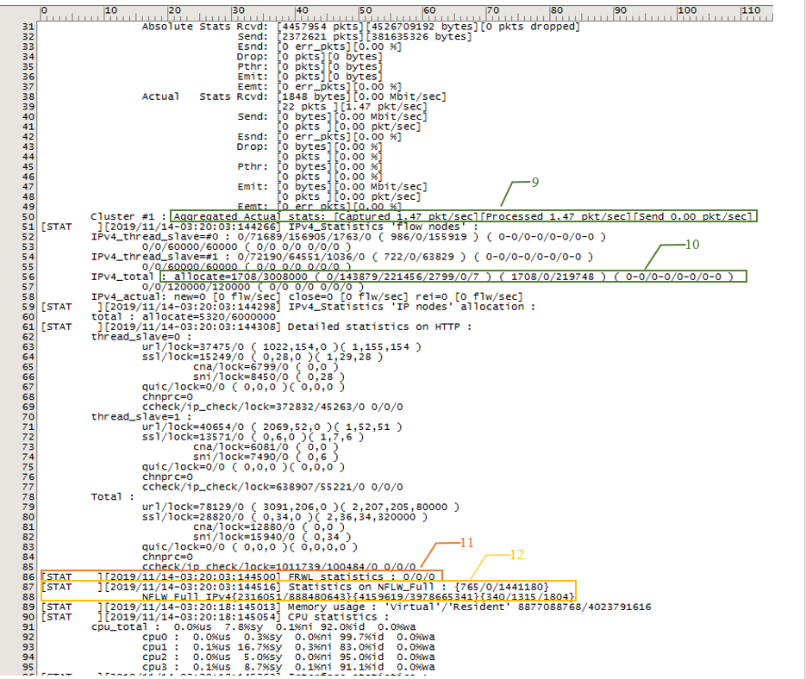
8 – actual statistics on received packets/bytes, blocked packets on dna0 interface,
9 – full statistics on the number of captured, processed, sent packets/sec (see Image 2), e.g. [Captured 1.47 pkt/sec][Processed 1.47 pkt/sec][Send 0.00 pkt/sec].
IPv4_thread_slave=#1 or 0 – flow statistics (0 or 1) – flow number.
Image 2
- Protocol statistics:
  - Statistics by IP:
10 – current flows number, here
IPv4_total : allocate=1708/3008000 – parameter is set in /etc/dpi/fastdpi.conf:
mem_tracking_flow (e.g.=3008000)
3008000 – total / 1708 – taken
  - Blocking counters:
url/lock=341/5 ( 0,0 )( 1,1,0,98879 )
ssl/lock=47/0 ( 21,457 )( 0,69,69,196647 )
chnprc=0
ccheck/ip_check/lock=2954/503/76
url/lock – URL checked/blocked
  - ( 0,0 ) :
first 0 – number of URLs that could not be parsed
second 0 – number of packets with partial URLs (URL in several packets)
( 1,1,0,98879 ) :
1 – parsers used
1 – parsers were used in total
0 – how many parsers are not involved after use
98879 –
how many parsers can be created
- ssl/lock – similarly to URL, but for cname
chnprc=0 – parser change http ←→ htpps
ccheck/ip_check/lock – 2954/503/76 statistics on check by IP/port
- 2954 – were to check by IP
503 – how many times the check was actually performed
76 – packets blocked
- Firewall statistics – 11.
- Netflow statistics – 12,
In version 9.4.1 statistics on packet sizes have been expanded, Jumbo Frames have been added
[STAT ][2020/09/09-13:44:33:322801] Packet size (abs/delta, in %):
<=64 <=128 <=256 <=512 <=1024 <=2048 <=4096 <=8192 >8192
subs->inet: 0.0/0.0 0.0/0.0 0.0/0.0 0.0/0.0 0.0/0.0 0.0/0.0 0.0/0.0 0.0/0.0 0.0/0.0
inet->subs: 0.0/0.0 0.0/0.0 0.0/0.0 0.0/0.0 0.0/0.0 0.0/0.0 0.0/0.0 0.0/0.0 0.0/0.0

