Configuring on-stick and LAG/LACP

Configuring on-stick
Blog: On-stick — a new mode of the Stingray Service Gateway to save router ports
[FastDPI 12+]
On-stick allows you to save on physical hardware. FastDPI usually works with bridges, bridging two physical ports (devices). For an on-stick device the physical port is one, on which fastDPI itself creates virtual ports - on the subscriber side (subs) and internet side (inet).
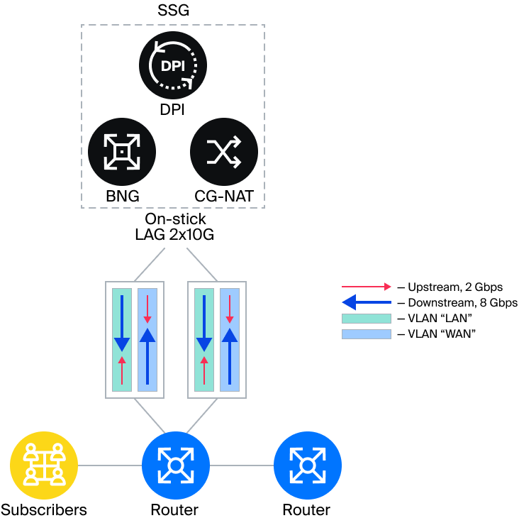
Each op-stick port is described in a specific way: first the base physical port is described using dpdk_device, then the virtual ports based on the base port are described.
Description of the base devices:
dpdk_device=port1:pci:04:00.0
dpdk_device=port2:pci:04:00.1
Description of on-stick based on devices port:
onstick_device {
base=port1
filter=<subs side filter expression>
subs=subs1
inet=inet1
}
onstick_device {
base=port2
filter=<subs side filter expression>
subs=subs2
inet=inet2
}
where:
base — base device
filter — boolean expression to determine the direction of the packet (filter). If this expression returns true, the packet is from the subs side, otherwise it is from the inet side
subs — the name of the device on the subs side.
inet — the name of the device on the inet side.
Setting Bridges.
Basic port type devices CANNOT be included in any bridges
in_dev=subs1:subs2
out_dev=inet1:inet2
Wherever you need to specify a device, you should use virtual devices (in this example, subs1, subs2 and inet1, inet2). The basic on-stick devices port1 and port2 is specified only when describing the on-stick device and nowhere else.
In the on-stick port description, the most important part is the filter clause to determine the direction of the packet (subs → inet or inet → subs). Packet direction is an important attribute of a packet in fastDPI on which processing depends. filter specifies a boolean expression over the L2 properties of the packet. If this expression returns true, the packet is on the subs side, otherwise it is on the inet side (uplink, internet).
The basis of a filter expression are terms that are combined into a logical expression using the logical operators & (AND) and | (OR), the parentheses ( and '), and the negation '!. The & operator is higher priority than |; by analogy with arithmetic expressions, we can think of & as multiplication and | as addition, which is the basis for placing parentheses.
Terms specify elementary expressions over L2 properties of a packet. The following terms exist (case is important):
- vlan(list). - a single VLAN packet with the specified VLAN numbers, e.g.: vlan(56,78,890)
- vlan is a packet with any single VLAN.
- qinq is a Q-in-Q packet.
- pppoe is a PPPoE packet.
- smac(MAC address) - source MAC address of the packet, example: smac(01:02:03:04:05:06)
- dmac(MAC address) - destination MAC address of the packet, example: dmac(01:02:03:04:05:07)
Examples (recall that filter specifies an expression for the subs side):
- subscriber-side Q-in-Q network terminated in a single VLAN: filter=qinq
- heterogeneous network: subscriber-side Q-in-Q or PPPoE in a VLAN: filter=qinq | pppoe. Here, the fact that PPPoE is encapsulated in a VLAN is irrelevant: PPPoE is terminated by BRAS, so PPPoE on the inet side is not possible.
- single VLAN, on the inet side VLAN=609, all other VLANs are subs: filter=vlan & !vlan(609). Here we need to explain in more detail. For the inet side, the filter expression would look like this: filter=vlan(609), but the filter defines the expression for the subs side, so it would seem that the negation is enough: filter=!vlan(609). But this expression will be true for any packet other than the packet with VLAN=609, even without VLAN. So you should specify that the packet should contain a single VLAN tag, but except for VLAN=609: filter=vlan & !vlan(609)
- on the inet side, the MAC address of the borderer is 3c:fd:fe:ed:b8:ad: filter=!smac(3c:fd:fe:ed:b8:ad). - all packets with source MAC not equal to the Border MAC address are subs-side packets.
A formal description of the grammar of the filter expression:
filter ::= and | and ‘|’ filter
and ::= mult | mult ‘&’ and
mult ::= ‘!’ mult | term | ‘(‘ filter ‘)’
term ::= vlan | qinq | pppoe | smac | dmac
vlan ::= ‘vlan’ | ‘vlan’ ‘(‘ list_int ‘)’
qinq ::= ‘qinq’
pppoe ::= ‘pppoe’
smac ::= ‘smac’ ‘(‘ mac_address ‘)’
dmac ::= ‘dmac’ ‘(‘ mac_address ‘)’
mac_address ::= xx:xx:xx:xx:xx:xx

LAG/LACP port aggregation
Port aggregation by SSG is supported for the following modes in-line и on-stick.

LACP port aggregation
lacp=0
Allowable values of the lacp parameter:
- 0 (default) - LACP is disabled, SSG does not hold LAG, but freely skips it
- 1 - LAG in passive mode: we don't send periodic LACPDUs, but we respond to LACPDUs that arrive
- 2 - LAG in active mode: we send periodic LACPDUs.
The aggregation traces the traffic balancing.

Configuring LAG
LAGs can include either regular ports or on-stick ports, no mixing is allowed. LAG on on-stick is organized on the base (physical) port. LAG is implemented in fastDPI at logical level: there is no single bond device, inside fastDPI work is done with ports as before.
The maximum number of ports in a LAG is 18.
3 different configurations are possible:
- LAG on the subs side, no LAG on the inet side
- LAG on the inet side, no LAG on the subs side.
- LAG on the subs side AND on the inet side
Requirements for devices included in a LAG:
- a device can only be part of one LAG device;
- all devices in a LAG must have the same speed;
Currently, LAGs are configured in fastdpi.conf without the ability to be applied on the fly, i.e. a fastDPI restart is required when the LAG configuration is changed.
LAG Description:
Each LAG requires a separate lag section. Only physical interfaces can be included in a LAG; mixing physical and logical interfaces is not allowed.
lag {
name=
device=
device=
system_id=
priority=
short_timeout=
}
where:
name - optional name of the LAG, used for log output.
device - lists all physical interfaces included in the LAG. The LAG must contain at least 2 devices.
system_id - MAC address is the system_id of this LAG. If not specified, "arp_mac" is used.
priority - system priority for this LAG, number in the range 1 - 65535, default is 32768.
short_timeout - short (off) or long (on) LACP timeout.

Applying balancing to outgoing LAG traffic
The type of the applied balancing algorithm is specified by the lag.balance_algo parameter:
- -1 — without load balancing — the packet is sent to the paired bridge port
- 0 (default) — load balancing by internal session_id (default balancing). session_id is used as the hash
- 1 — hash based on flow key <srcIP, dstIP, srcPort, dstPort, proto>. if there is no flow, balancing is performed by session_id
Additional hash configuration parameters in the lag section: hash_seed, hash_offset, hash_bits
How many significant bits we take from the 64-bit hash during balancing. The balancing algorithm in the general case looks like this:
- calculate a 64-bit hash of certain packet fields and hash_seed;
- from the 64-bit hash we take the hash_bits bits starting from the hash_offset bit;
- use the resulting number N to determine the port number in LAG: port := N mod LAG_active_port_count, i.e.
port := ((hash(packet, hash_seed) >> hash_offset) & (2^hash_bits - 1)) mod LAG_active_port_count
- Example:
// +------------------------------------------------+
// hash: | XXXXXXXXXX------|
// +------------------------------------------------+
// ^ ^
// | hash_offset = 6
// hash_bits = 10
Only basic on-stick devices must be specified in the LAG description. Mixing on-stick and conventional devices in one LAG is not allowed.
During aggregation, a traffic balancing trace is traced.

Example of on-stick + LACP configuration for two physical interfaces
In this scenario, subscriber traffic in VLANs 101, 102, and QinQ
dpdk_device=port1:pci:86:00.0
dpdk_device=port2:pci:86:00.1
lag {
name=LACP
device=86:00.1
device=86:00.0
lacp=1
system_id=6c:b3:11:60:fa:66
priority=32768
balance_algo=0
}
onstick_device {
base=port1
filter=vlan(101,102) | qinq
subs=subs1
inet=inet1
}
onstick_device {
base=port2
filter=vlan(101,102) | qinq
subs=subs2
inet=inet2
}
in_dev=subs1:subs2
out_dev=inet1:inet2

Diagnosis
LACP diagnostics is performed using the pcap entry. To do this, the parameter pcap must be added to the LAG description.
Parameter values:
- on — enable pcap recording
- off — disable pcap recording
# tracing (writing to pcap) of LACP packets of the given LAG
#pcap=on
Logging is enabled via the bras_trace parameter. See the BRAS tracing section for possible values.

