18 Channels and services

Subscribers and services
In this section, when you go to the "Channels" tab, the channel section will open, in which you can manage the list of all channels on DPI equipment and bind services and tariff plans to them.
Synchronization of lists is performed on a schedule every 30 minutes.
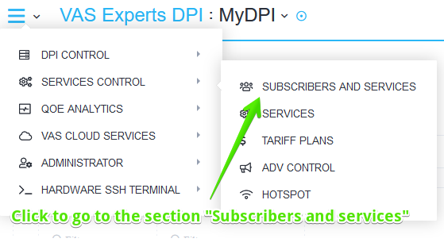
To go to the section, open the Service management menu and click "Subscribers and services".
Next, you need to click on the "Vchannels" tab.
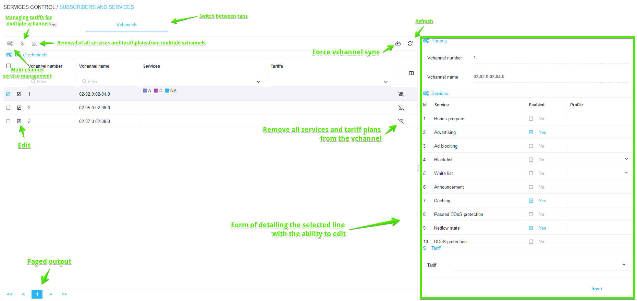
A section will open as in the picture below.
The section has the following options:
- Viewing the list of subscribers and vchannels, as well as connected services with the ability to filter
- Detailing by vchannel
- Activate / deactivate services
- Perform group operations
- Activate / deactivate tariff plan

Vchannel editing
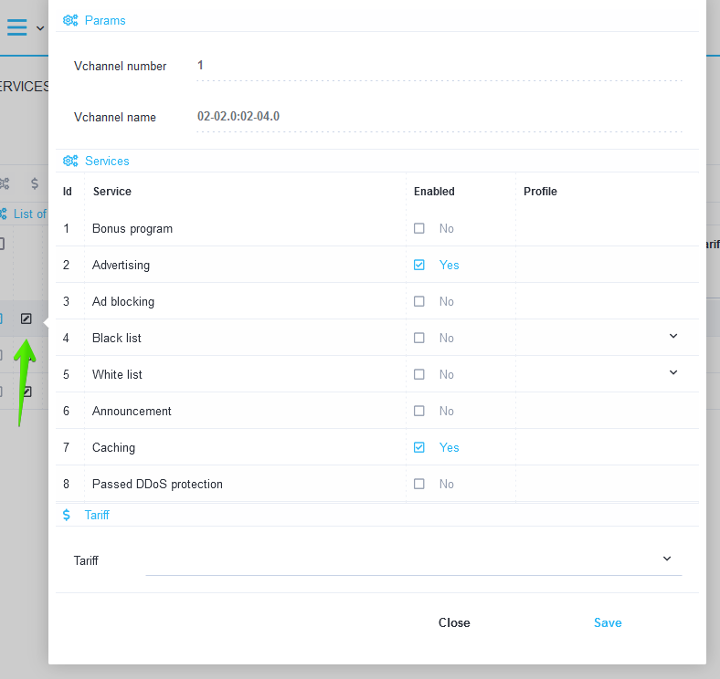
You can edit a vchannel either through the detail form (on the right), or through a separate form, if you click on the Edit icon opposite the vchannel.

Group connection / disconnection of services
It is possible to connect and disconnect services to several vchannels at once. To do this, select several lines (using ctrl or shift) and click the Services button.
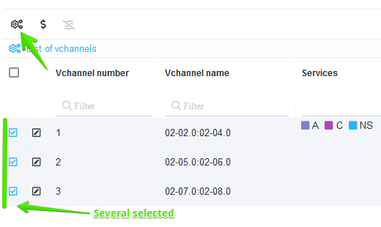
A form will open where you can connect and disconnect services to selected subscribers.

Group connection / disconnection of tariff plans
It is possible to connect and disconnect the tariff plan for several vchannels at once. To do this, select several lines (using ctrl or shift) and click the Tariffs button.
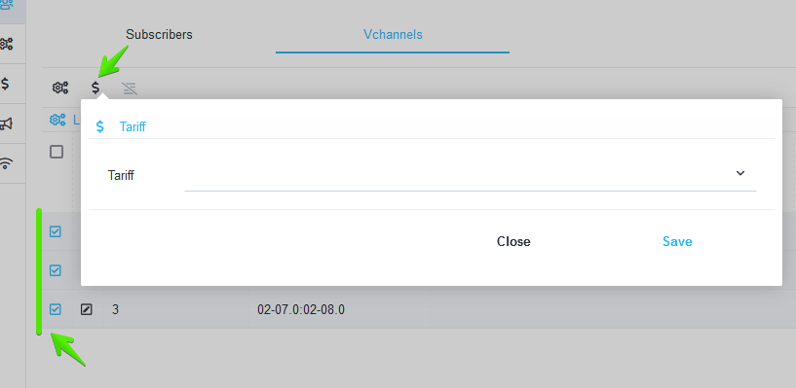
A form will open where you can connect and disconnect services to the selected vchannels.

Removal of all services and vchannel tariffs
It is possible to remove all connected services and tariff plans from the selected vchannels. To do this, click on the icon for deleting all services and vchannel tariffs in the penultimate column of the table.
A modal window will appear confirming the deletion of all services and vchannel tariffs.

Services
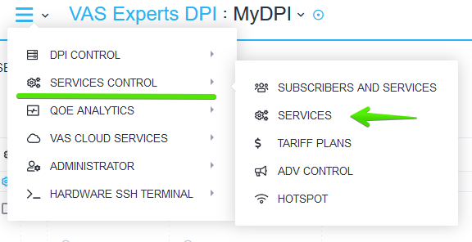
To go to the section, open the Service management menu and click "Services".
Then you need to go to any of the tabs except "Advertising & Ad Blocking".
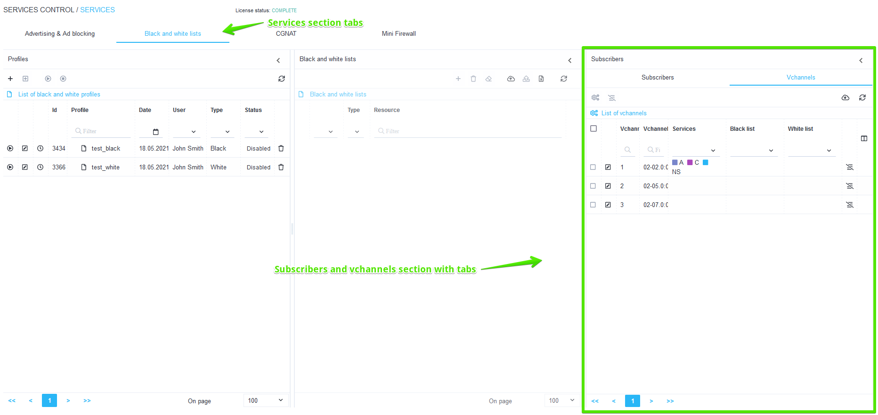
A section will open as in the picture below.

Black and white lists
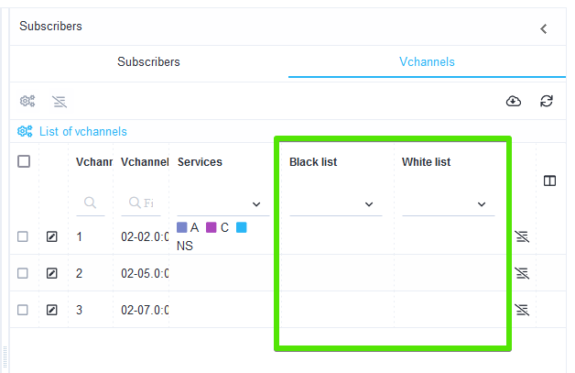
The picture below shows the vchannel table, which has 2 columns, in which it is possible to view which "Black list" and "White list" profiles are applied to the vchannel.

CGNAT
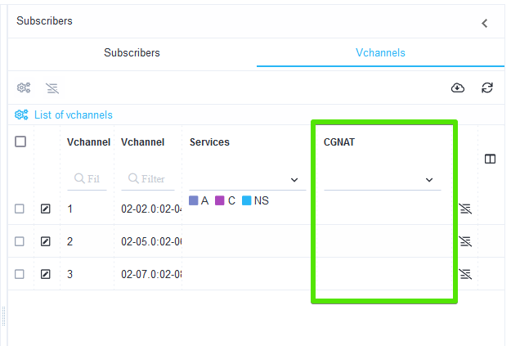
The picture below shows the vchannel table, which has a column "CGNAT", in which it is possible to view which CGNAT profiles are applied to the vchannel.

Mini Firewall
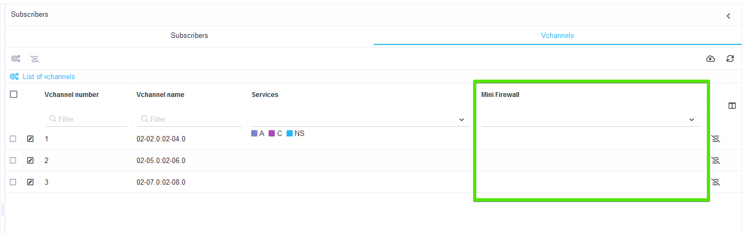
The picture below shows the vchannel table, which has a "Mini Firewall" column, in which it is possible to view which Mini Firewall profiles are applied to the vchannel.

Tariff plans
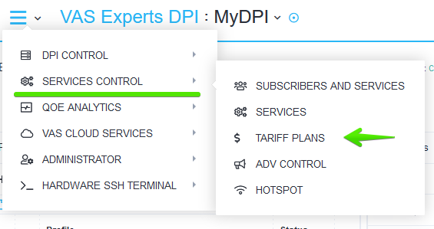
To go to the section, open the Service management menu and click "Tariff plans".
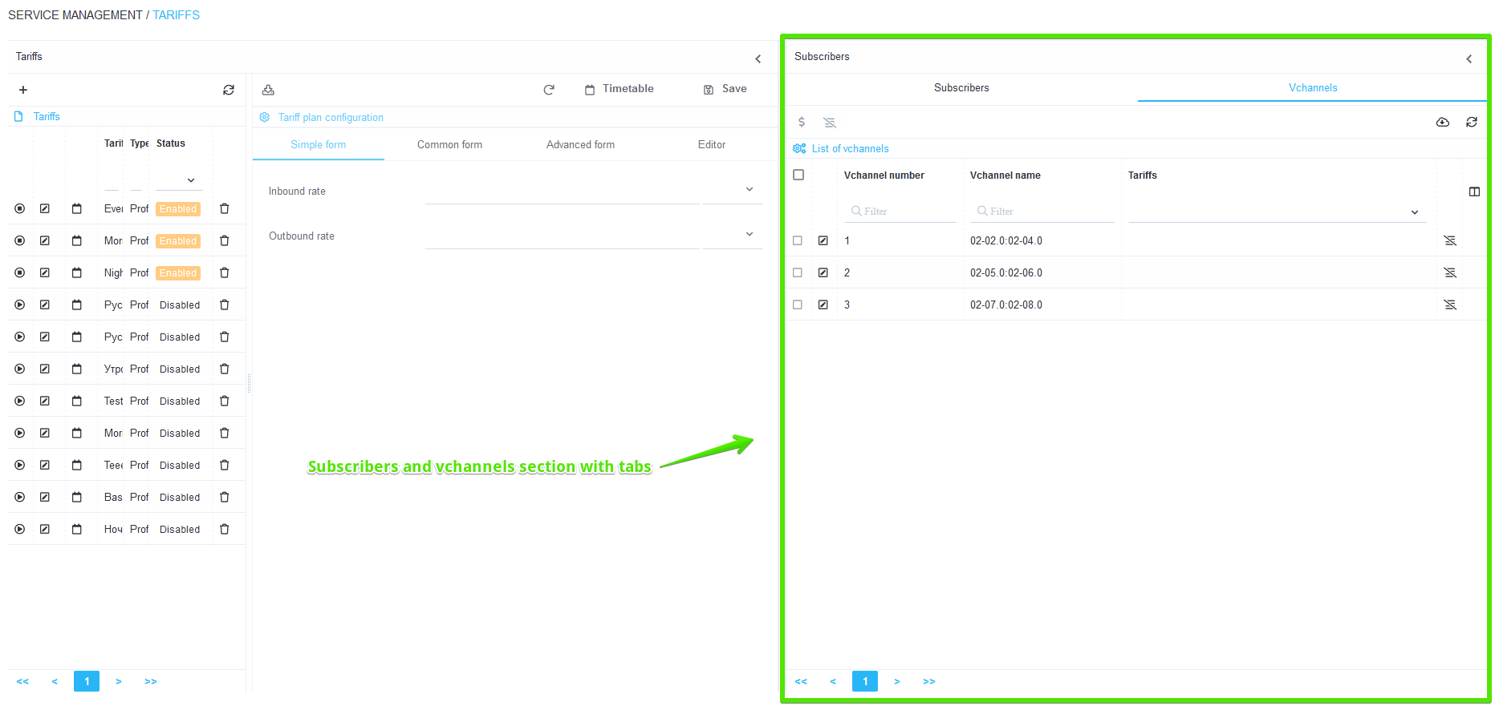
A section will open as in the picture below.
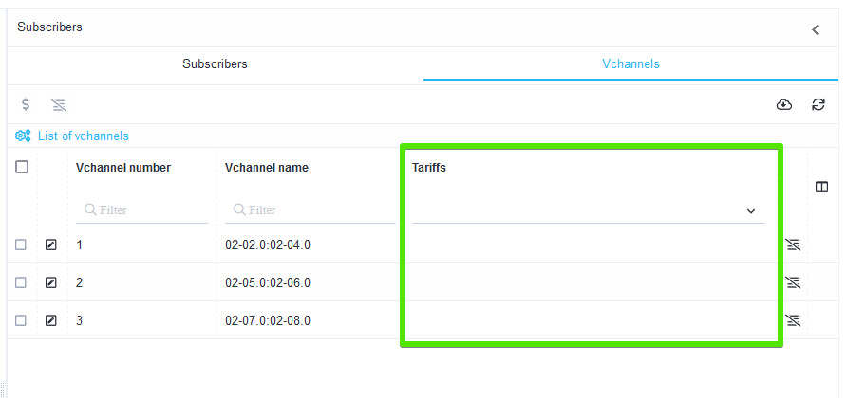
The picture below shows a table of vchannels, which has a column "Tariffs", in which it is possible to view which tariff plans are applied to the vchannel.

