Protocol groups
This option is used when you need to create a new group (e.g., from custom protocols) or modify the composition of protocols within a standard group. The names of standard groups can also be edited.
All changes will be reflected throughout the interface, including in QoE reports.
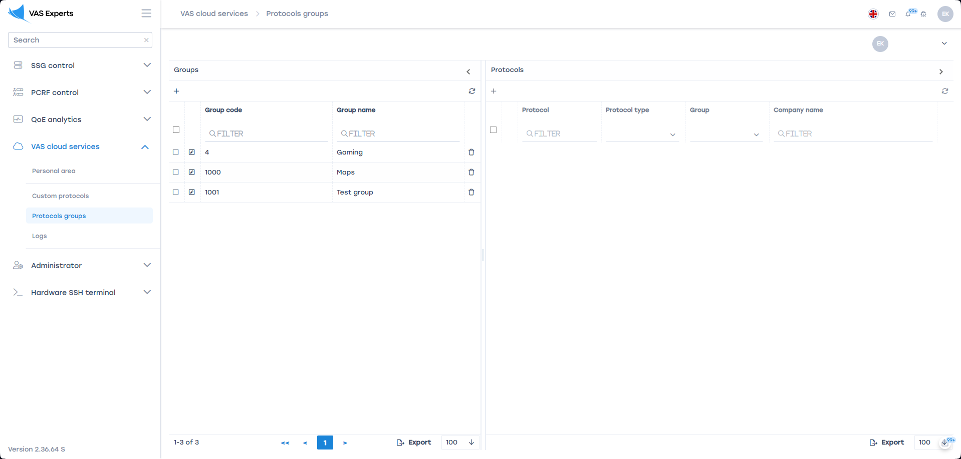
Protocol groups have the following identifiers:
- 1 to 32 are used for standard (cloud) groups
- 1000 and above — used for custom groups

Setup

Step 1 – Creating a Group
Go to VAS cloud services → Protocols groups and click the “+” button in the “Groups” column.
You can either override a standard group or create a new one.
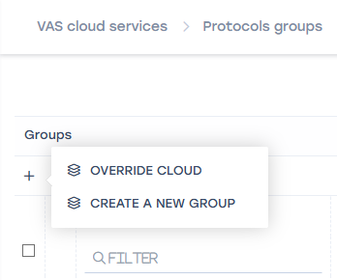
- For Cloud Groups:
  - Select the desired group
  - If needed, edit the group name
  - Click “Save”
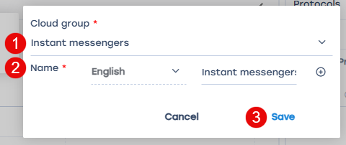
- For a Custom Group:
  - Enter the group name
  - Click “Save”
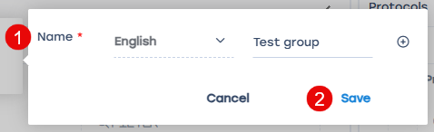

Step 2 – Adding Protocols
Select the created group and click the “+” button in the “Protocols” column.
You can add both custom and built-in (cloud) protocols.
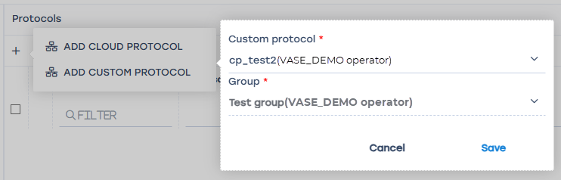
After selecting the protocol, click “Save”. The protocol will be added to the group.
The created group will be available across all sections of the interface.

