2 Tariff schedule
This section allows you to create schedule for tariff plans. After the schedule is created and saved, selected sub-tariffs will be applied according to its settings.
To open the form with the schedule of the tariff plan, you should to select one of the tariff plans in the “Tariff plans” section and click on the “Schedule” button. You can also open the form by clicking on the calendar icon located opposite each tariff plan.
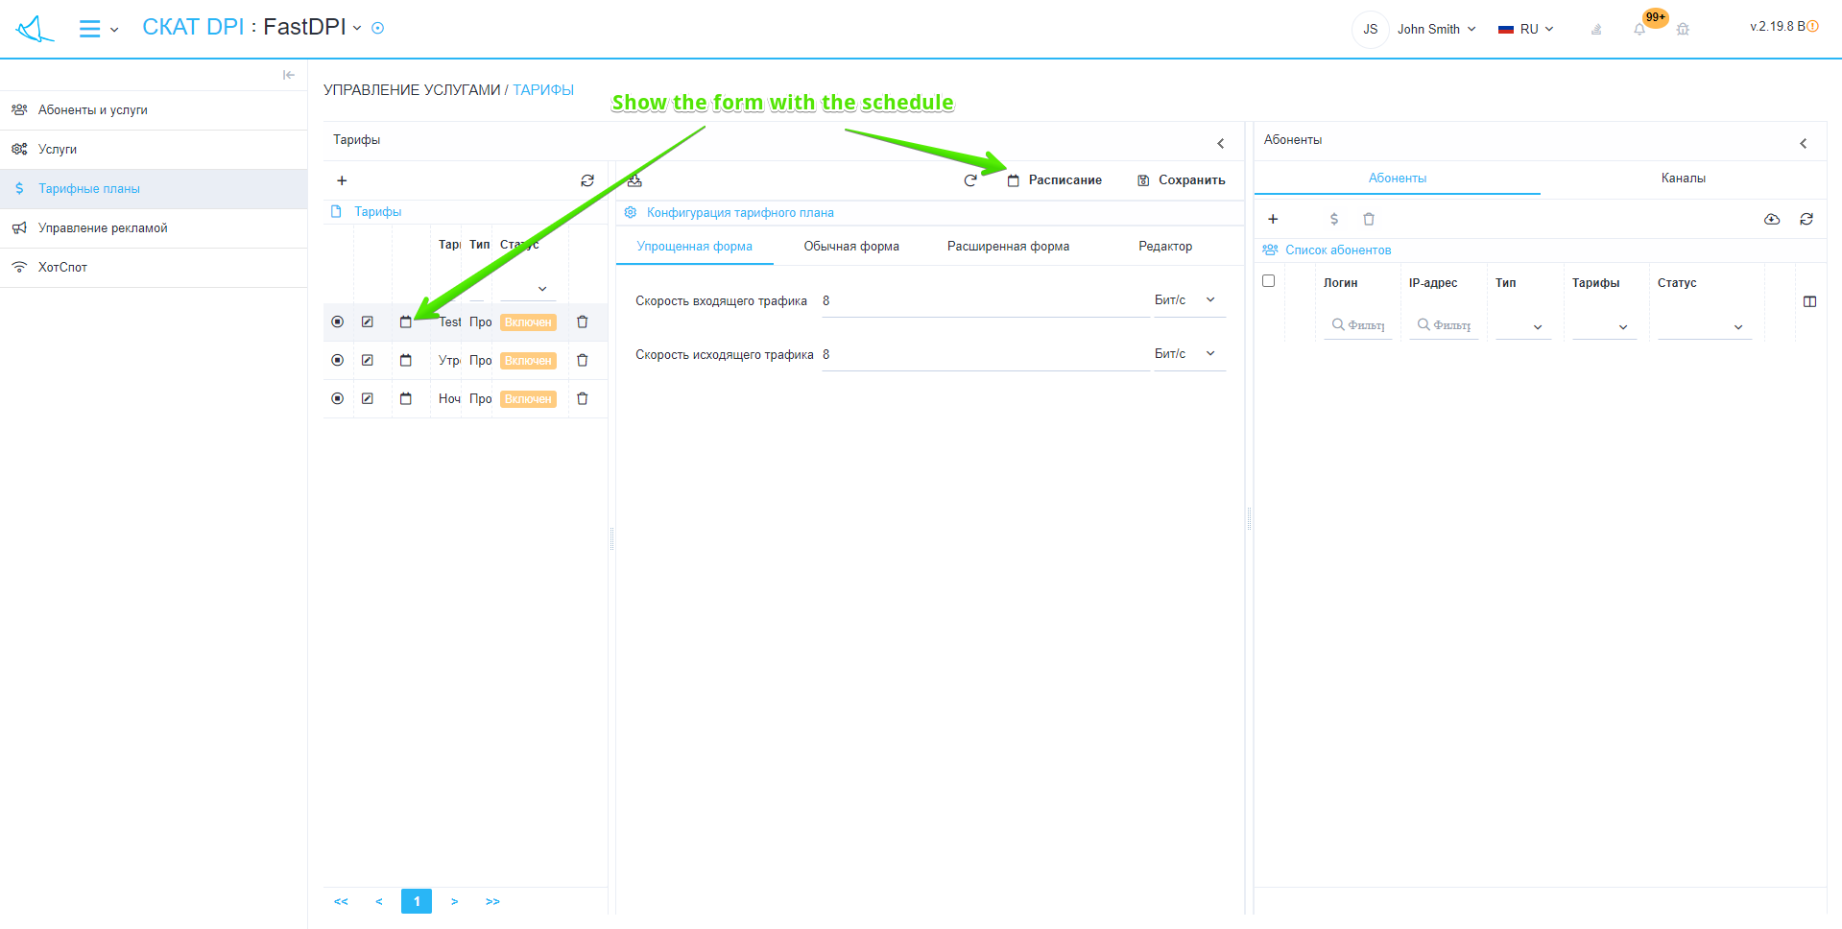

Tariff plan schedule setting form
Here you can create, modify and delete a schedule for the selected tariff plan.
Also, you can disable the schedule for a particular tariff plan.
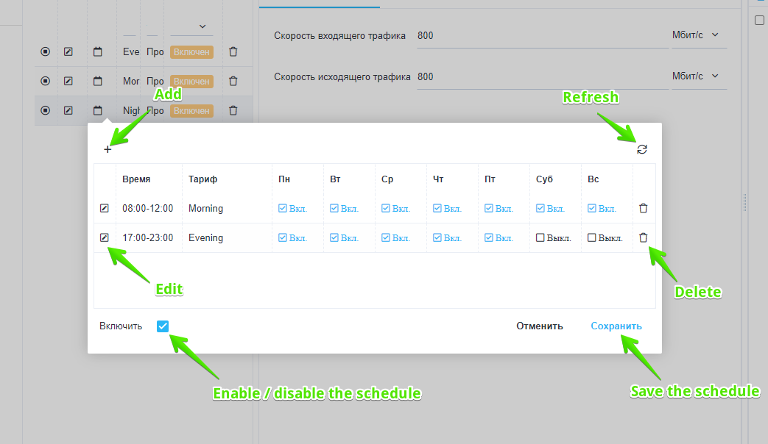
On this form are located:
- “+” button – opens the form for add a schedule line (Figure 3).
- “Edit” button – opens the form for edit the selected schedule line (Figure 4).
- “Refresh” button – returns the table to its origin state.
- “Delete” button – deletes the selected schedule line.
- The “Enable” flag in the selected state enables the schedule, in the unselected state disables the schedule.
- “Cancel” button – closes the form.
- “Save” button – saves the form (Necessarily click the button, otherwise all unsaved changes will be lost).

Create a tariff plan schedule
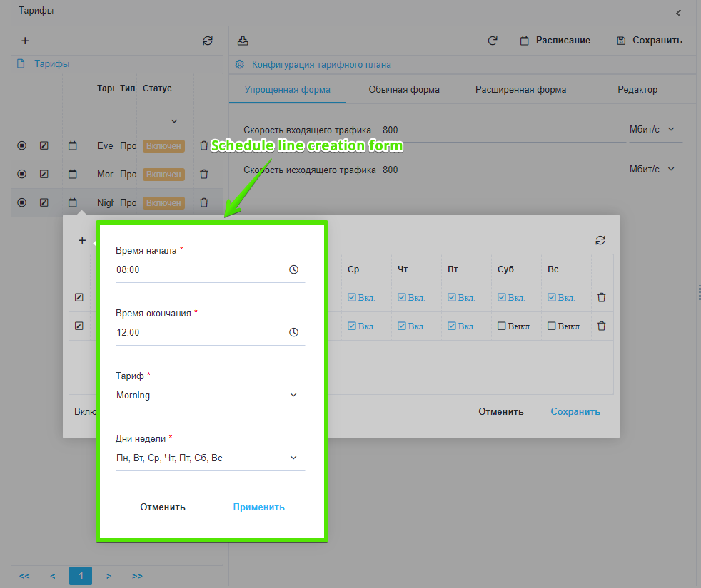
You must specify the following in this form:
- The time from which the schedule begins to operate.
- The time after which the schedule stops to operate.
- Name of the tariff plan whose settings will be used by the tariff plan for which the schedule is created.
- Days of the week on which the schedule will be active.
- Click on the “Apply” button will create a schedule line with the configuration specified in the form.
- Click on the “Cancel” button the form will close.

Edit the schedule of the tariff plan
You can modify the time, tariff name, and days of week in this form.
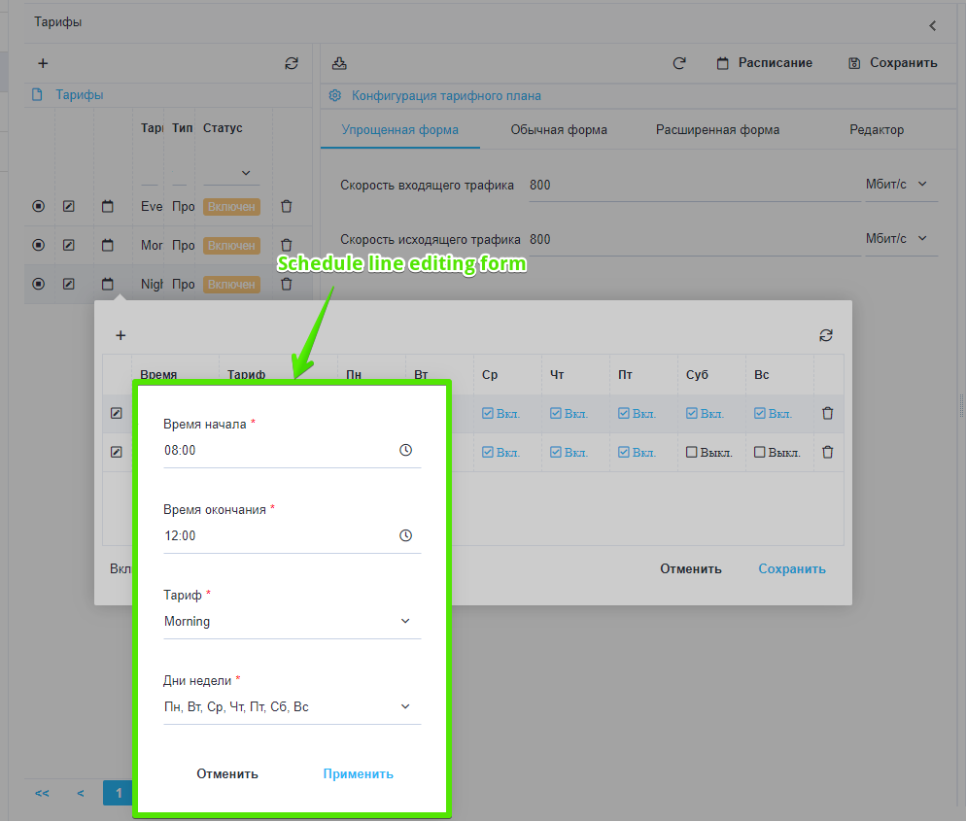
- Click on the “Apply” button for the selected schedule line will change the corresponding values.
- Click on the “Cancel” button the form will close, the changes made will be canceled.

