PCRF logs

Files
To go to the section, click the PCRF control menu item, then click the Logs menu item.
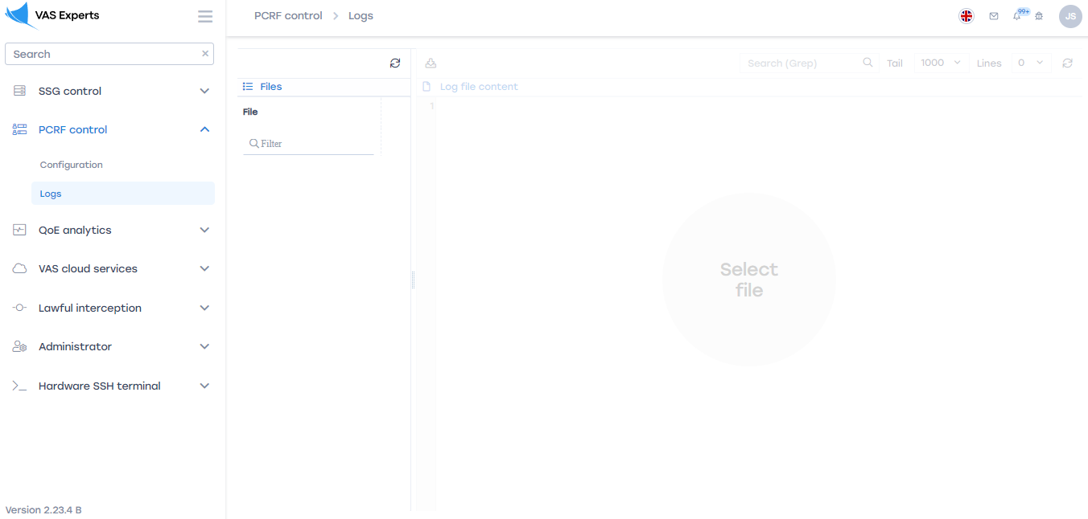
To create or view a custom server that provides work access in the section, go to

Updating the list
To update the list of files, click on the "Update" button located in the toolbar.
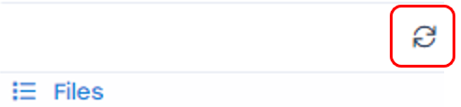
To view the contents of the file, double-click on the selected file. A form with information will open on the right.

Contents of the log file

Downloading a log file
To download the file completely to your device, click on the "Download the file completely" button.

Information on the last lines of the file
To get information on the last n-lines of the log file, select the appropriate value from the drop-down list.

Updating the file
To update the file, click on the "Update" button.

