4 Prioritization by ASN

Editing
To go to the section, open the "DPI CONTROL" menu and click "PRIORITY FOR ASN".
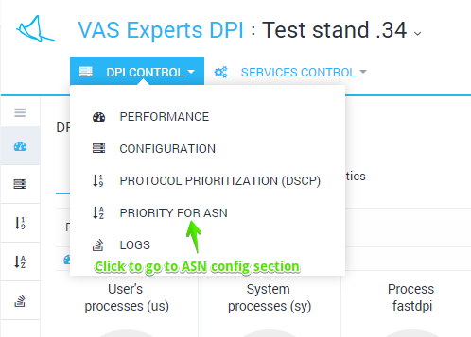
The section looks like the figure below.
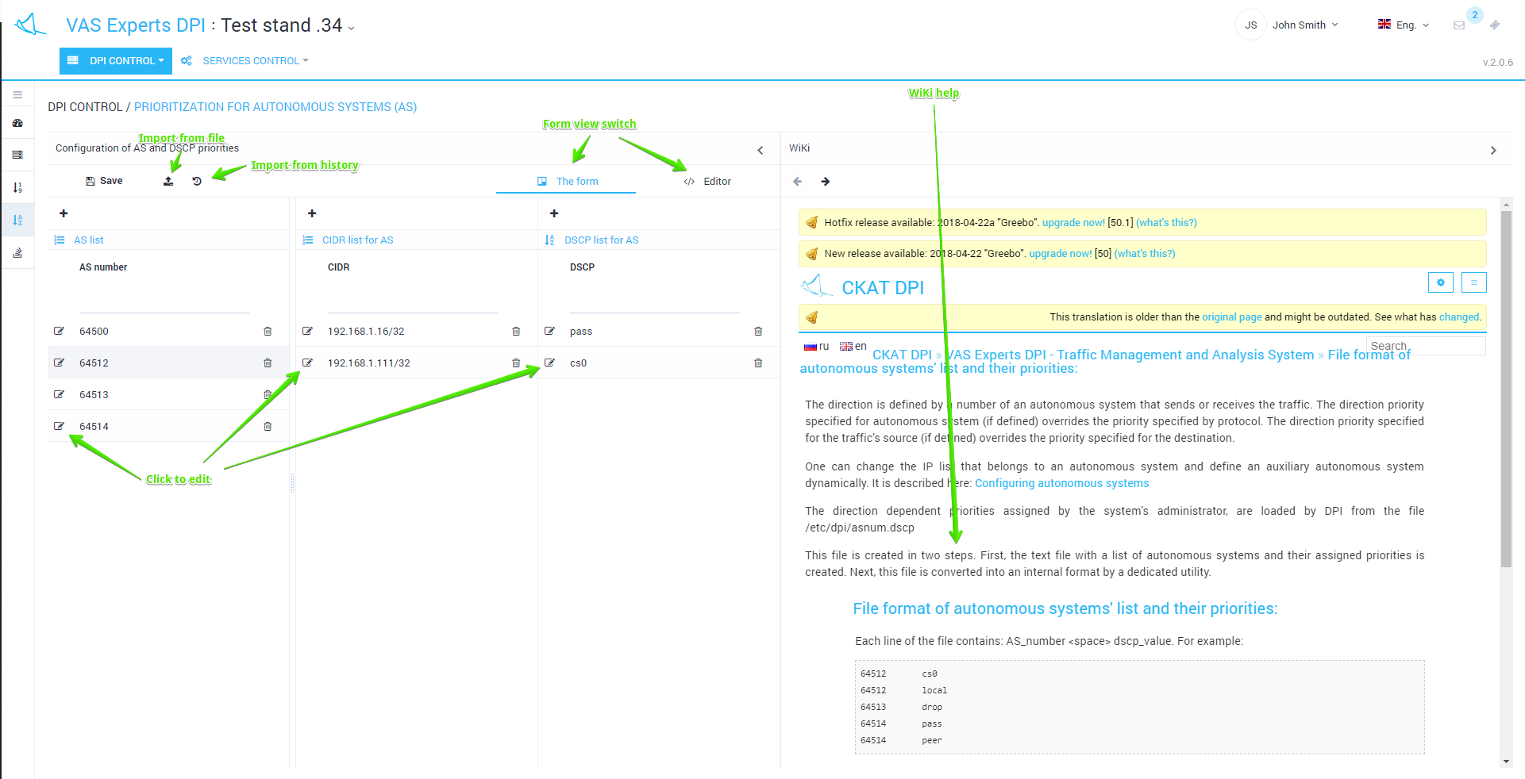
In this section, you can view and filter the list of AS (autonomous systems) and its corresponding priorities and CIDR, add, delete or edit them.
Editing is done in tabular form. To edit, double-click on the line.
Editing is conditionally divided into 3 stages:
- The AS list is filled in/edited (left column)
- The CIDR list is filled (central column) for each AS
- The DSCP list for AS is filled (right column) for each AS
When populating the dscp values, a drop-down prompt appears.
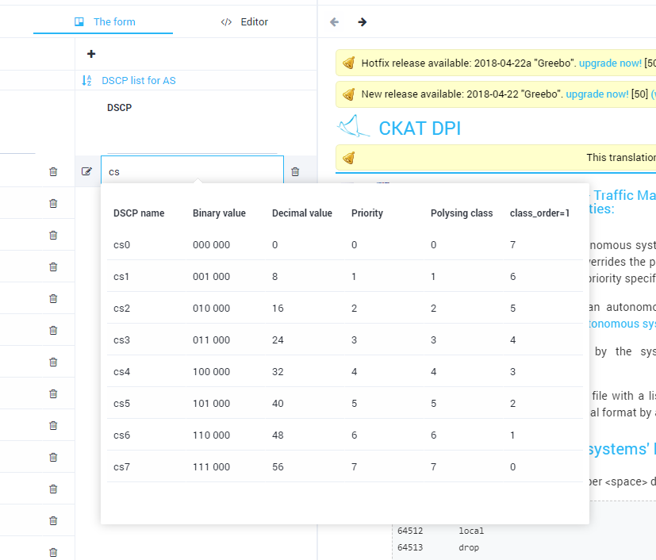
Do not forget to click Save after making changes.

Direct editing
It is possible to edit the file directly without using tabular forms. To switch to the direct editing mode, click "Editor".
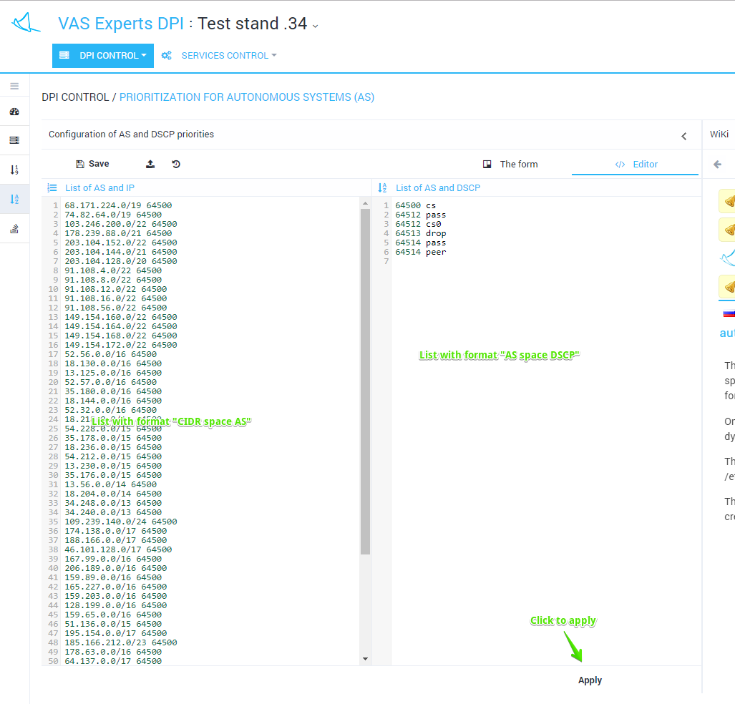

View and import from history
To view the history changes, click the "History" button. The form will be opened as in the figure below.
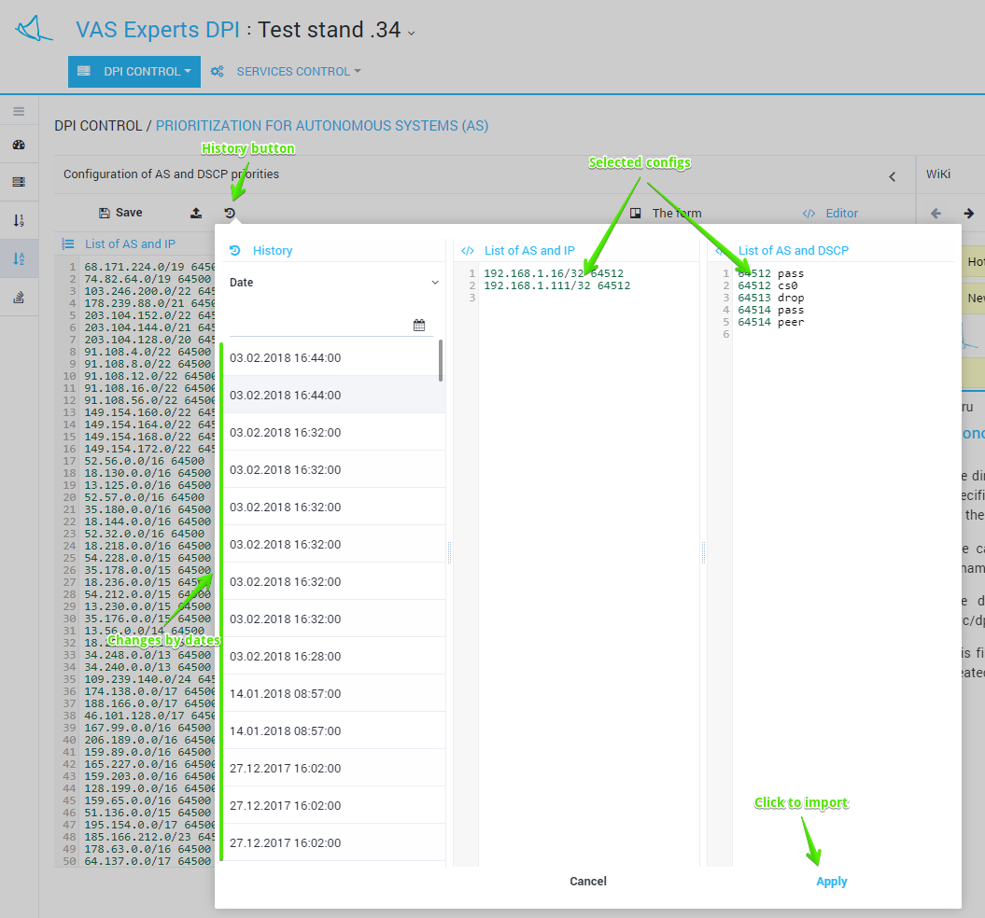
It is possible to view and filter by date a list of changes. Select and apply a change from the history.

Import and view from a file
To import from a file, click the "Import" button. The form will be opened as in the figure below.
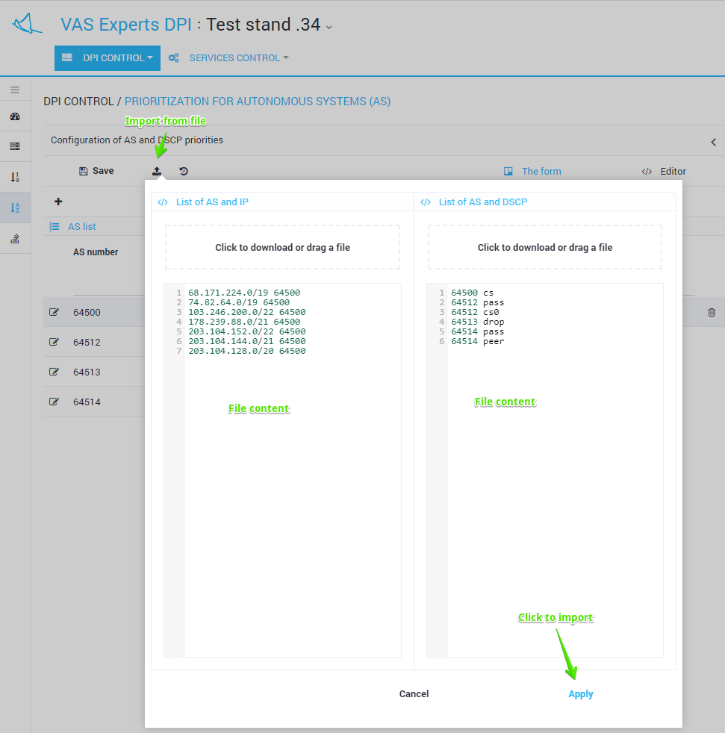
Drag the file to the import zone. The contents of the file will be displayed below. Click Apply to import the contents of the file.

