2 Notifications
In the upper right corner of the program window there is a Message button. Above the button the indicator of CRITICAL messages number is displayed, if any.
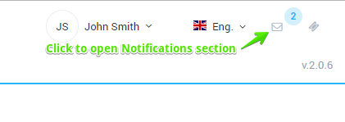
If you click on the button, the form will be opened as in the figure below.
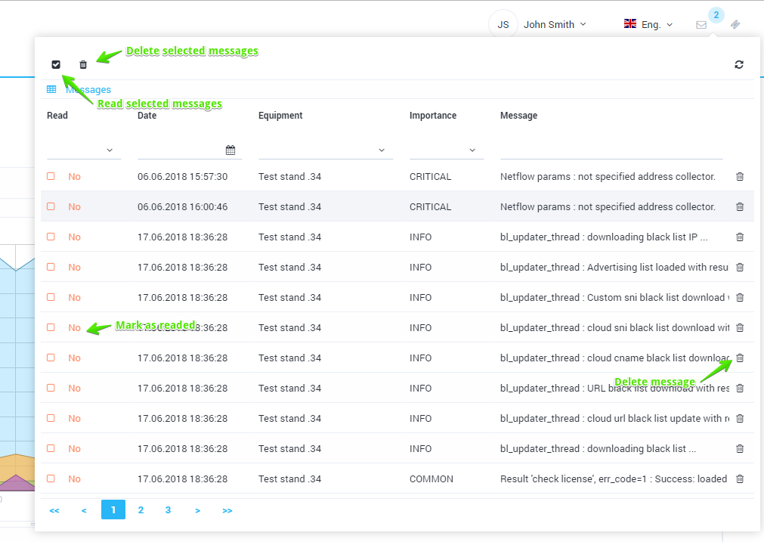
The form displays a list of recent messages, you can filter it. If you hover over a line with a message, its full text is displayed. Messages can be marked as read and deleted.

