Classifier logs

To open the "Classifier logs" section, open the main menu, point to the "Classifier" item and click on the "Logs" item. (fig. 1) (fig. 1)
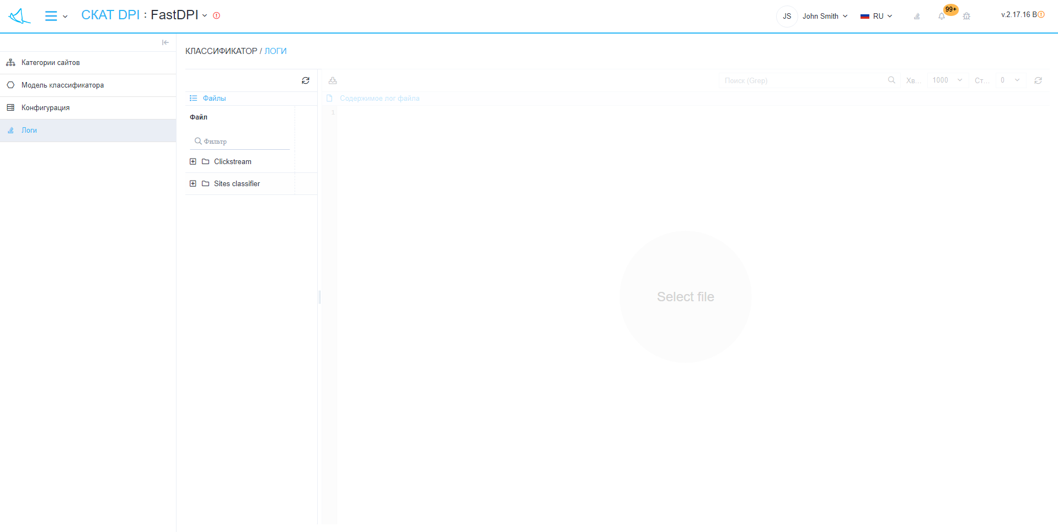
The section looks like the picture below. (fig. 2) (fig. 2)
"Classifier logs" has sections:
- Files:
  - "Refresh" button - refreshes the list of files.
  - List of files.
- Content of the log file:
  - Button "Download file completely" - downloads the file to your device.
  - Options
    - Search (Grep)
    - Tail
    - Number of lines before and after matching
- "Refresh" button - loads the contents of the file from the last saved copy.
- A form for viewing the contents of the selected file.

