Classifier configuration
To open the "Classifier configuration" section, open the main menu, point to the "Classifier" item and click on the "Configuration" item. (fig. 1)

(fig. 1)
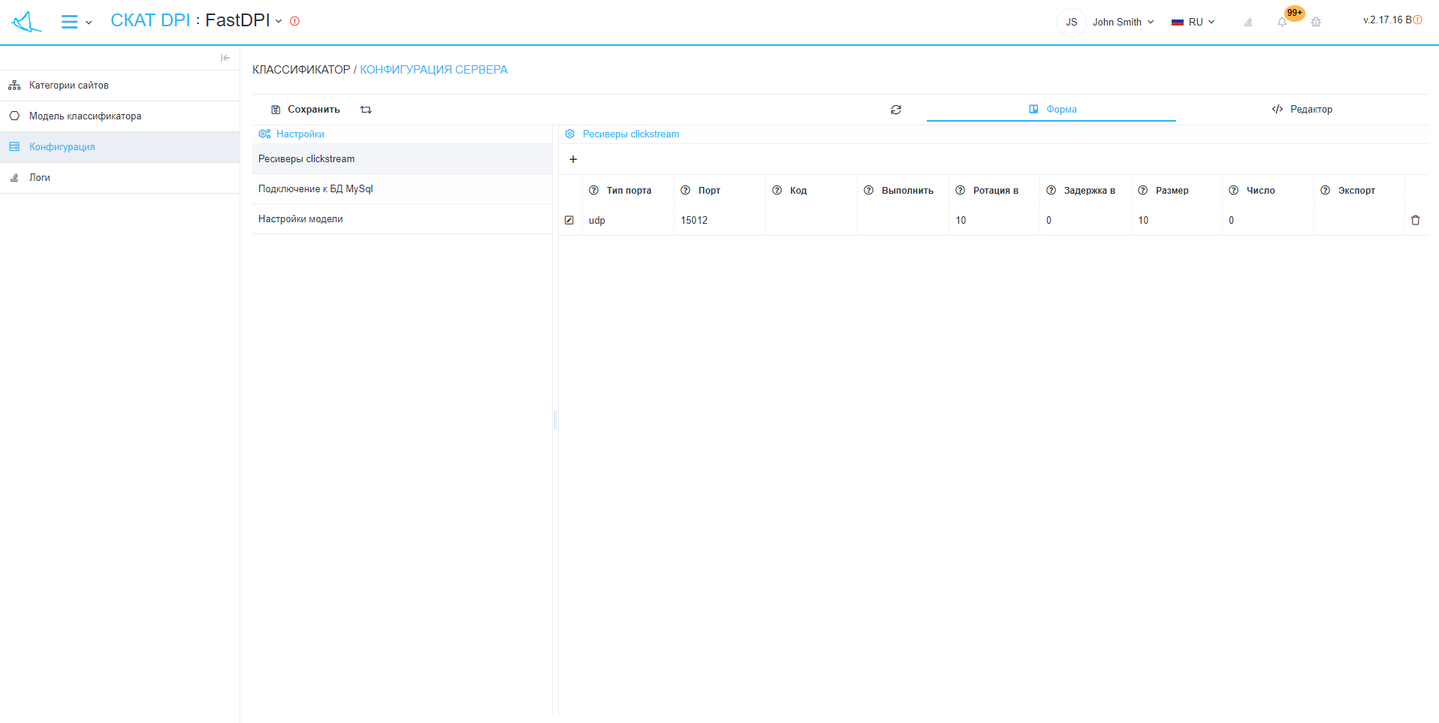
The section looks like the picture below. (fig. 2) (fig. 2)
"Classifier configuration" has sections:
- Settings:
  - Button "Save" - ​​saves changes in the configuration of the classifier.
  - "Restart" button - restarts the classifier with the updated configuration.
  - "Refresh" button - requests the last saved configuration from the server.
  - Switch "Form / Editor" - toggles the editing modes of the configurator
    - Form - allows you to edit the server configuration using the graphical interface.
    - Editor - allows you to edit the server configuration by editing the configuration file directly, that is, in text format.
- List of configuration categories:
  - Clickstream receivers
    - Button "+" - opens a form (fig. 3) for adding a receiver.
    - List of receivers.
- Connection to MySql DB
  - DB connection type (DB_CONNECTION)
  - Database host (DB_HOST)
  - DB port (DB_PORT)
  - Database name (DB_DATABASE)
  - Database username (DB_USERNAME)
  - DB password (DB_PASSWORD)
- Model settings
  - Default models (CFG_SITES_CLSFR_MODEL)
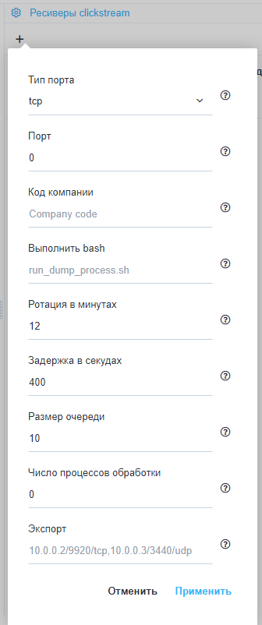
(fig. 3)

