Traffic decode logs
To go to the Traffic decode logs section, open the LAWFUL INTERCEPTION menu and TRAFFIC DECODE LOGS.
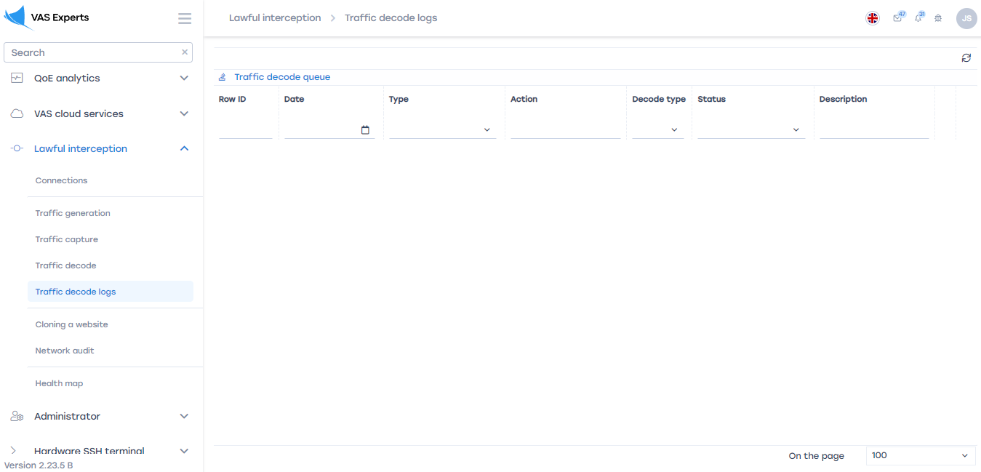
This section contains a list of pcap servers and tasks created by the user in the "Traffic Analysis" section. This list can be filtered by the line number of the list, date, type, action, type of parsing, status and description.

Updating the list
To update the list, click on the "Update" button located on the right in the toolbar.
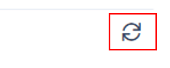

Contents of the log file
To view the file, click on the "Information" button located to the right of each item in the list.
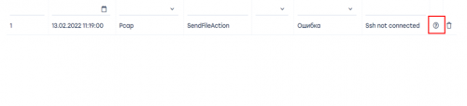

Deleting a list row
To delete a line in the list, click on the "Delete" button located to the right of each item in the list.


