9 Hardware SSH Terminal
To go to the Hardware SSH Terminal section, open the HARDWARE SSH TERMINAL menu and HARDWARE SSH TERMINAL.
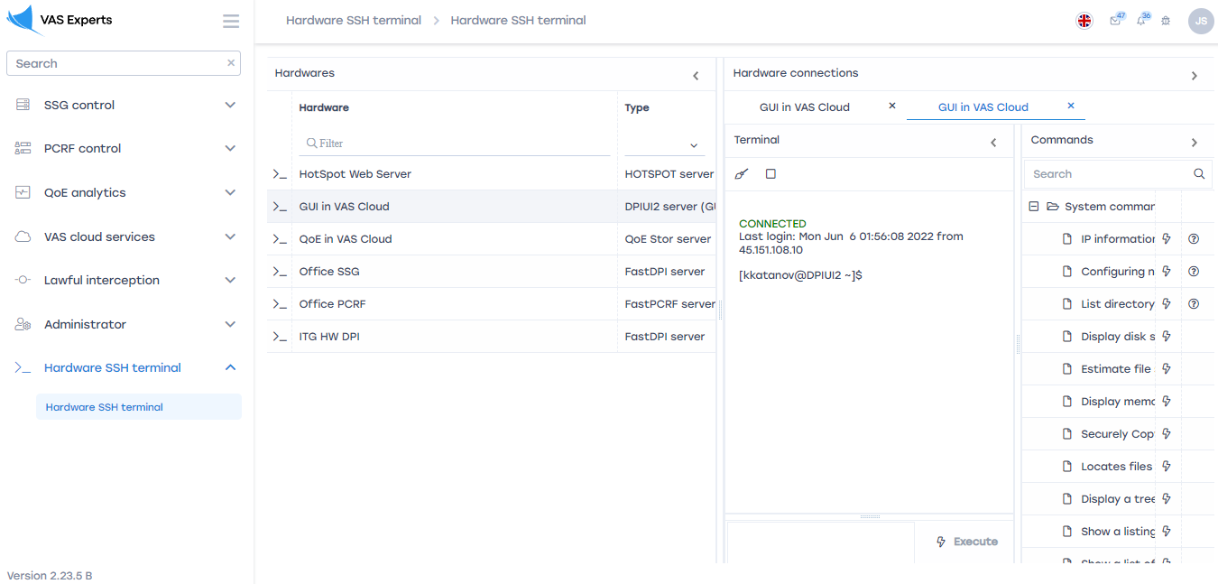
This section is intended for entering and executing commands by the terminal. At the top, above the block name, there is a number of equipment selected by the user.

Device
This subsection lists all the user's equipment.
To start the terminal of the selected equipment, click on the start button.
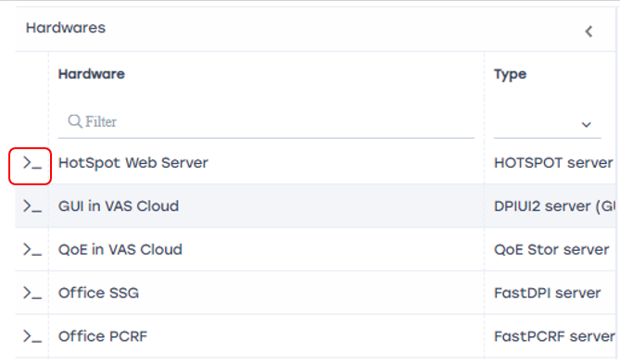

Terminal
At the bottom of the subsection there is a field for entering commands.
To execute the command, click on the "Execute" button.
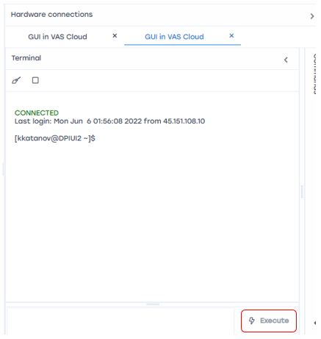

Clear History
In the middle of the block is a window that stores the history of commands and the results of their execution.
To clear the history, click on the "Clear" button.
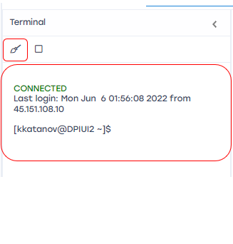

Stop terminal operation
To stop the terminal operation, click on the "Stop" button.
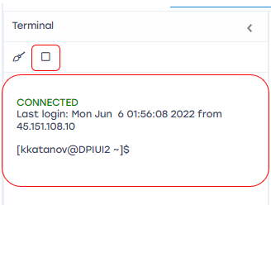

Commands
This subsection contains System Commands and Dpiui2 Commands, search for commands and their designation.
In the terminal, the command selected from the list of commands is automatically inserted into the command input field.
To select a command, double-click on it.

