2 Report a bug
In the upper right corner of the program there is a Ticket button, which allows you to send a message to the technical service.
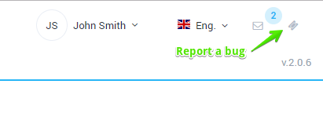
When you click on the button, the form is opened as shown in the figure below.
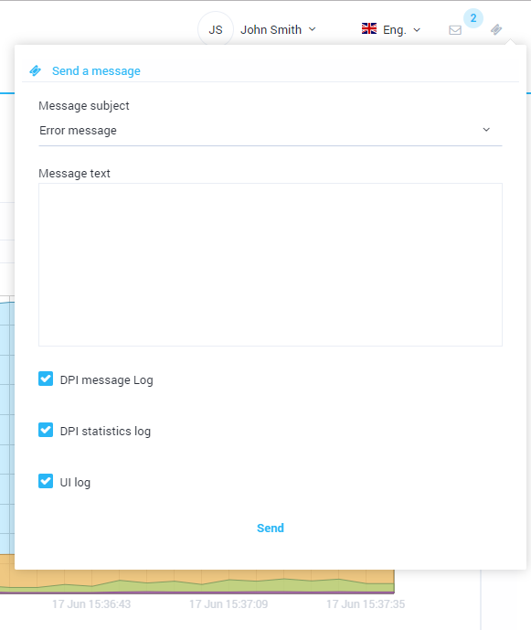
The form allows you to select a topic, write text, attach logs. The message is sent to the technical service.
In case of abnormal program termination the error message is displayed in the center of the screen. Also you can send a message with the error text to the technical service.

