5 DPI Configuration
In this section, you can manage the DPI platform settings.

Editing
To go to the Configuration section, open the DPI CONTROL menu and click on CONFIGURATION.
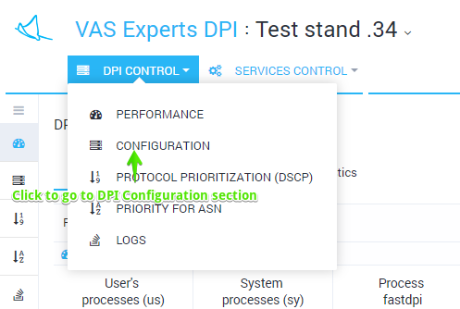
The section looks like the figure below.
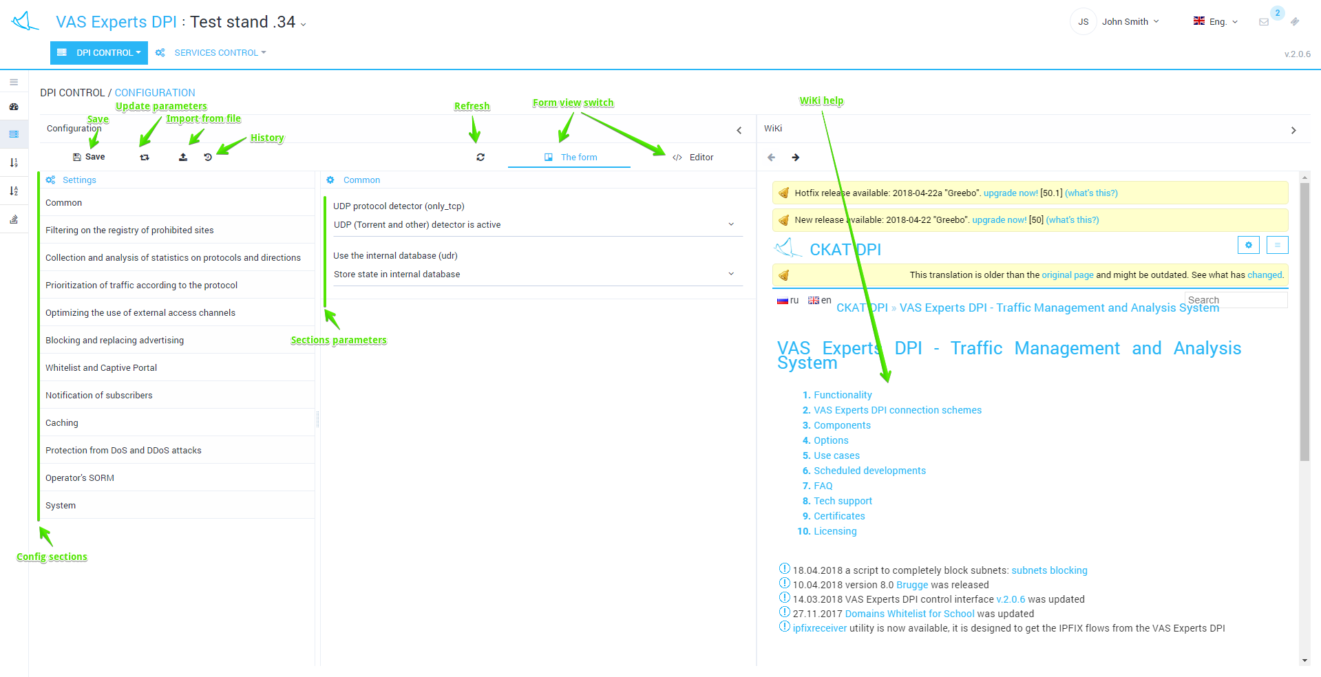
The configuration is divided into sections (the list on the left). For each section corresponding form (centered) and documentation (right) are opened.
Do not forget to save the changes. When you click Save a selection menu appears, there you can check and save the configuration.
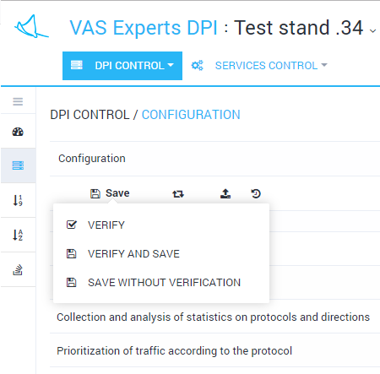

Direct editing
It is possible to edit the file directly without using sections and forms. To switch to the direct editing mode, click the Editor within the opened DPI control / Configuration submenu
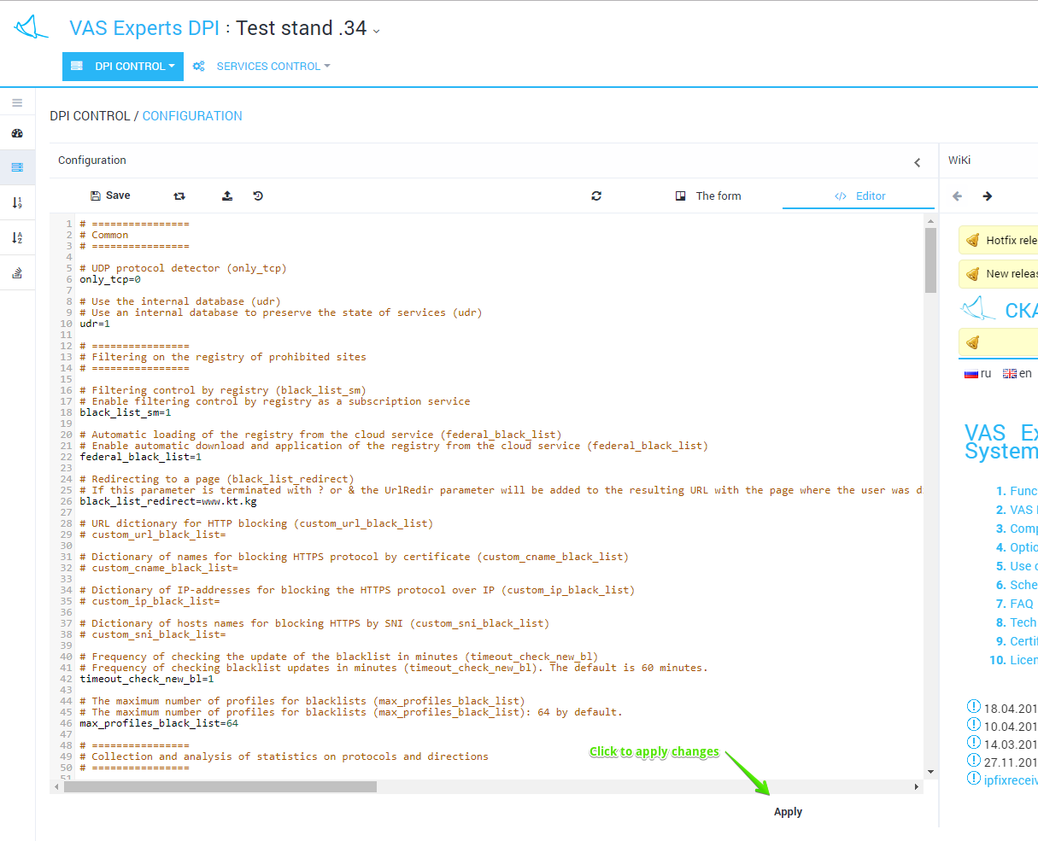
Do not forget to click the Save button (after making changes in the editor).

History view and import
To view the history changes in the Configuration section, click the "History" button (Download from history tooltip). The form will be opened as in the figure below.
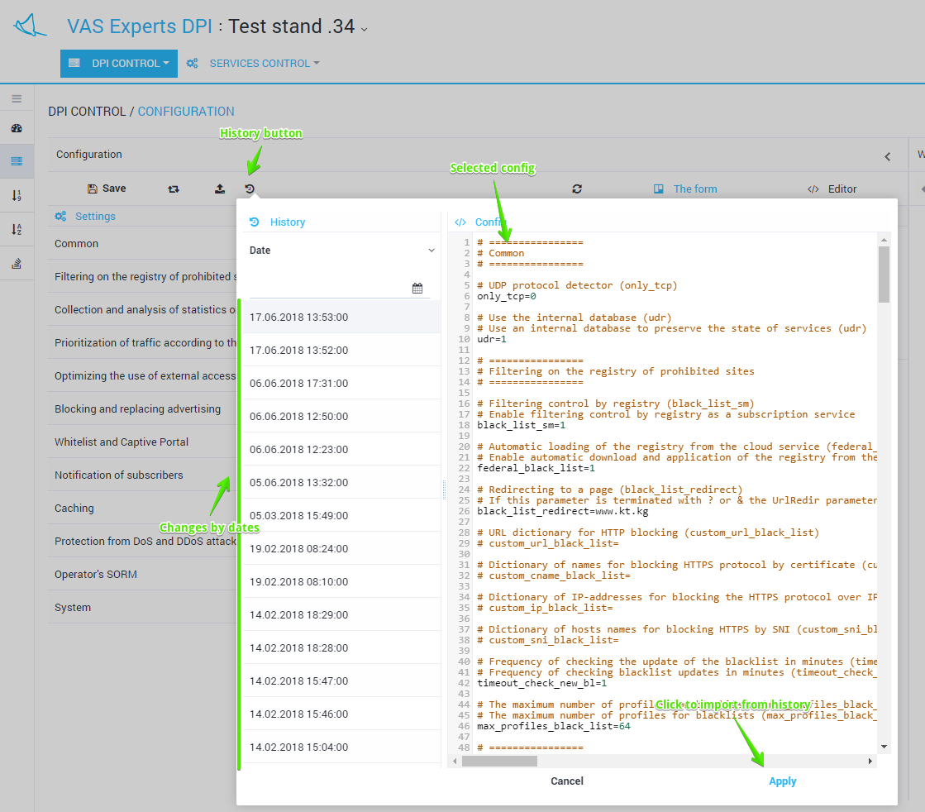
It is possible to view and filter a list of changes by date. Select and apply a history change.

Import and view from file
To import from a file click the Import button (Upload from file tooltip) in the Configuration section. The form will opened as in the figure below.
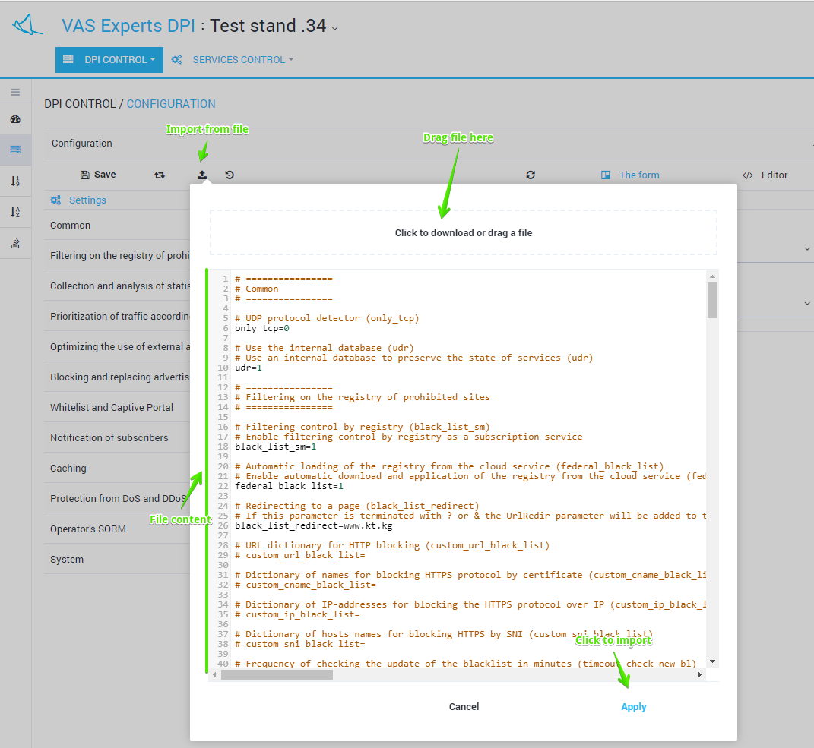
Drag the file to the import area. The contents of the file will be displayed below. Click Apply to import the contents of the file.

