1 Authorization and first launch
Since a self-signed ssl certificate is installed, the window that follows will appear in the browser (in different browsers it appears in different ways, in the screenshot below Google Crome is shown):
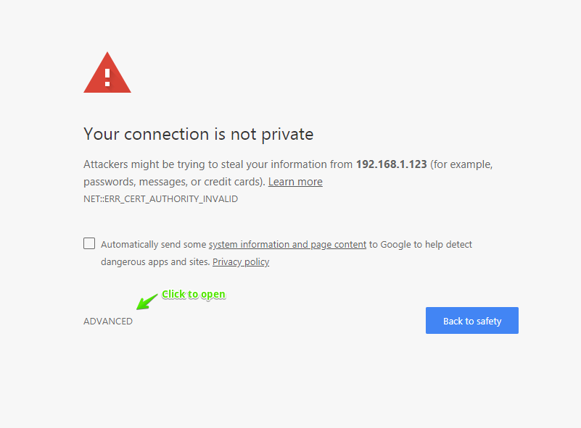
Click on "ADVANCED" to open. The window will appear:
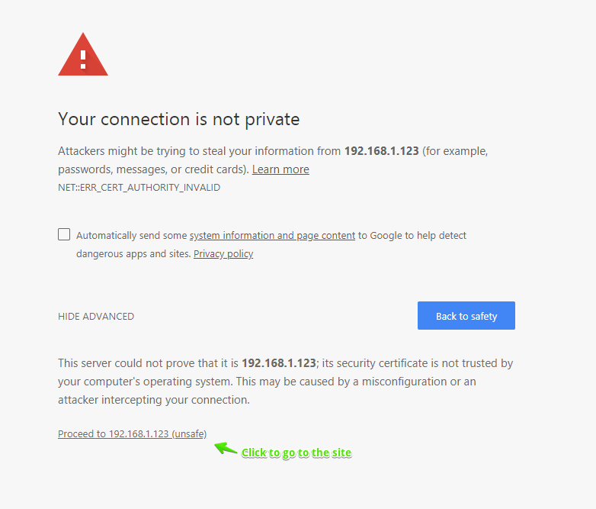
Press "Proceed to …" to the site.
At the first start the login window opens. You need to supply a username and a password.
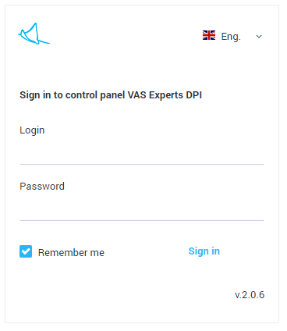
If the "Remember me" check box is selected the session is remembered and the authorization is no longer required.
During the installation the following user is created by default:
- Login - admin
- Password - vasexperts
If you are logged in for the first time, you need to configure the hardware. See the section Managing the list of devices

