2 Users and roles
Section content:
- My profile
- Users list
- Roles

My profile
To open My profile, open the user menu and click on "My profile" user menu.
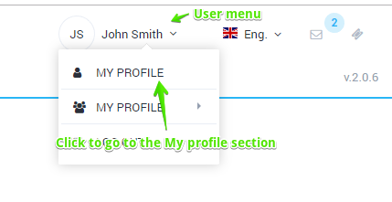
The form looks like the figure below.
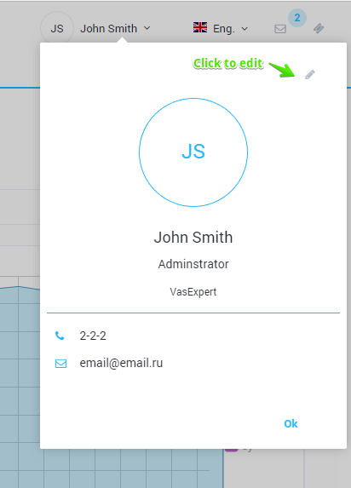

Profile editing
To edit a profile on the My profile form, click edit. The editing form will be opened.
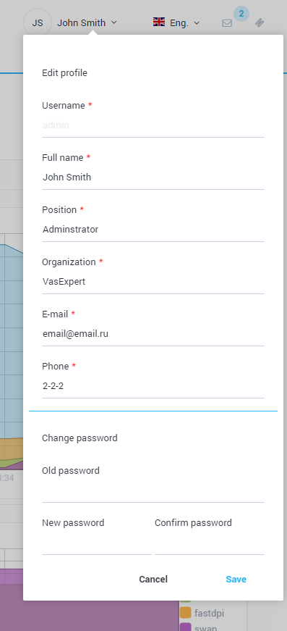
The form allows to edit following data:
- Username
- Full name
- Position
- Company
- E-mail
- Phone number
To change the password, enter the old password, new password and confirmation.
To save the changes, click Save.

Users list
To go to the user management section, open the user menu and click Users.
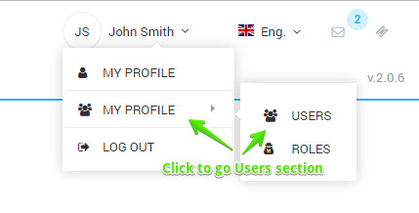
The section looks like the figure below.
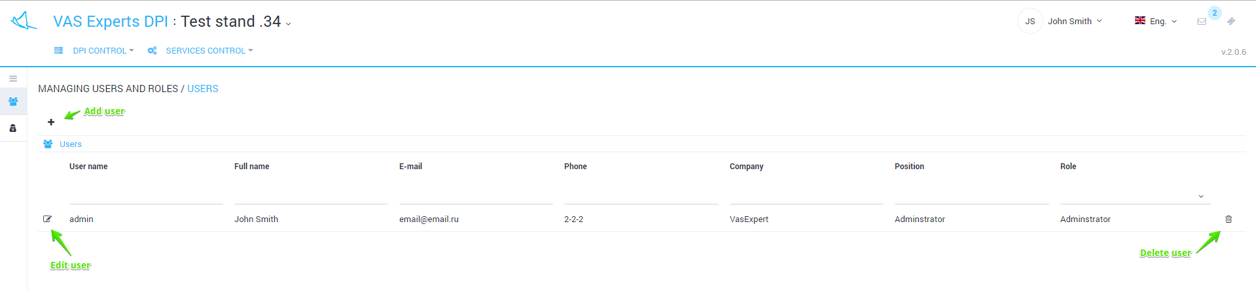
The section implements the following features:
- View a list of users with filtering options
- Add a new user
- Edit properties of existing user
- Delete user
The editing form looks like the figure below.
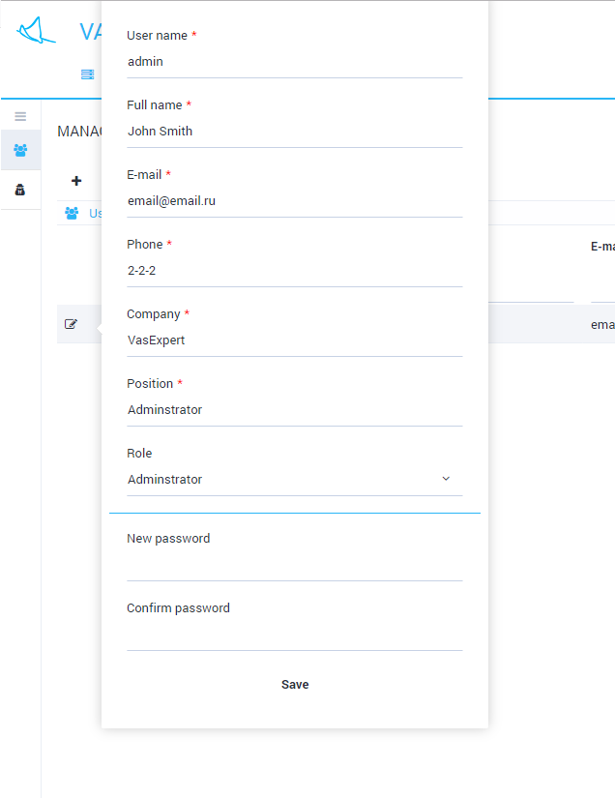
The form allows you to edit the following data:
- User name
- Full name (Last, first and middle names)
- E-mail
- Phone number
- Company
- Position
- Role
- Password
To save the changes, click Save.

Roles
To go to the user management section, open the user menu and in the Users submenu, click Roles.
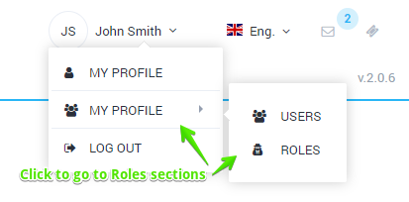
The section looks like the figure below.
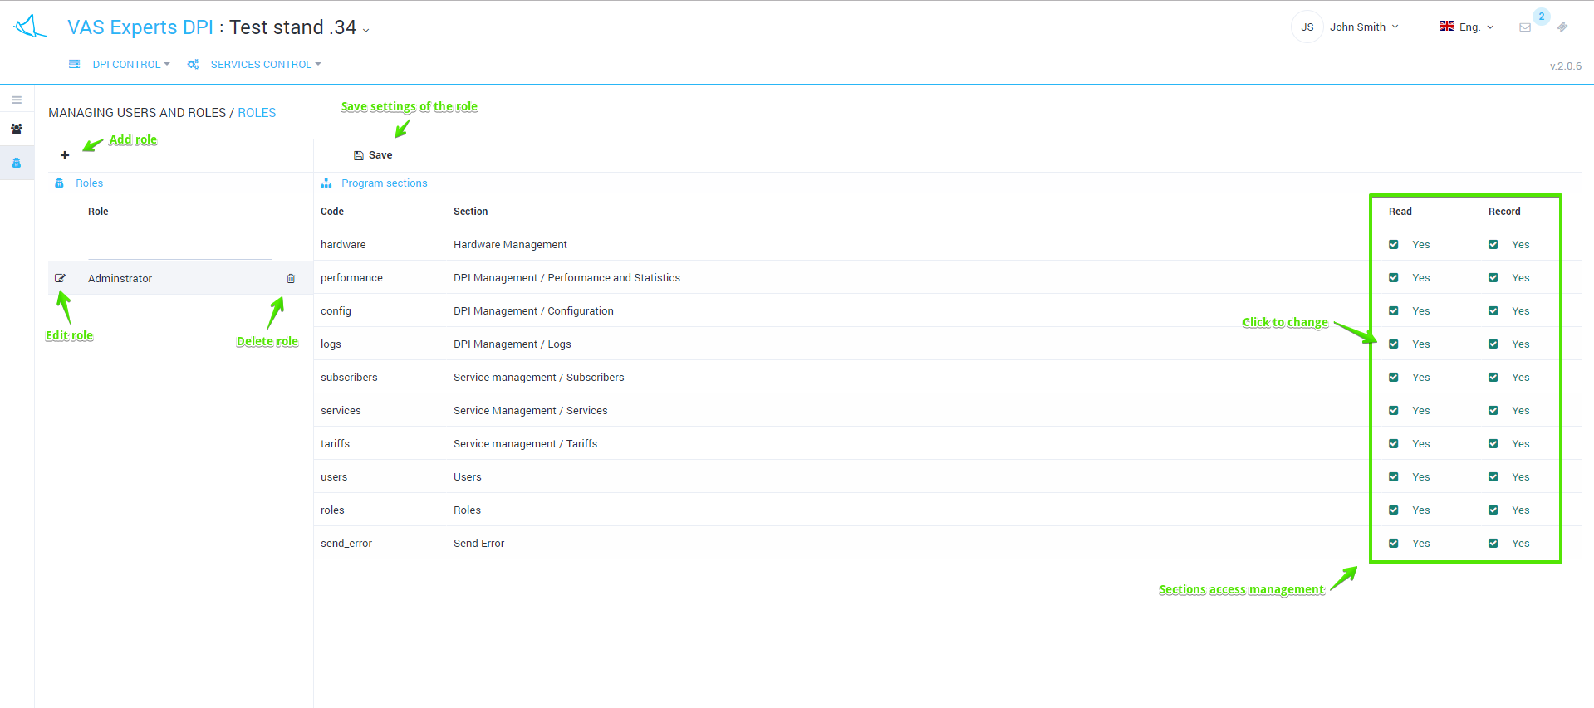
This section implements the following features:
- Add role
- Delete role
- Edit role name
- Manage the access to the sections depending on the role
To save changes, do not forget to click Save.

