GUI Update
You can find information about updates in the Administrator → GUI Update section.
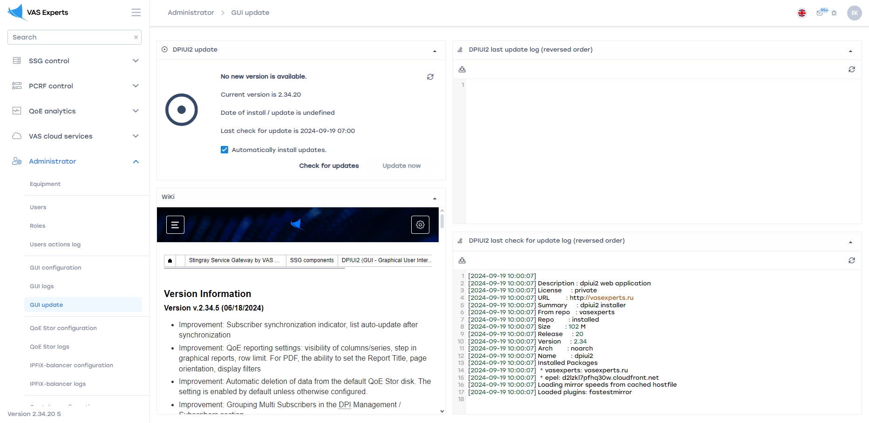

Check for DPIUI2 Updates
The data is located in the "DPIUI2 Update" block.
- You can check for updates by clicking the Check for updates button.
- If an update is available, the Update now button will be active. By clicking the button, you can update DPIUI2.
- You can also select the Automatically install updates option to enable automatic updates by default.
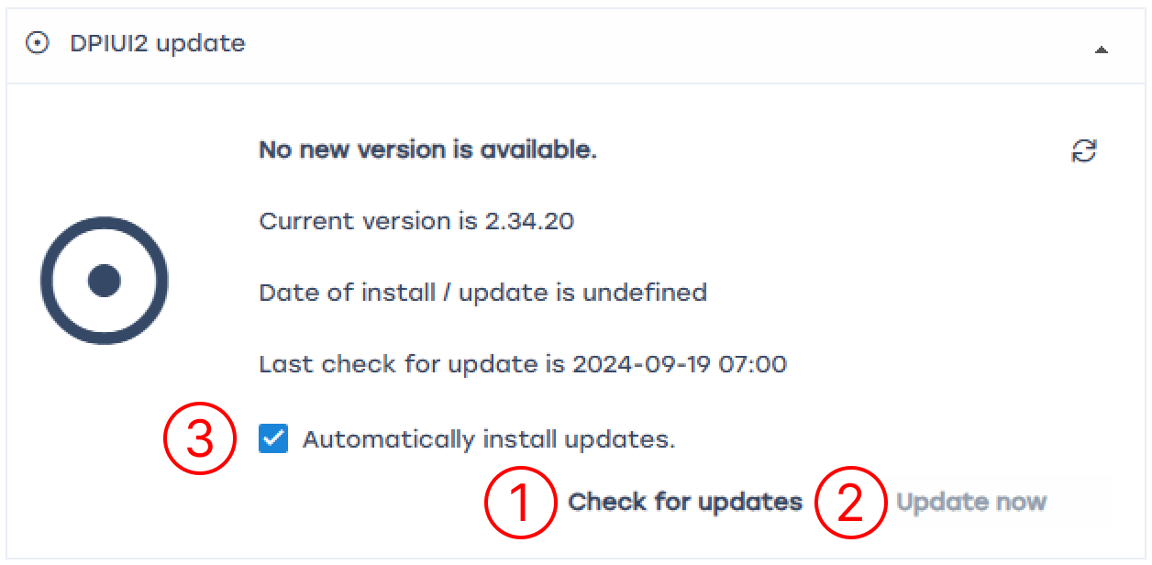

Review Previous Versions of DPIUI2
The data is located in the "Wiki" block.
Use the scroll bar to view the page.
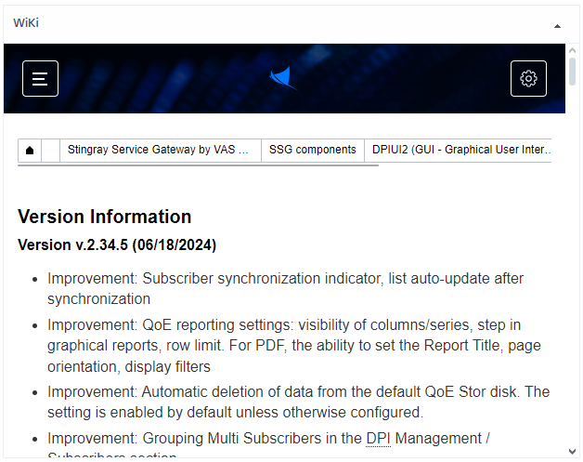

View the Last Update Log
The data is located in the "DPIUI2 Last Update Log (reversed order)" block.
Use the scroll bar to view the log files.
- To download the file, click the Download file button.
- To refresh the file, click the Refresh button.
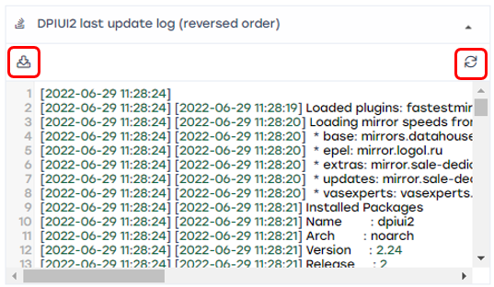

View the Last Update Check Log
The data is located in the "DPIUI2 Last Check Update Log (reversed order)" block.
Use the scroll bar to view the log file.
- To download the file, click the Download file button.
- To refresh the file, click the Refresh button.


