SSH key for connecting to equipment
Connection to the equipment through the graphical interface is performed via SSH. Authorization can occur either by password or by using a key — the latter method is more secure.
In this section, we will cover the key-based authorization process.
Connection must be made under a user with sudo privileges or as root (not recommended).
Add a sudo user on the equipment: Sudo user.

sshd configuration
The configuration file is located at /etc/ssh/sshd_config. We recommend checking the PubkeyAuthentication property — if it is missing, commented out, or set to no, change the property value to yes.
After any changes to the /etc/ssh/sshd_config file, the sshd service must be restarted with the command
sudo systemctl restart sshd

Step 1. Creating a key
- Navigate to the Administrator → SSH Keys section
- Click on the + at the top of the screen to add a new key
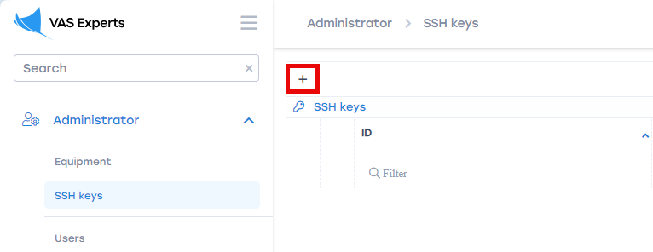
- Enter the key name
- Upload the public and private key files
  - If you already have ready-made keys, you can upload them by clicking the appropriate buttons
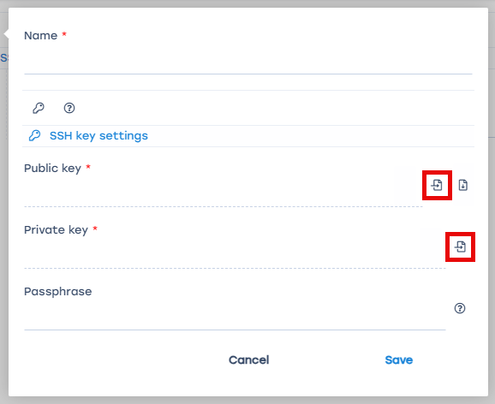
  - If the necessary ssh files are missing, they can be generated by clicking on the key icon. Optionally, you can add a passphrase. Then click Generate
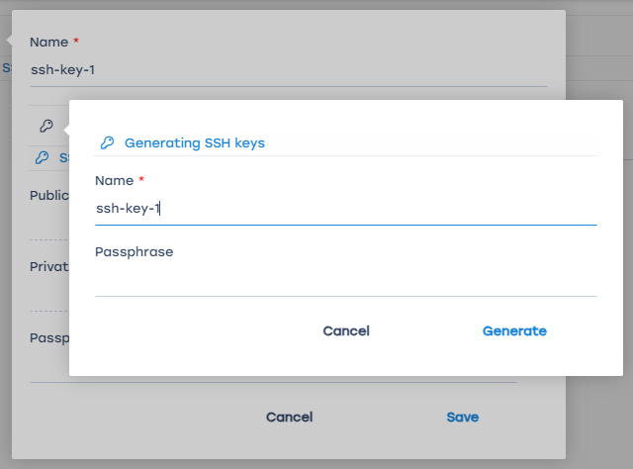
After generating the ssh files, download the public key to add it to the server.
If necessary, you can also download the private key — this is only possible at this stage.
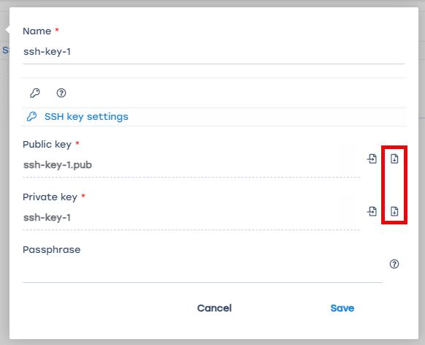
- If the private key is encrypted, provide the passphrase set during key creation
If no passphrase was set, leave the field blank
- Click Save

Step 2. Adding the ssh key to the equipment
- Navigate to Administrator → Equipment
- Open the equipment settings. The ssh key can be added to new or existing equipment.
  - Create new equipment: click on the + at the top of the screen
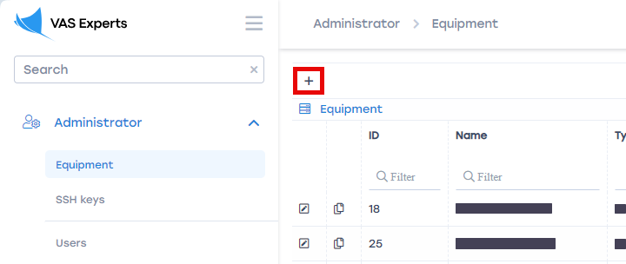
  - Edit existing equipment: click the edit icon to the left of the equipment
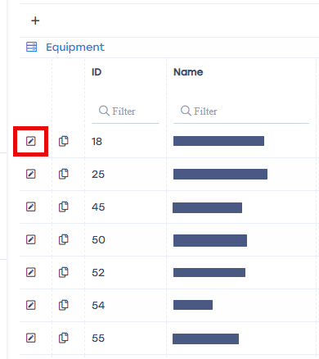
- When creating new equipment, fill in all fields with the necessary information. More details in the Equipment management section.
- Select the Key-based authorization type
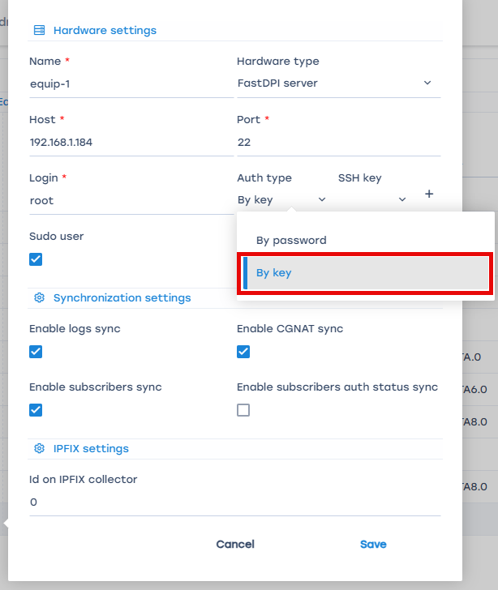
- In the SSH Key field, select the previously created key. Or by clicking on the + create a new SSH key, the process is identical to that described in Step 1. Creating a key (starting from point 4)
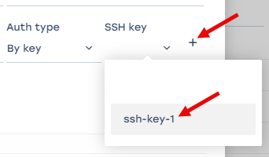
- Click Save

Step 3. Adding the ssh key to the server
- Under the root user, navigate to the /root/ folder
Under a regular user, navigate to the /home/<username>/ folder
- Go to the hidden directory /.ssh/
- Open the authorized_keys file
- Add the public key content to the file
After completing these steps, check the connection by clicking on the Hardware State button in the Administrator → Equipment section.
If all properties are in the “Ok” state, the connection was successful.


