QoE Stor Logs
To go to the section, click the ADMINISTRATOR menu item, then click the QOE STOR LOGS menu item.
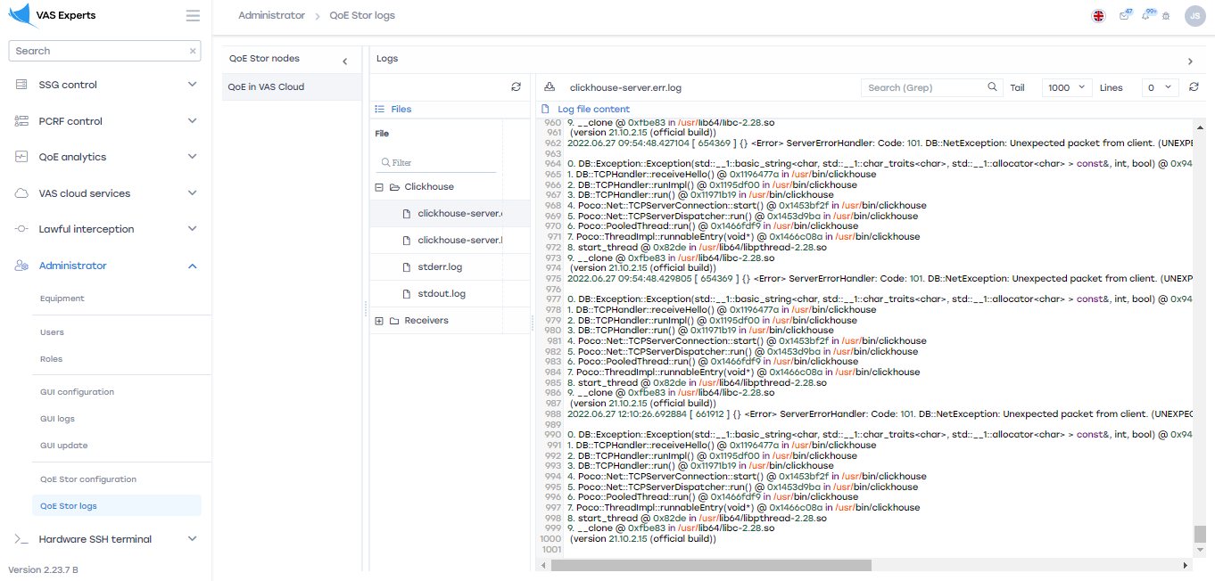

QoE Stor Nodes
The "QoE Stor Nodes" block contains the user's servers.
To create or view a custom server that provides work access in the "QoE Stor Logs" section, go to «Equipment»

Update the file list
To update the list of files, click on the "Update" button located in the toolbar.
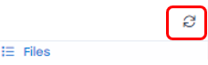
To filter the list of files, enter the keyword by which the search will be performed.
To view the contents of the file, double-click on the selected file. A form with information will open on the right.

Contents of log files
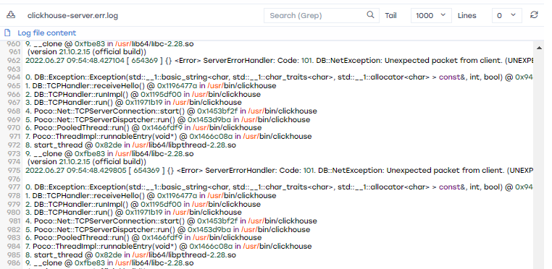
To download the file completely to the device, click on the "Download the file completely" button.
To update the file, click on the "Update" button.

