2 Backups
Starting with version 2.25.9, the function of backup DB and FS has appeared. By enabling the function, you can configure the frequency of copying, storage duration, as well as export via SCP to a remote storage.
Move to the DB and FS settings section, open the Administrator menu item, section «Backup settings».
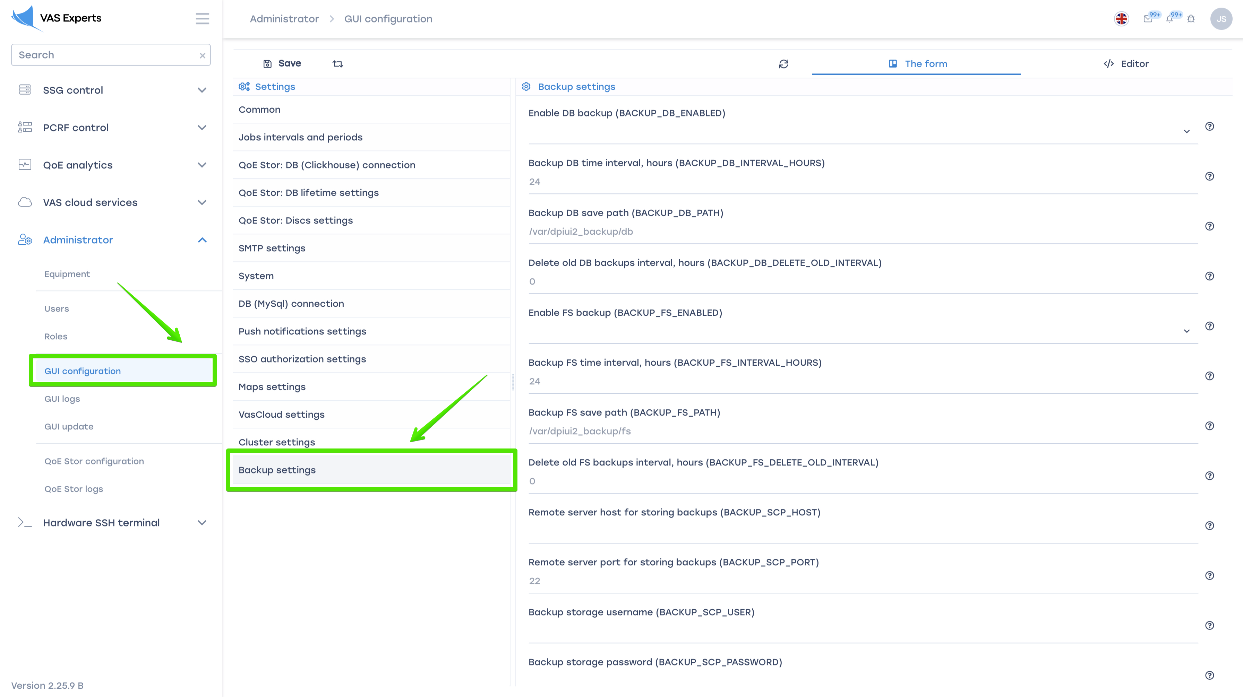

Configuration

Enable DB backup
To enable DB backup, select "Enabled".
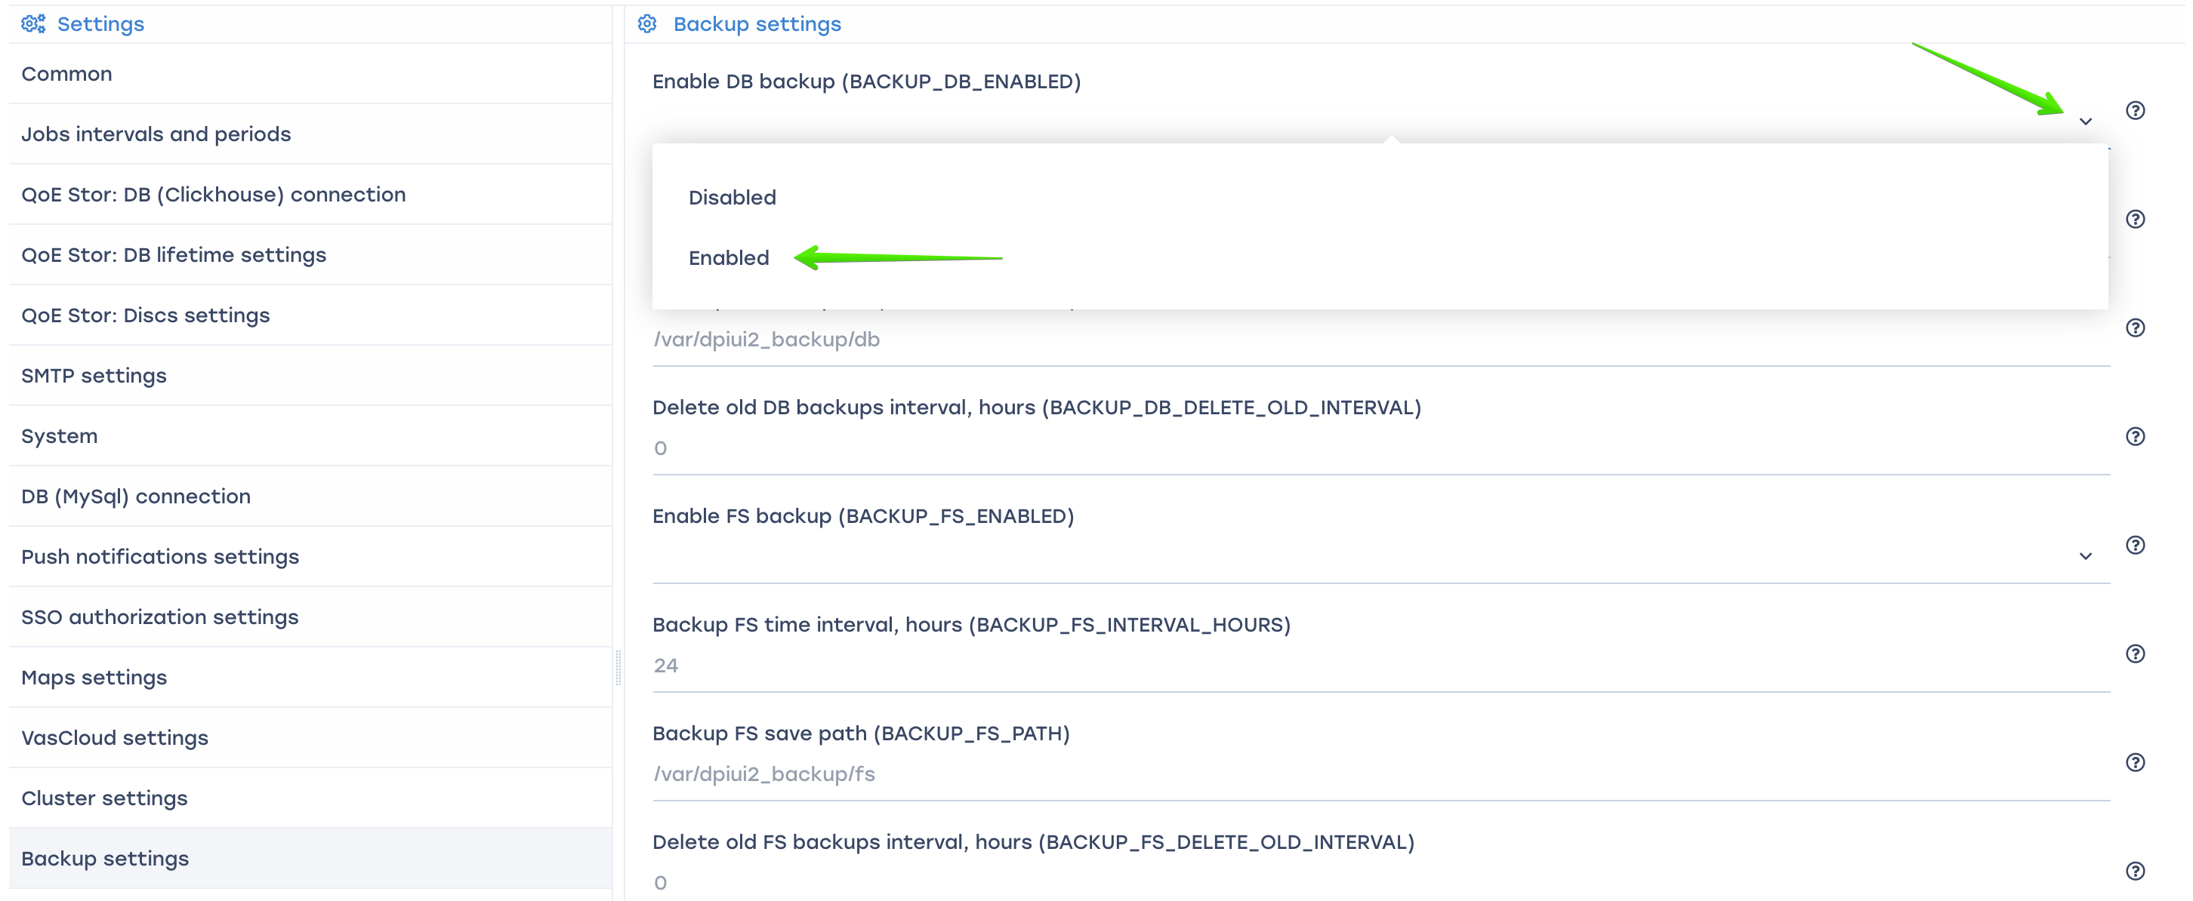
Specify the following settings
- BACKUP_DB_ENABLED - enable DB backup. (Default value is Disabled)
- BACKUP_DB_INTERVAL_HOURS - backup DB time interval, hours. (Default value is 24)
- BACKUP_DB_PATH - backup DB save path. (Default path is /var/dpiui2_backup/db)
- BACKUP_DB_DELETE_OLD_INTERVAL - delete old DB backups interval, hours. (Default value is 0)
When set to "0", old backups will not be deleted.

Enable FS backup
FS backup include .env files and folder contents /var/dpiui2/backend/storage
To enable FS backup, select "Enabled".
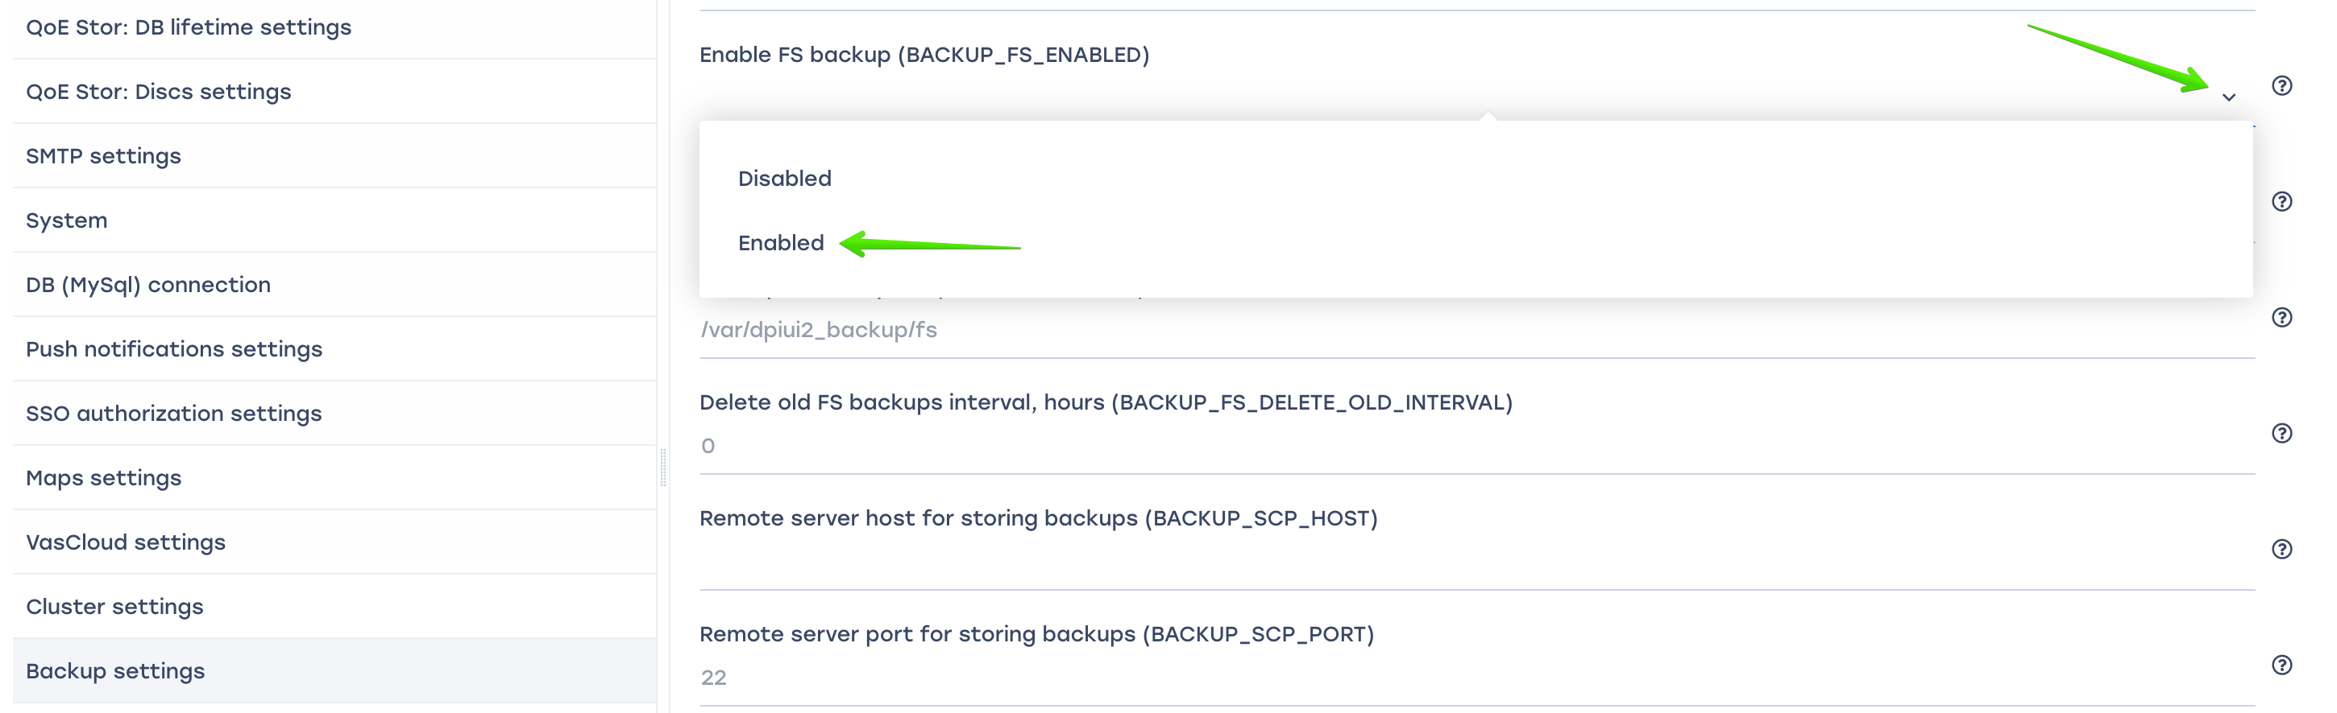
Specify the following settings
- BACKUP_FS_ENABLED - enable FS backup. (Default value is Disabled)
- BACKUP_FS_INTERVAL_HOURS - backup FS time interval, hours. (Default value is 24)
- BACKUP_FS_PATH - backup FS save path. (Default path is /var/dpiui2_backup/fs)
- BACKUP_FS_DELETE_OLD_INTERVAL - delete old FS backups interval, hours. (Default value is 0)
When set to "0", old backups will not be deleted.

Remote server for storing backups settings
- BACKUP_SCP_HOST - remote server host for storing backups.
- BACKUP_SCP_PORT - remote server port for storing backups.
- BACKUP_SCP_USER - backup storage username.
- BACKUP_SCP_PASSWORD - backup storage password.
SCP will use key authentication if no password is specified.
- BACKUP_SCP_DB_PATH - backup DB remote path. (Default path is /var/dpiui2_backup/db)
The folder must exist. The user must have access rights to this folder.
- BACKUP_SCP_FS_PATH - backup FS remote path. (Default path is /var/dpiui2_backup/fs)
The folder must exist. The user must have access rights to this folder.

Saving сhanges
To save the edited parameters, click the "Save" button.


