Backup auto restoration
Starting from version 2.25.13 there is a function to automatically restore FS and DB from backups backups.
When automatic restore from backups is enabled, the dpiui2 server will work in replication mode (all kernel processes will be disabled).
Move to the DB and FS settings section, open the Administrator menu item, section «Backup auto restoration settings».
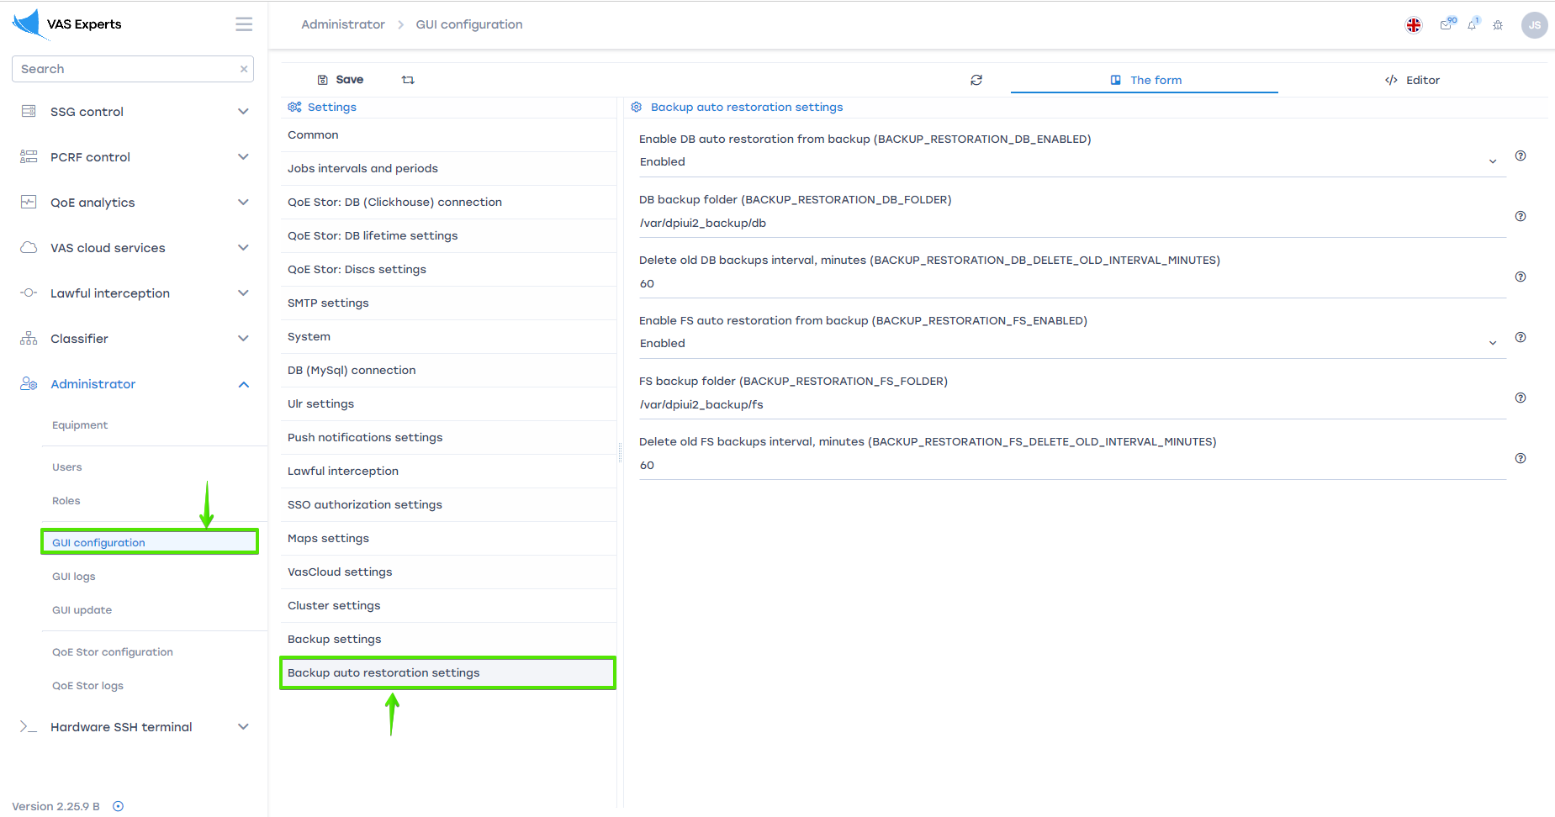

Enable auto restoration DB from backups
To enable auto restoration DB from backups, select "Enabled"
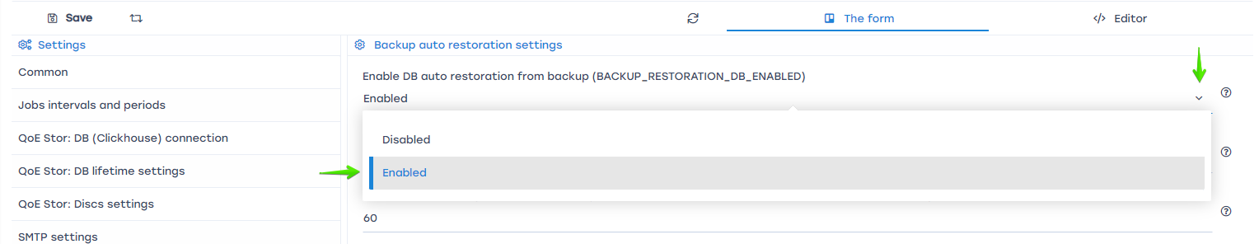
Specify the following settings
- BACKUP_RESTORATION_DB_ENABLED - enable auto restoration DB from backups. (Default values is Disabled)
- BACKUP_RESTORATION_DB_FOLDER - folder path with DB backups.
- BACKUP_RESTORATION_DB_DELETE_OLD_INTERVAL_MINUTES - delete old DB backups interval, minutes. (Default value is 0)
When set to "0", old backups will not be deleted.

Enable auto restoration FS from backups
To enable auto restoration FS from backups, select "Enabled"
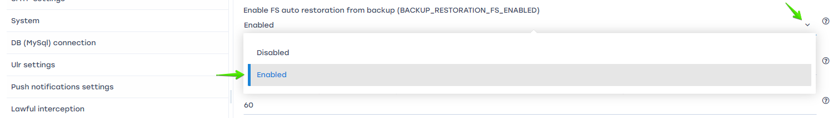
FS backup include .env files and folder contents /var/dpiui2/backend/storage
Укажите следующие настройки
- BACKUP_RESTORATION_FS_ENABLED - enable auto restoration FS from backups. (Default values is Disabled)
- BACKUP_RESTORATION_FS_FOLDER - folder path with FS backups.
- BACKUP_RESTORATION_FS_DELETE_OLD_INTERVAL_MINUTES - delete old FS backups interval, minutes. (Default value is 0)
When set to "0", old backups will not be deleted.

Saving сhanges
To save the edited parameters, click the "Save" button.
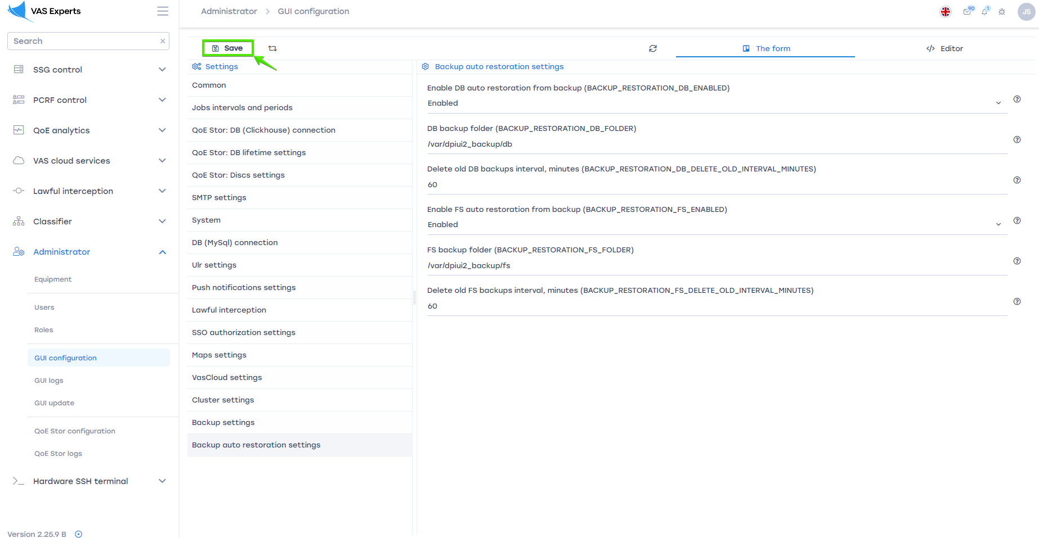
When automatic restore from backups is enabled, the dpiui2 server will work in replication mode (all kernel processes will be disabled).

