13 Advertising control
This section appeared in version 2.1.0.
To switch to the section, open the menu SERVICES CONTROL and click ADV CONTROL.
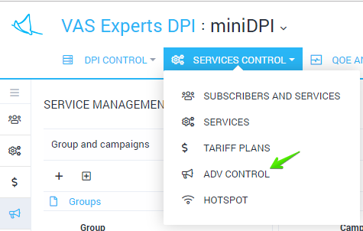
The section looks like the figure below.
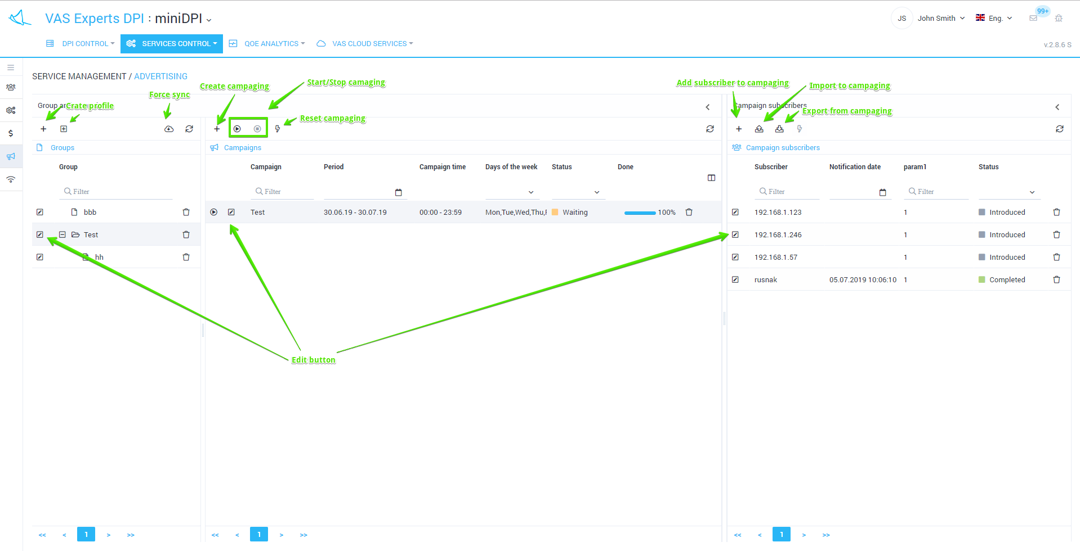

Advertisement campaign profiles
Here you can create profiles for combining several adv campaigns, as well as edit and delete them. The form for creating/editing advertising campaigns profiles is shown in the figure below.
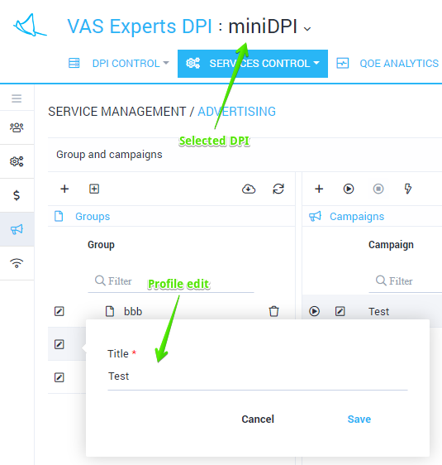
You can control advertising campaigns for only one selected device.

Advertisement campaigns
Here you can create advertising campaigns for the selected advertising campaign profile. Along with deleting, starting and stoping the previously created advertising campaigns.
The form allowing to create/edit an advertising campaign is shown in the figure below.
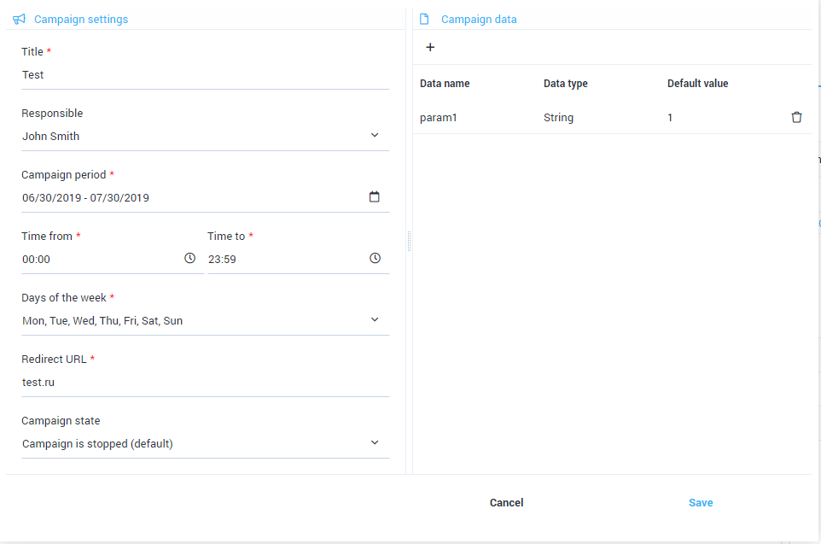
The form allows you to fill in the following parameters:
- Campaign Name
- User responsible for the campaign
- Campaign Period
- Campaign time
- Days of the week
- Redirect URL
- Campaign status (It is stopped by default. In order to start a campaign, you should select the "Started" option in the form or use the start/stop buttons shown in the "Section" figure)
- Campaign data (campaign parameters) used to generate a redirection URL for subscribers added to the campaign

Subscribers of advertisement campaigns
Here you can manage the list of subscribers and the campaign parameters set for them (if they were added during the creation/editing of an advertising campaign) for the selected advertising campaign.

Adding/editing subscriber in advertising campaign
The form for editing the subscriber in advertising campaign is shown in the figure below.
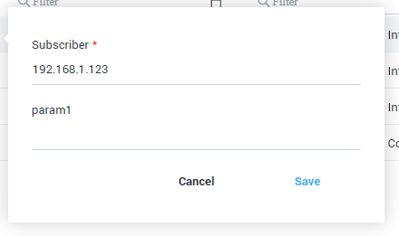
The form allows you to fill in the following parameters:
- Subscriber - login or subscriber IP address
- The values of the advertising campaign parameters for this subscriber (if they were added when creating/editing an advertising campaign). In case you leave these fields blank, the default values specified while creating/editing an advertising campaign will be set.

Importing the subscribers to the adv campaign from file
The form of importing subscribers to an advertising campaign from a file is shown in the figure below.
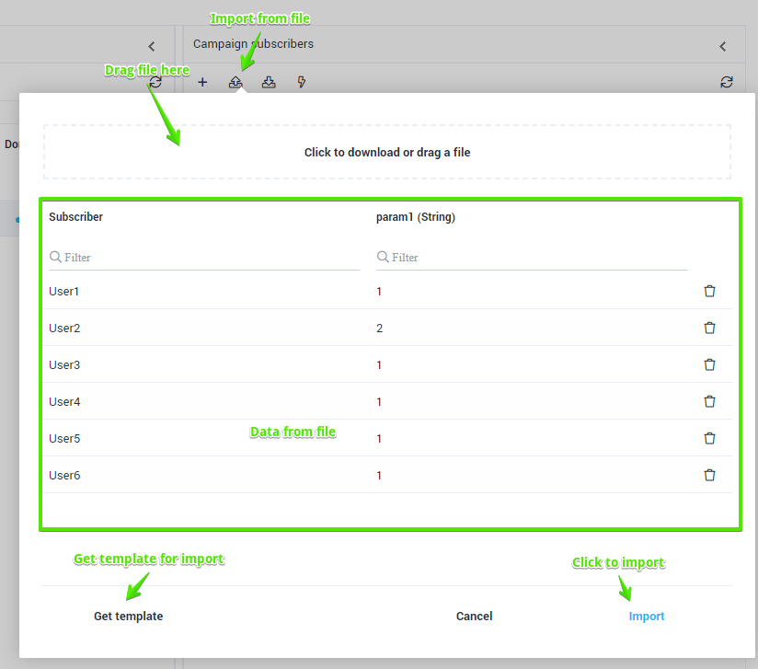
Before importing subscribers and their data into a campaign, it is recommended to download a template Excel file for this campaign (the download button is shown in the figure) in order to make sure that:
- The first column of the table is the name of the account (login) or the subscriber IP address
- The names of the parameters of the advertising campaign in the file matches to specified ones in the campaign

