9 Subscribers and services
This section SERVICES CONTROL / SUBSCRIBERS AND SERVICES allows you to manage the list of all subscribers processed by DPI device and bind services to them (so far without profiles - this feature is currently under development).
Lists synchronization is performed every 30 minutes on a schedule.
It is possible to add subscribers with the following connection types:
- Single: one login (subscriber) is assigned only one ip address
- Multi: one login (subscriber) can be assigned several ip addresses, also it can be assigned a range of ip addresses and CIDR
- Without bind: the subscriber does not have a login, and the services are assigned using the ip address
To go to the section, open the SERVICES CONTROL menu and click on "SUBSCRIBERS AND SERVICES".
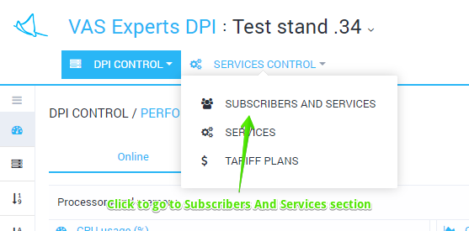
The section will be opened as on the figure below.
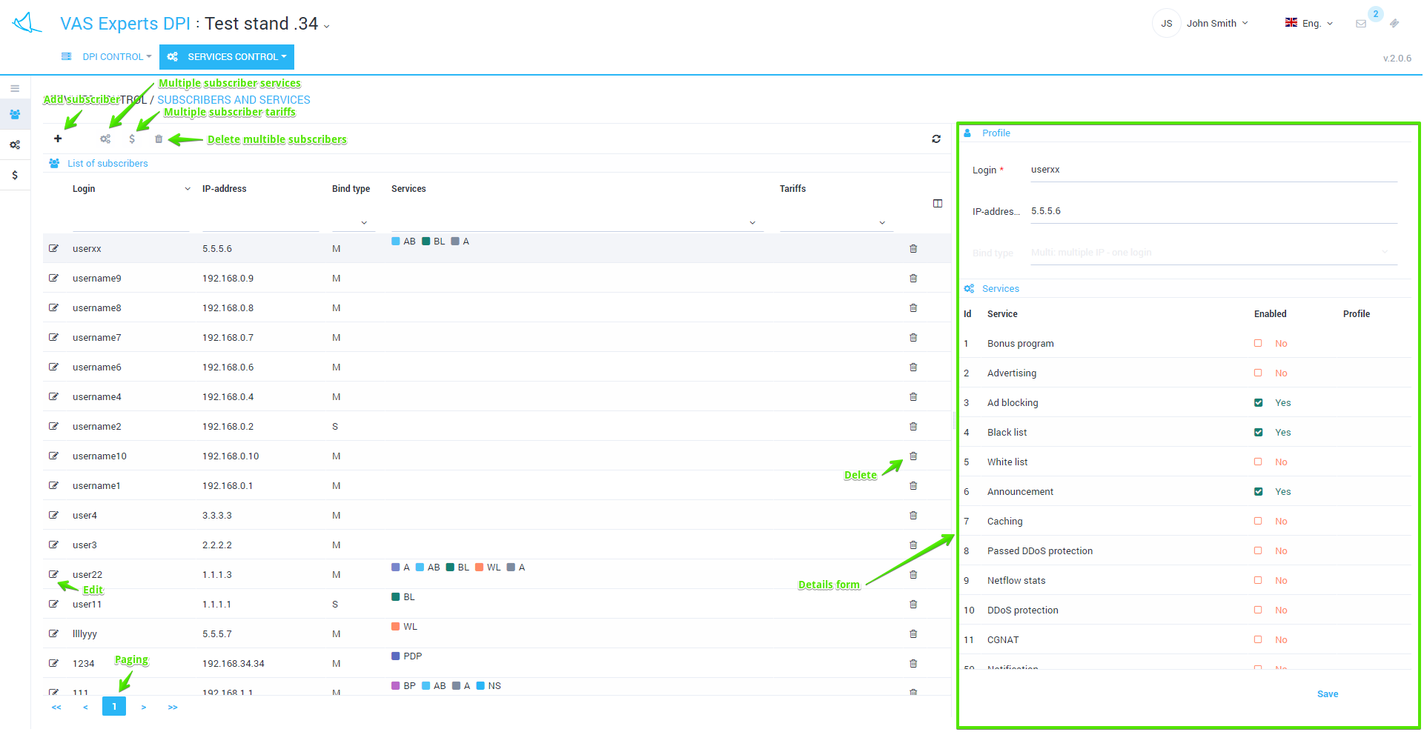
The section has the following features:
- View the list of subscribers and activated services with filtering
- Details by subscriber
- Add / edit subscriber properties
- Enable / disable services
- Perform group operations

Adding a new subscriber
Click the Add button. At the bottom of the table, a new line will be added and the form will be opened as in the figure below.
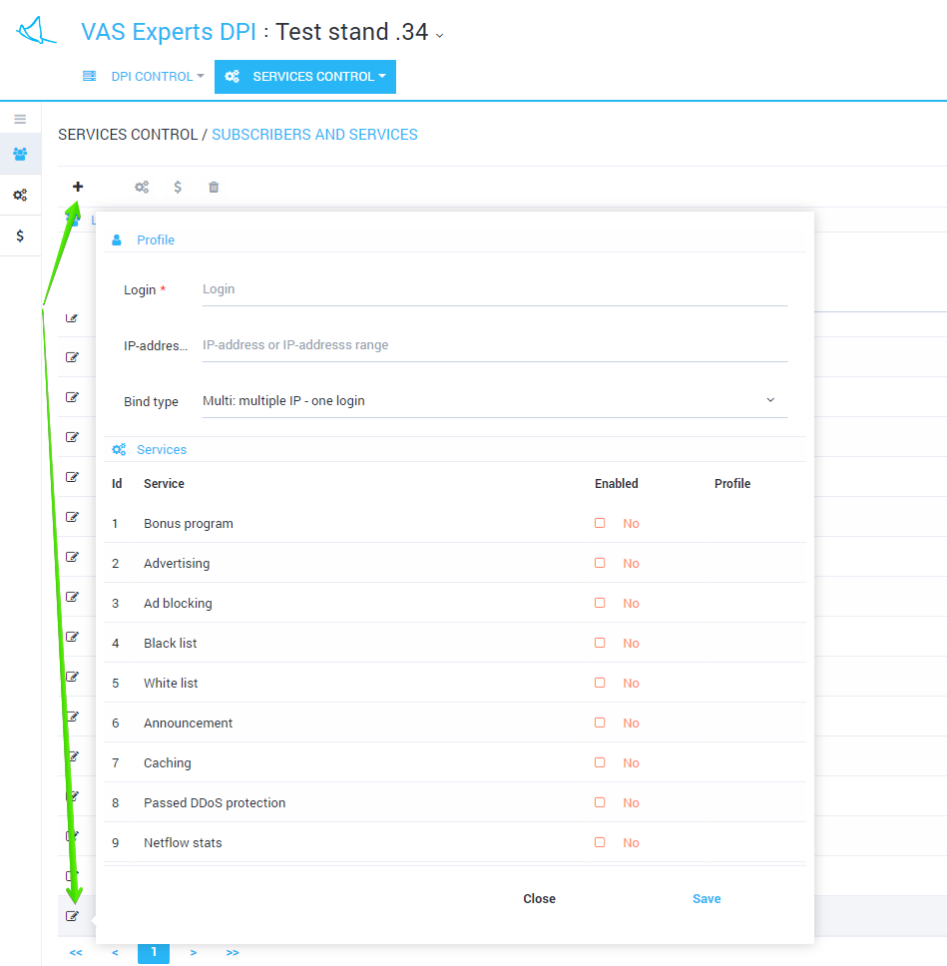
Select the connection type, fill in the Login and IP address fields. Activate the necessary services. Click Save.

Editing a subscriber
You can edit the subscriber either by using the detailization form (on the right) or by using another separate form, if you click on the Edit icon opposite to the subscriber.
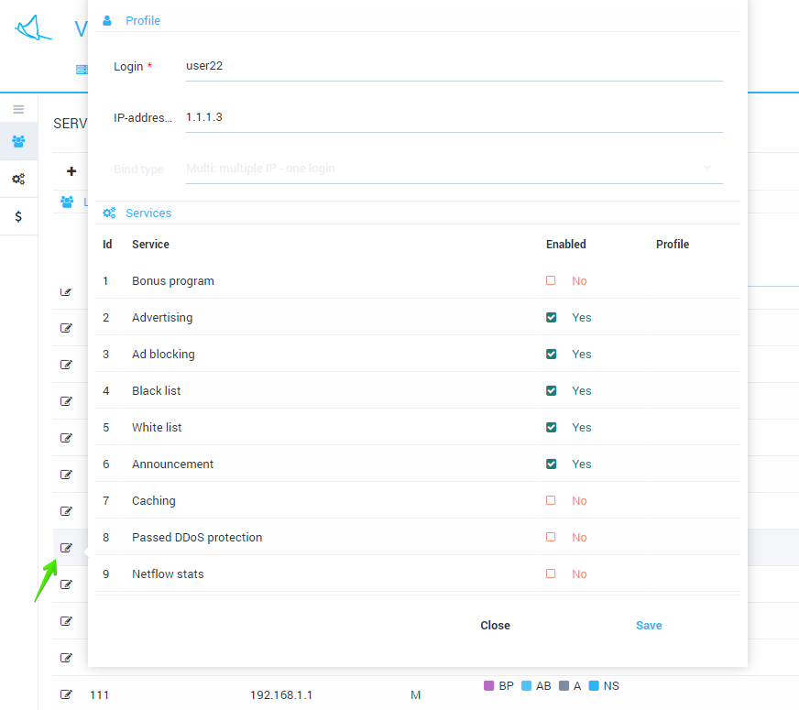
You can change the subscriber login and IP address. For the subscriber using the "Without bind" connection type you can change only the IP address. Services can be enabled or disabled.
Note: if the subscriber has a "Multi" connection type, then enabling and disabling of services will be performed for all of the subscriber's IP addresses.

Group-wide services enabling/disabling
It is possible to enable and disable services to a group of subscribers at once. To do this, select several lines (with ctrl or shift) and click the Services button.
A form will be opened, where you can activate and deactivate services for the selected subscribers.


