QoE Subscribers
This section contains reports for netflow and clickstream analysis in terms of subscriber properties.
The feature of the section is that you can create a custom list of named filters (search patterns): for example, search for subscribers visiting competitors' web-sites; search for subscribers using IPTV or VoIP; search for Internet speed measurements performed by subscribers and so on.
To switch to the section, open the QoE ANALYTICS menu and click SUBSCRIBERS
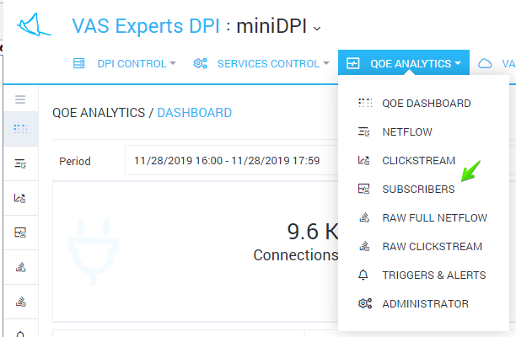
The section will be opened like the figure below.
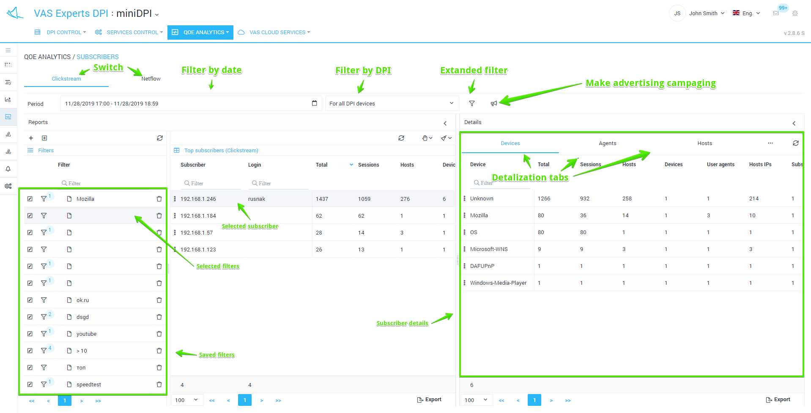
To analyze subscribers in terms of netflow, please open Netflow tab.


