6 Приоретизация по протоколам (DSCP)

Editing
To go to the corresponding section, open the DPI CONTROL menu and click "PROTOCOL PRIORITIZATION (DSCP)".
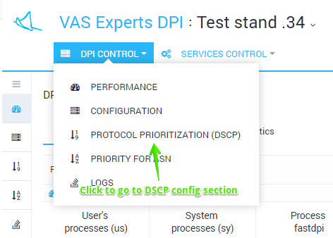
The section looks like the figure below.
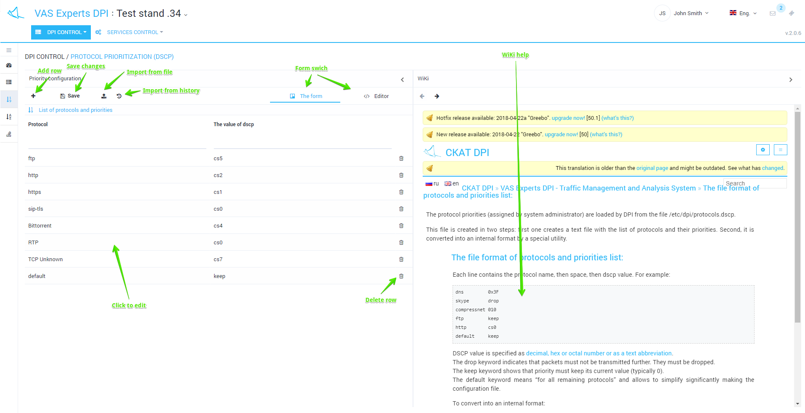
You can view and filter the list of protocols along with its corresponding priorities and add, delete or edit in this section.
Editing is done in tabular form. To edit, just click on the line. When filling out the protocol values and dscp, drop-down lists of hints appear.
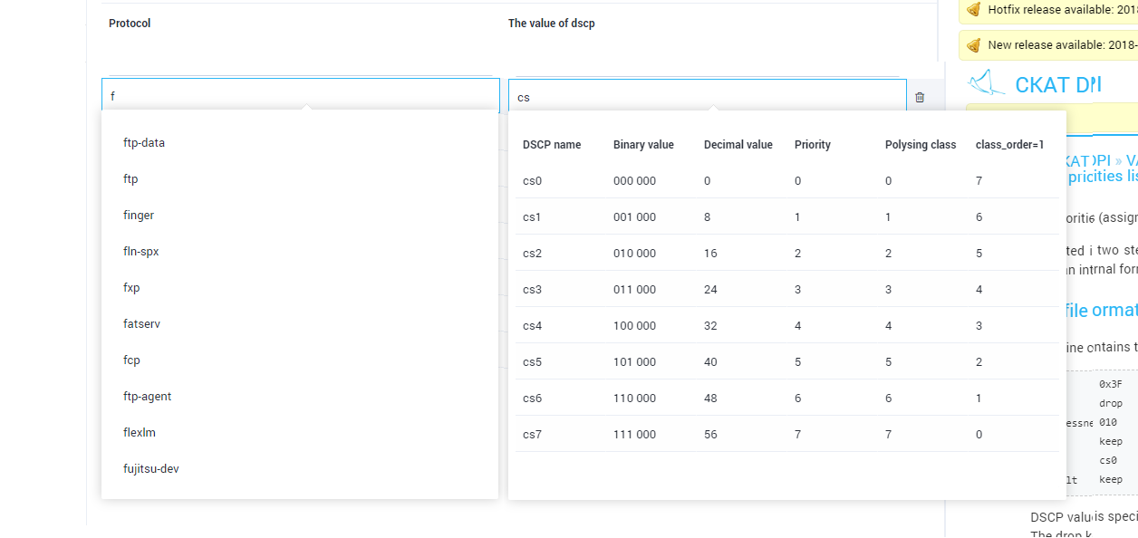
Do not forget to click Save after making changes.

Direct editing
It is possible to edit the file directly without using a table form. To switch to the direct editing mode, click the "Editor".
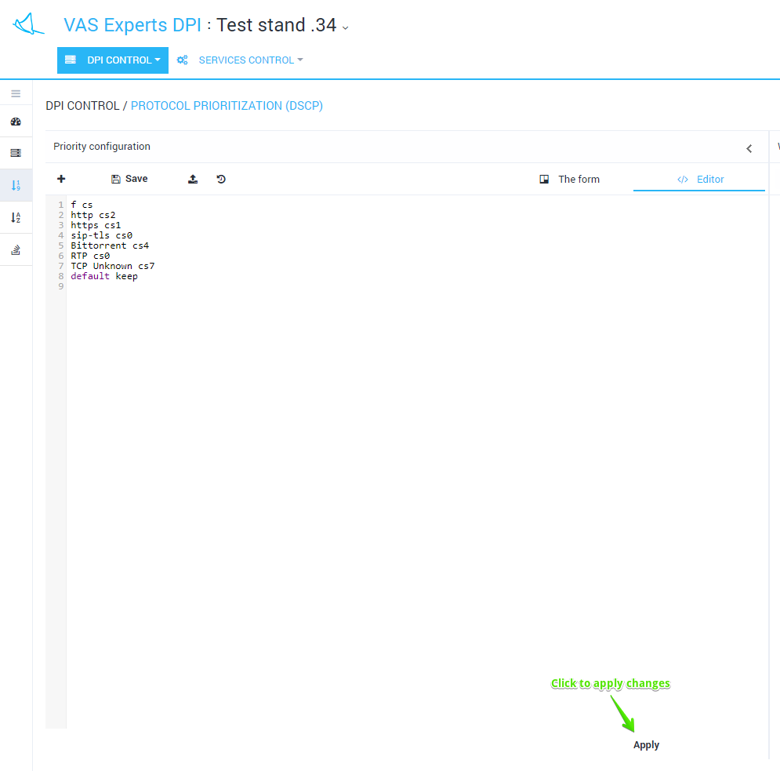

History view and import
To view the history changes, click the History button. The form will be opened as in the figure below.
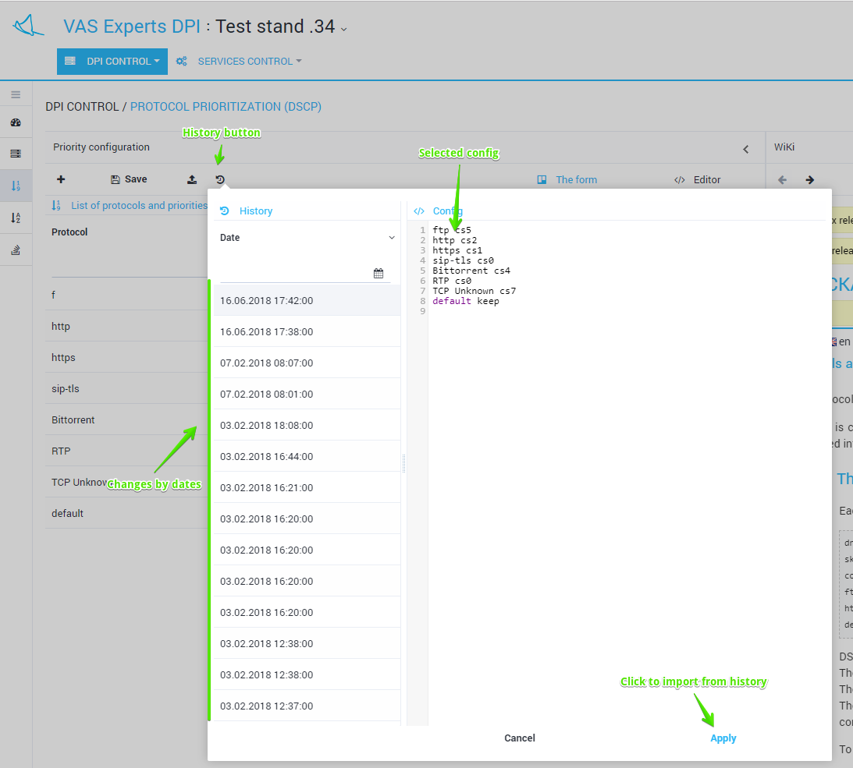
It is possible to view and filter a list of changes by date. Select and apply a a history change.

Import and view from a file
To import from a file, click the "Import" button. The form will be opened as in the figure below.
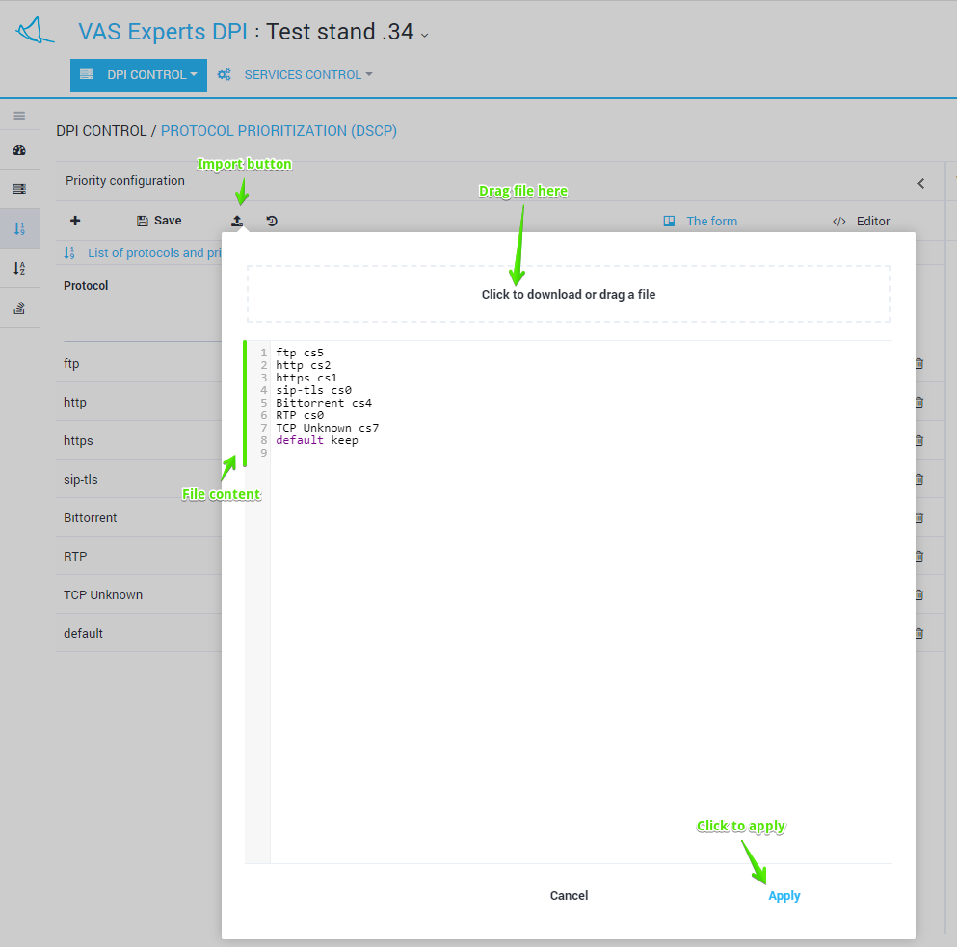
Drag the file to the import zone. The contents of the file will be displayed below. Click Apply to import the contents of the file.

