1 Managing the list of devices
To switch to the section "Managing the list of devices" open the "Device_name" menu and click "Managing the list of devices".
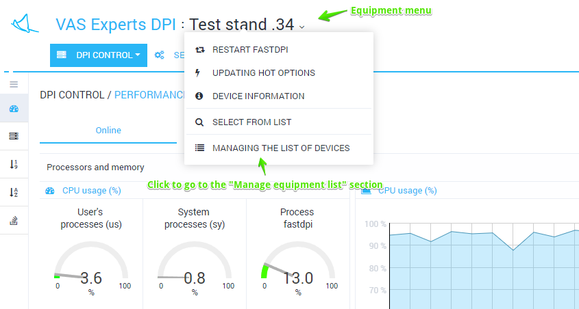
The section looks like the figure below.
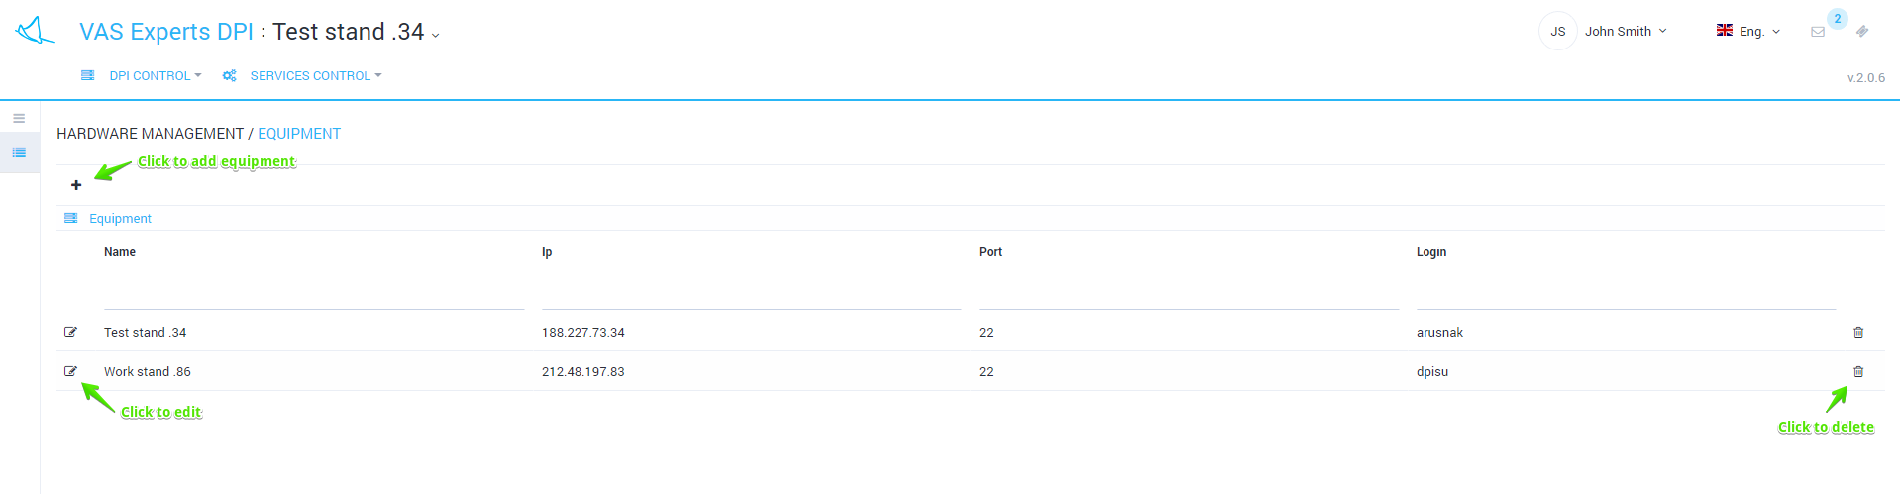
This section implements the following features:
- View a list of devices along with filtering feature
- Add new device
- Edit parameters of existing device
- Delete device
Edit form looks like the figure below.
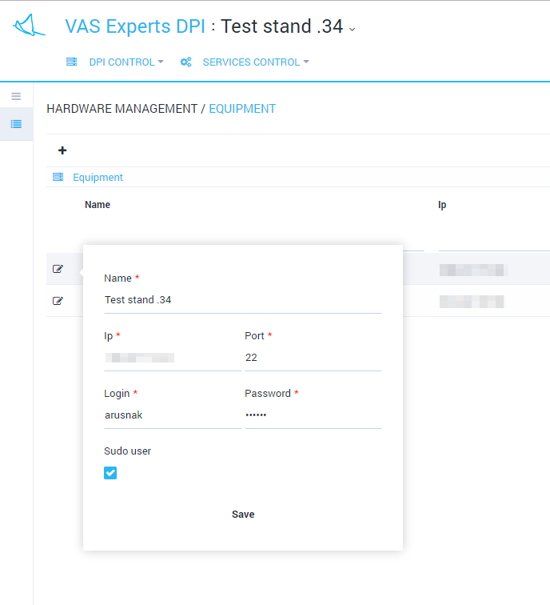
The edit form allows to specify following parameters:
- Device name
- Device IP address used to establish ssh connection
- Port number used to establish ssh connection
- User name
- Password
- Flag, specifying whether the user added to the /etc/sudoers file (allowed to run programs as super user do) or not
Note: For a proper work use a user with sudo rights (defined in the /etc/sudoers file ). See section Configuring a connection to DPI

