2 FastDPI server

Switching between devices
You can control only one selected device.

To switch to the section "Managing the list of devices" open the "Device_name" menu and press "Select from list".
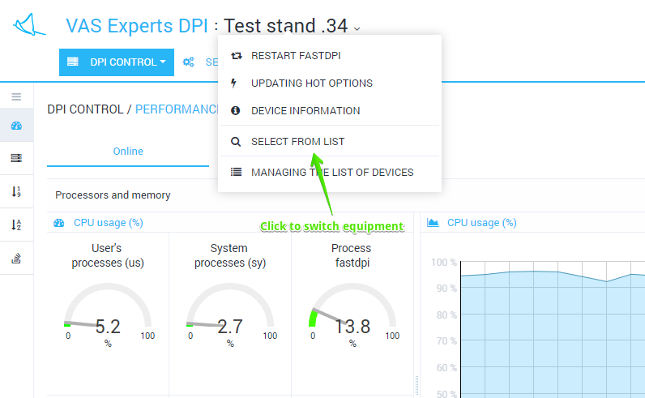
The list (with filtration options) of available devices will be opened.
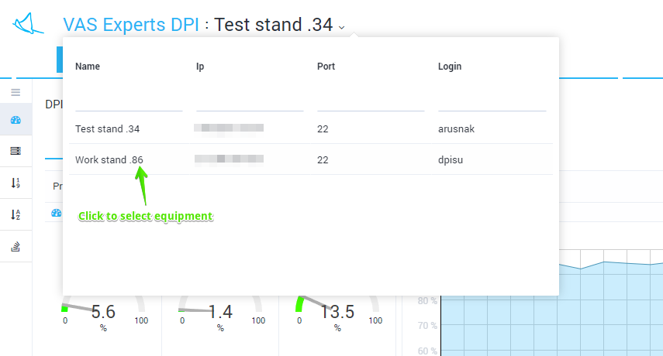
Clicking on a list item causes switching to the device

Device information
For device information open the "Device_name" menu and press the "Device information".
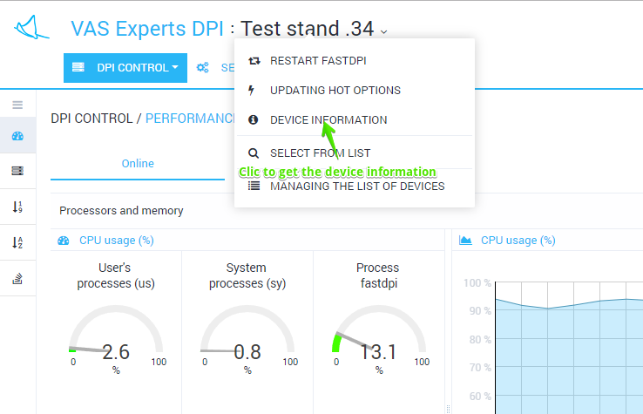
Subwindow "Device information" containing device main characteristics will be opened
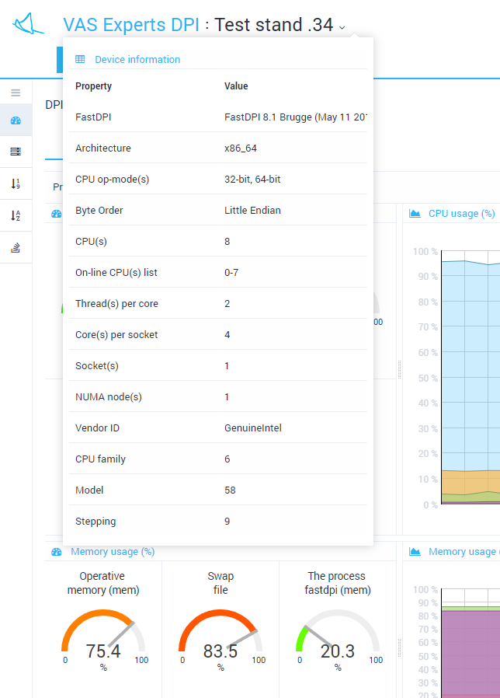

Updating hot options
When you change some options (the so-called "on-the-fly" or "hot" options) in the hardware configuration, it is not necessary to restart the fastdpi service. You can use "Updating hot options".
To update "hot" ("on-the-fly") options open the "Device_name" menu and press "Updating hot options".
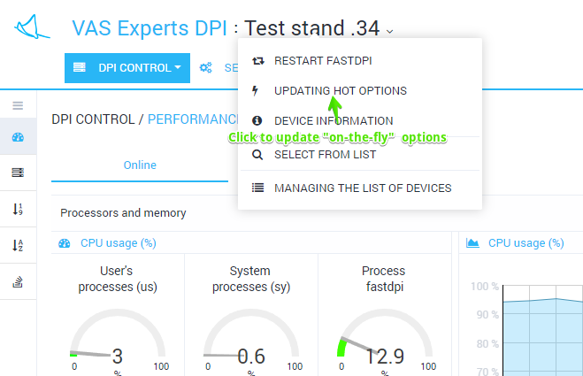
You will be prompted to confirm the operation. Click Refresh.
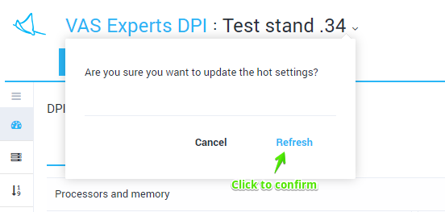
An operation will be performed. The result will be displayed.

Restart fastdpi
If you change standard (not "on-the-fly") options you need to restart the fastdpi service.
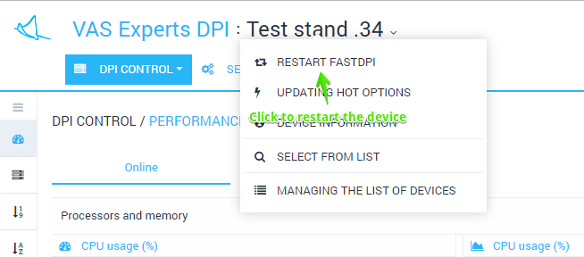
To restart the service, open the "Device_name" menu and click "Restart fastdpi".
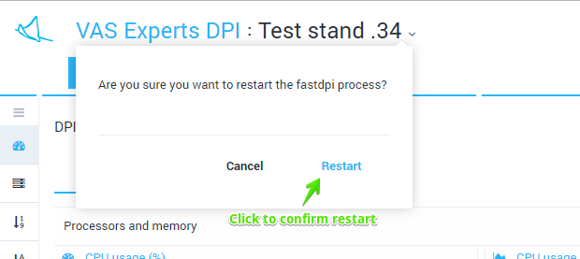
A restart will be performed. The result will be displayed.

