8 Wi-Fi HotSpot Module

Introduction
The module provides the feature to authorize users by phone number in public Wi-Fi networks.

Architecture
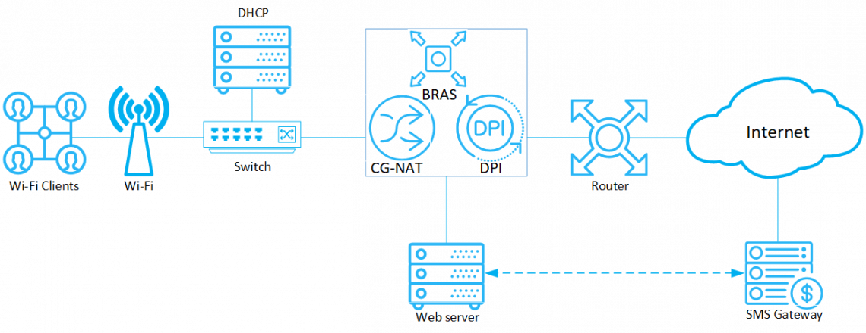

Scenarios of use
When a subscriber connects to Wi-Fi, the router requests the DCHP server to obtain a new IP address. The server returns the addresses to the router and runs the shell-script, which activates the tariff with limited access and the “White List”. It makes sense to include in the white lists, for example, the site of the provider or organization providing public Wi-Fi.
Then the subscriber is redirected to the browser start page, where he needs to go through the authorization by phone number. The web server receives a successful authorization response from the SMS gateway and, using a shell-script, disables restrictions specified on the DPI and redirects the subscriber to the desired page.
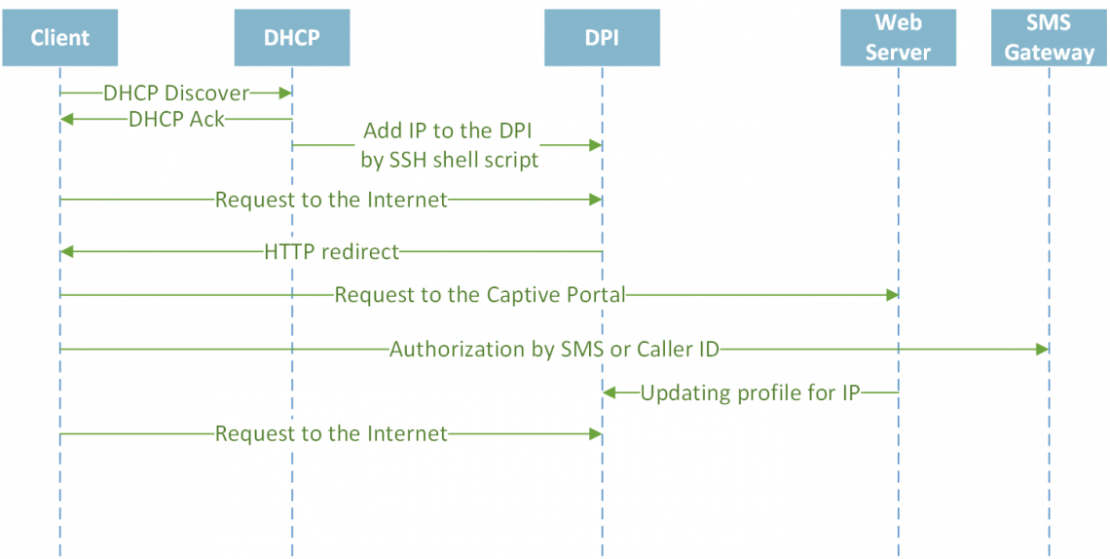

Installation and Upgrade

Hardware Recommendations
In order to run the module you can use the following hardware or virtual machines matching the following characteristics:
- CPU 2.5 GHz, 1 pcs
- RAM 512 MB - 1 GB
- HDD 20 GB - 50 GB
- Operating system Cent OS 6.4 - 7+
- NIC ranging from 10 Mб/сек
Recommended operating system is Cent OS 7+ If you need to install the module on Cent OS 6, make sure that supervisor 3+ is installed. If you do not have the needed package, plese contact the Stingray Service Gateway technical support.
Do not install the module on the same hardware running the DPI or the SSG DPI 2 management interface! Use a dedicated virtual machine instead.

Before installation

New Virtual Machine
- Make sure the openssh-clients is installed, it is required to connect to the DPI
- The rest of environment will be installed automatically

Old Virtual Machine
- Make sure the openssh-clients is installed, it is required to connect to the DPI
- If PHP version <7.1 is installed, uninstall the old one:
yum -y remove php*
The new version will be installed automatically during dpiui2 installation.
- If MySql is installed, uninstall it:
yum remove mysql mysql-server mysql-community-common
Also delete the MySql directory:
mv /var/lib/mysql /var/lib/mysql_old_backup
During wifi_hotspot installation MariaDB 10.2+ will be installed

CentOS 6
Recommended operating system is Cent Cent OS 7+ If you need to install the module on Cent OS 6, make sure that supervisor 3+ is installed. If you do not have the needed package, plese install it using the following commands:
sudo wget https://vasexperts.ru/install/supervisor-3.0-1.gf.el6.noarch.rpm
yum install supervisor-3.0-1.gf.el6.noarch.rpm

Installation
Before installing or upgrading, check your internet connection. Run scripts with root privilege or using sudo.
Attention: You should to disable selinux. To do this, set SELINUX = disabled in the /etc/selinux/config file and restart server.
Attention: If you've configured the virtual machine using HotSpot Management section before you install this module, all the needed tools and settings will be installed automatically.
To install, run the script:
#!/usr/bin/env bash
info () {
echo -e " info: $@ ";
}
ok () {
echo -e " done: $@ ";
}
error () {
echo -e " ERROR: $@";
}
CENTOSRELEASE=`cat /etc/redhat-release`
SUBSTR=`echo $CENTOSRELEASE|cut -c1-22`
SUBSTR2=`echo $CENTOSRELEASE|cut -c1-26`
#Check OS version
CentOsVersion=0
if [ "$SUBSTR" = "CentOS Linux release 7" ]
then
CentOsVersion=70
elif [ "$SUBSTR2" == "CentOS release 6.5 (Final)" ]
then
CentOsVersion=65
elif [ "$SUBSTR2" == "CentOS release 6.4 (Final)" ]
then
CentOsVersion=64
else
CentOsVersion=60
fi
#Configure repos
info "Configuring repos..."
rpm --import http://vasexperts.ru/centos/RPM-GPG-KEY-vasexperts.ru
rpm -Uvh http://vasexperts.ru/centos/6/x86_64/vasexperts-repo-1-0.noarch.rpm
MARIADB_REPO=/etc/yum.repos.d/mariadb.repo
if [ "$CentOsVersion" == 70 ]
then
rpm -Uvh https://dl.fedoraproject.org/pub/epel/epel-release-latest-7.noarch.rpm
rpm -Uvh https://mirror.webtatic.com/yum/el7/webtatic-release.rpm
echo "[mariadb]
name=MariaDB
baseurl=http://yum.mariadb.org/10.2/centos7-amd64
gpgkey=https://yum.mariadb.org/RPM-GPG-KEY-MariaDB
gpgcheck=1" > $MARIADB_REPO
else
rpm -Uvh https://dl.fedoraproject.org/pub/epel/epel-release-latest-6.noarch.rpm
rpm -Uvh https://mirror.webtatic.com/yum/el6/latest.rpm
MACHINE_TYPE=`uname -m`
if [ ${MACHINE_TYPE} == 'x86_64' ]
then
echo "[mariadb]
name=MariaDB
baseurl=http://yum.mariadb.org/10.2/centos6-amd64
gpgkey=https://yum.mariadb.org/RPM-GPG-KEY-MariaDB
gpgcheck=1" > $MARIADB_REPO
else
echo "[mariadb]
name=MariaDB
baseurl=http://yum.mariadb.org/10.2/centos6-x86
gpgkey=https://yum.mariadb.org/RPM-GPG-KEY-MariaDB
gpgcheck=1" > $MARIADB_REPO
fi
fi
ok "Finished Configuring repos."
#wifi_hotspot install
info "Wifi hotspot package installing..."
yum install -y wifi_hotspot --exclude=php-common*;
info "Finished wifi_hotspot package installing."
The rpm wifi_hotspot package will be installed. It will be configured automatically according to the default configuration.
Installation/upgrading of the following environment will be performed during the installation:
- PHP >= 7.1
- MariaDB >= 10.2
- Apache
- Composer
- PHP SSH2 lib
- Laravel/Lumen
The necessary ports will be opened, and cron will be launched to perform scheduled background tasks during the installation process.
The module will be installed to the
/var/www/html/wifi_hotspot/
directory.
After the installation, enter in the browser:
http://<IP address of VM>/

Upgrade
To update a previously installed version, run the following command:
yum install -y wifi_hotspot

Configuration
System settings of the module are in the .env file:
/var/www/html/wifi_hotspot/backend/.env
The contents of the file are as follows:
#System settings, it’s worth to avoid modifying it
APP_ENV=local
APP_DEBUG=true
APP_KEY=
APP_TIMEZONE=UTC
#System settings for connecting to the MySql database, it’s worth to avoid modifying it
DB_CONNECTION=mysql
DB_HOST=localhost
DB_PORT=3306
DB_DATABASE=wifi_hotspot
DB_USERNAME=root
DB_PASSWORD=vasexperts
#Settings for connecting to the SMTP server. They serve to send authorization data in debug mode.
CFG_SMTP_UNAME=smtptestvasexperts@gmail.com
CFG_SMTP_PW=pH3xkXTp1
CFG_SMTP_HOST=smtp.gmail.com
CFG_SMTP_PORT=587
CFG_SMTP_SECURE=tls
CFG_SMTP_SENDER=smtptestvasexperts@gmail.com
#System settings, modifying is fobidden
CACHE_DRIVER=file
QUEUE_DRIVER=database
SESSION_DRIVER=cookie
If .env file has been modified, you should run the following command:
php /var/www/html/wifi_hotspot/backend/artisan queue:restart

Version Information

Version v.1.2.4 (02.10.2020)
- Bugs fixed

Version v.1.1.0 (06.11.2019)
- The process of replacing the logo and icons through the dpiui2 interface reworked
- The size limitation of logo or icon file from 64kb to 750kb changed

Version v.1.0.10 (10/25/2019)
- Correction of the display of the portal on mobile devices
- Correction of the re-authorization algorithm

Version v.1.0.7 (15.09.2019)
- Created a new Wi-Fi HotSpot module

Known Issues
- When changing the logo within the HotSpot Management section there is a 64kb limit on the maximum file size. Will be fixed in version v.1.1.0.

