Purpose of Use
Thank you for your interest in our solutions!
VAS Experts is a developer of software for network traffic control and analysis, and our main product is the multifunctional Stingray Service Gateway. Based on Deep Packet Inspection technology, Stingray performs the functions of:
- BRAS/BNG (Broadband Remote Access Server or Broadband Network Gateway)
- Carrier Grade NAT (Network Address Translation)
- Bandwidth control and policing (Quality of Service)
- Web Traffic filtering
- Network Visibility and Quality of Experience.
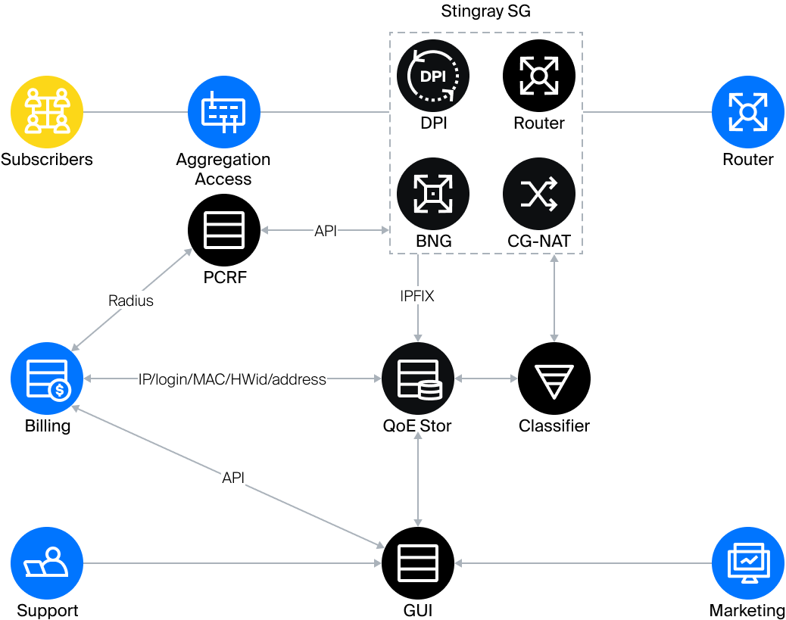

Why Stingray?
The Stingray platform allows you to analyze network traffic, identify the protocols used and provide channel management. Key ISP challenges addressed by VAS Experts products:
- Cost reduction: because the solution is software-based, it is easy to scale, upgrade, and maintain.
- Ease of management: the operator does not need to use heterogeneous equipment, and can build a reliable and efficient core network.
- Increased subscriber loyalty by providing high quality services.
Using Stingray increases the profitability of the operator's business through a more rational use of bandwidth, savings on equipment, subscriber behavior analytics, quick elimination of threats from outside and inside the network.

Where to start?
At the stage of getting acquainted with VAS Experts solutions, we recommend to start with studying these sections:
The "Connection Schemes" page describes the options for implementing SSG in the operator's network and their features. In the "Options" section you will find a list of all SSG functions and a detailed description of each of them. We also advise to learn "Use cases". The best solutions are described there. This information helps you use our system in the best way.

Follow Us
YouTube
LinkedIn
Facebook
We wish you good luck in your business!
VAS Experts Team

