Appliance installation instruction
A typical connection diagram for x86 server hardware:
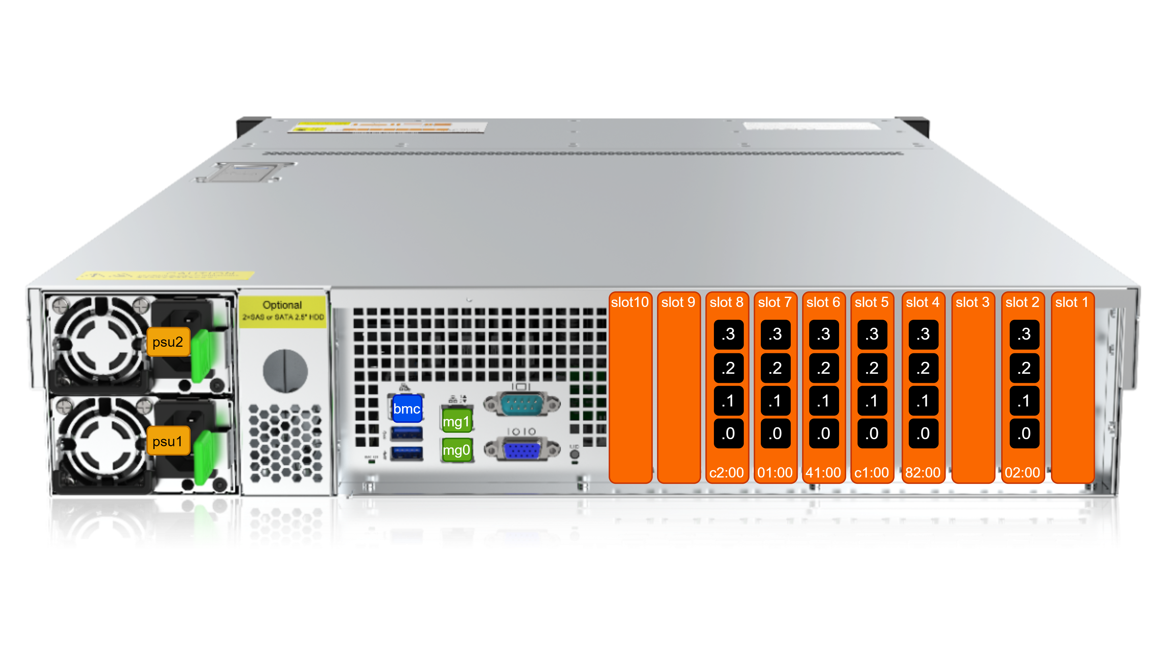
Cards with 10/25/40/100 network ports are placed in slots 1-10
Each slot has a unique PCIe bus identifier, e.g. 02:00.
Each port has a unique identifier on the card, e.g: 02:00.0, 02:00.1, 02:00.2, 02:00.3.
Example of interfaces orientation in pairs:
# In, to the subscriber side - port 02:00.0, 02:00.2
in_dev=02:00.0:02:00.2
# Out, to the Internet side - port 02:00.1, 02:00.3
out_dev=02:00.1:02:00.3
Port configuration is described in the section DPDK Interfaces Configuration.
Ports mg0, mg1 are used for SSH management, IPFIX sending (Full flow, NAT log, ClickStream), integration with Radius/PCRF . For fault tolerance, they are combined in LAG.
The bmc port is used to connect to the BMC server controller.
Each server has two power supplies psu1, psu2 for power redundancy.

