IP address pools
Support for IP address pools for DHCP Radius Proxy and PPPoE modes has been added to the Stingray Service Gateway ver. 8.4.
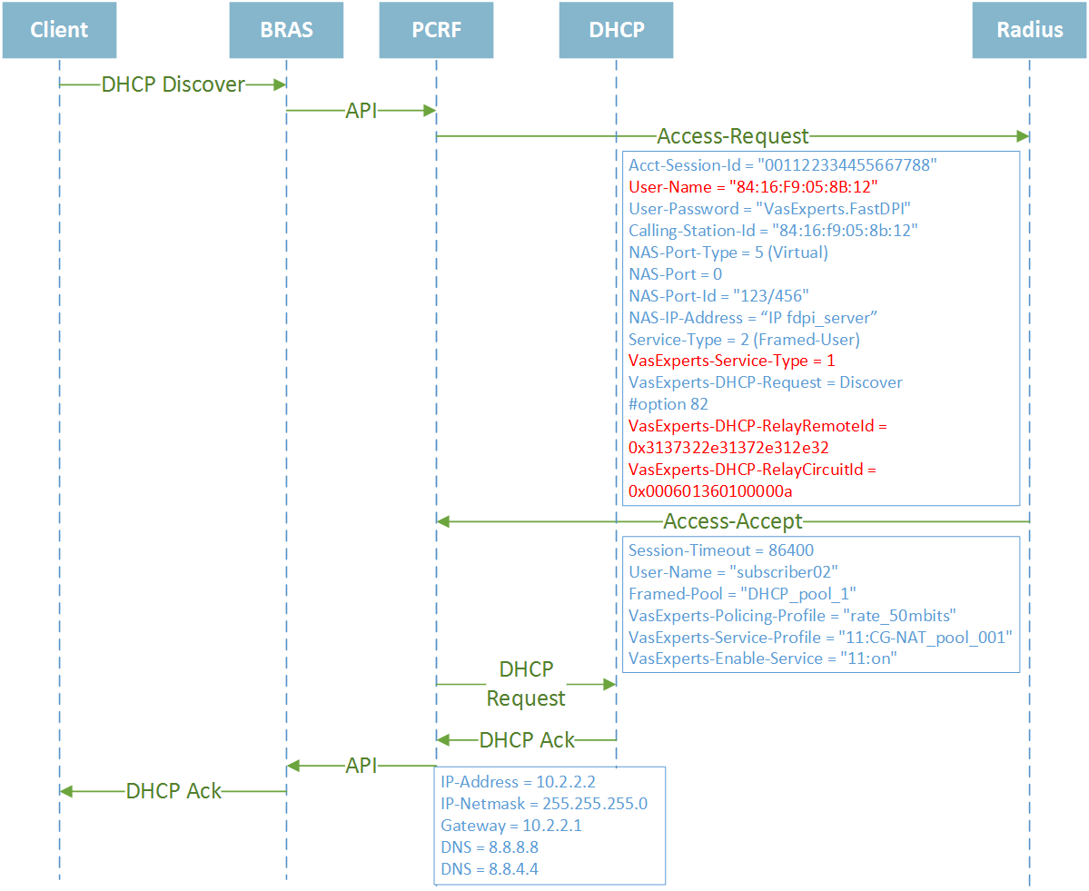
Support for pools can be briefly described this way:
SSG expects to receive the subscriber IP address in the Radius Access-Accept response. A billing system behind the Radius server can provide the name of the address pool from which the address should be allocated to this subscriber rather than directly provide an IP address. The pool name is specified in the attribute Framed-Pool in case of IPv4 and in Framed-IPv6-Pool attribute in case of IPv6.
Once received pool name within the Access-Accept, FastPCRF requests the subscriber IP address from the DHCP server. Having received a response from the DHCP server, fastPCRF extracts the IP address from it, combines the options specified in the DHCP response with Access-Accept attributes, and sends the authorization response via fastdpi to the subscriber.
Technical details of configuring IP pools mode in fastPCRF and special features of particular modes are given below:
- IPv4 pools - Framed-Pool attribute and fastPCRF configuring
- IPv6 pools - Framed-IPv6-Pool attribute and fastPCRF configuring

